
TAX SYSTEM REFORM STRATEGY
(2021-2025)

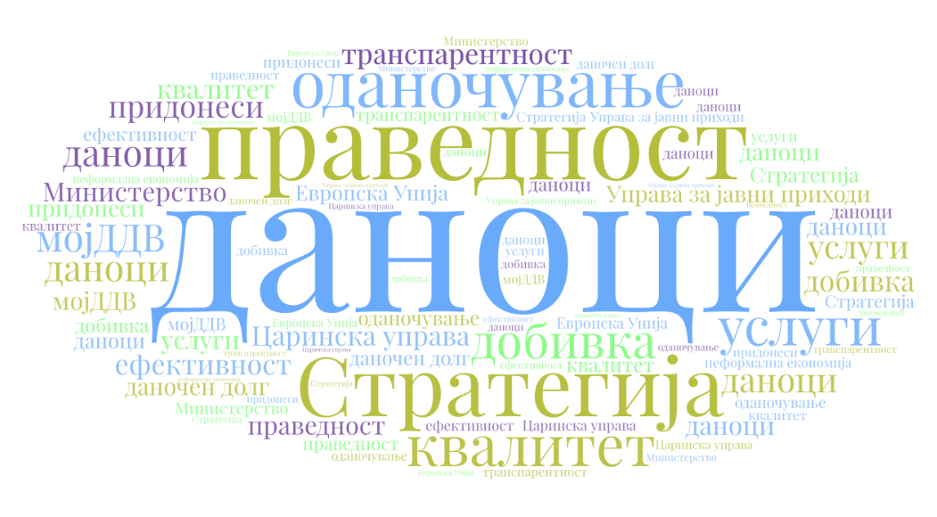

Skopje, December 2020

SUMMARY
Tax System Reform Strategy (hereinafter referred to as: Strategy) is a result of two-year successful cooperation between the national institutions (above all, the Ministry of Finance, the Public Revenue Office and the Customs Administration) and the international development counterparts. It applies the strategic and inclusive approach in creating policies adopted by the Ministry of Finance of the Republic of North Macedonia, in line with the 2018-2021 Public Financial Management Reform Program.
Its main objective is to ensure fair, efficient, transparent and modern tax system based on contemporary digital technologies and innovations in taxation, all to the end of attaining an accelerated, inclusive and sustainable economic growth.
The Strategy outlines five priorities for tax policy creators and tax authorities in the period 2021-2025, with associated key activities, deliverables, responsible entities and KPIs.
- Priority 1 – Increased fairness in taxation, so as to ensure that everyone meets its social obligation and pays its fair share of tax. Main focus in the next five years will be placed on establishing vertical equity, which can be considered as a wider solution than the progressivity of taxes. The expected results are a re-designed model for fair taxation, implementation of Base Erosion and Profit Shifting (BEPS) standards, review of the national legislation to meet EU requirements.
- Priority 2 – Increased efficiency and productivity of the tax system to the end of improved revenue collection, through a more efficient fight against illicit activities and tax evasion and strengthened institutional capacity, analysis and review of the tax base, reduction of tax arrears and implementation of registry of beneficial owners. Some of the envisaged measures aimed at improving the efficiency and the productivity of the tax collection system include review of the existing tax regulations, introduction of advanced technologies, strengthening the institutions’ capacities, modernization and automation of working processes, enhanced institutional coordination, as well as a better cooperation at the international level.
- Priority 3 – Increased tax transparency, including improvement of the exchange of information between tax authorities and other entities, primarily based on e-services and process digitalization. This priority is expected to result in enhanced fiscal literacy and increased voluntary tax compliance.
- Priority 4 – Improved quality of services, designed to simplify and speed up the procedures and to reduce the administrative burden. The targeted outcomes are more digitized services, better management of the import-export licenses’ issuance, elimination of unnecessary non-tariff barriers, as well as improved internal control and tax audit.
- Priority 5 – Introduction of environmental (“green”) taxation, in order to incentivize tax payers to reduce their polluting behaviour and/or activities. The main goal is both to curb pollution and protect natural resources to the end of attaining sustainable economic development.
Strategy implementation will comprise the following steps:
- On the basis of the priorities, the measures and the activities contained in the Strategy, annual action plans will be prepared, elaborating in details all steps for implementation of the activities pertaining to the respective priorities.
- Implementation of the Strategy will be assessed on the basis of Performance Assessment Framework, containing detailed instructions on the assessment of each measure.
- Implementation monitoring and reporting as regards the Tax System Reform Strategy will be carried out by the Tax System Reform Strategy Working Group (TSRS WG) consisted of the Ministry of Finance, the Public Revenue Office, the Customs Administration, the Financial Police Office and the Financial Intelligence Office. The reports will be reviewed by the PFM Sector Working Group, approved by the PFM Council and adopted by the Government.
Competent institutions are fully aware that credibility and success of the Tax System Reform Strategy depends, above all, on the right sequencing of reforms, in a manner that economic policies and political complementarities will result in a single policy. They are aimed at implementing a reform roadmap thus maximizing the economic growth and gaining wider political consent.
Institutions of the Republic of North Macedonia that have contributed to designing the Strategy and will be involved in its implementation are the Ministry of Finance, the Public Revenue Office, the Customs Administration, the Financial Intelligence Office and the Financial Police Office.
On the basis of the Strategy, the TSRS WG will develop an annual action plan to be published by the end of the first quarter each year. Progress of the action plan will be evaluated each year before publishing the action plan for the following year.

LIST OF ACRONYMS
ALP | Arm’s Length Principle
AML | Anti-Money Laundering
AML/CFT | Anti-Money Laundering/Combating the Financing of Terrorism
BEPS | Base Erosion and Profit Sharing
CA | Customs Administration
CAA | Competent Authority Agreement
CbC | Country-by-Country
CDD | Customer Due Diligence
CDEPS | Customs Declarations and Excise Documents Processing System
CIT | Corporate Income Tax
CRS | Common Reporting Standards
CSOs | Civil Society Organizations
DCS | Diagnostic Control System
EU | European Union
FIO | Financial Intelligence Office
FP | Financial Police
GAAR | General Anti-Avoidance Rule
GDP | Gross Domestic Product
HR | Human Resources
IMF | International Monetary Fund
IPA | Instrument for Pre-Accession Assistance
IT | Information Technology
LTO | Large Taxpayer Office
MAP | Mutual Agreement Procedure
MLI | Multilateral Instrument
MNEs | Multinational Enterprises
MoF | Ministry of Finance
OECD | Organization for Economic Co-operation and Development
PEFA | Public Expenditure and Financial Accountability
PFM | Public Financial Management
PFM SWG | Public Financial Management Sector Working Group
PIT | Personal Income Tax
PRO | Public Revenue Office
SEED | System for Exchange of Excise Data
SSORNM | State Statistical Office of the Republic of North Macedonia
SSCs | Social Security Contributions
TADAT | Tax Administration Diagnostic Assessment Tool
TCF | Tax Control Framework
TP | Transfer Pricing
TPL | Transfer Pricing Law
TSRS | Tax System Reform Strategy
TSRS WG | Tax System Reform Strategy Working Group
VAT | Valued Added Tax

LIST OF TABLES

Table 1.1. Tax rates in the countries in the region in 2019 14
Table 1.2 Tax rates in European Union Member States 15
Table 3.1: Implementation of Measure 1.1 - Review the existing tax policy and introduce improvements 29
Table 3.2 Implementation of Measure 1.2 - Ensuring fair competition 31
Table 3.3 Implementation of Measure 1.3 - Harmonization with EU and best practices 33
Table 3.4 Implementation of Measure 2.1 - Analysis of the tax base 35
Table 3.5 Implementation of Measure 2.2 - Reduction of tax evasion 38
Table 3.6 Implementation of Measure 2.3 - Addressing illicit financial flows 39
Table 3.7 Implementation of Measure 2.4 - Reduction of tax arrears 40
Table 3.8 Implementation of Measure 2.5 - Improving the capacities of institutions of the tax system 42
Table 3.9 Impementation of Measure 3.1 - Improved exchange of information 44
Table 3.10 Implementation of Measure 3.2 - Increased availability and quality of tax-related information 45
Table 3.11 Implementation of Measure 4.1 - Improved services to citizens and companies 47
Table 3.12 Implementation of Measure 4.2 - Improved control mechanisms 48
Table 3.13 Implementation of Measure 5.1 - Introducing incentives for environmental responsibility 50
Table 3.14 Environmental taxation in 2018 52
Table 3.15 Implementation of Measure 5.2 - Introducing environmental (“green”) taxation framework 54
Table 5.1 Strategy financing 56
Table 6.1. Increased fairness in taxation 58
Table 6.2 Improved revenue collection 58
Table 6.3 Increased tax transparency 59
Table 6.4 Improved quality of services 59
Table 6.5 Introduction of environmental (“green”) taxation 59
Table 7.1 Assessment of Strategy implementation risk 60
Table 7.2 Risk assessment and Strategy management 60

CONTENTS

SUMMARY 2
LIST OF ACRONYMS 4
LIST OF TABLES 6
INTRODUCTION 8
APPROACH USED TO DEVELOP THE STRATEGY 9
1. FEATURES OF THE TAX SYSTEM IN THE COUNTRY 10
1.1 Direct Taxes 11
1.2 Value Added Tax 12
1.3 Excise Duties 12
1.4 Customs Duties 13
1.5 Mandatory Social Security Contributions 13
1.6 Property Taxes 13
1.7 Summary Comparison Tables 13
1.8 Additional Analysis of the Tax System in North Macedonia 15
2. ASSESSMENT OF THE MACEDONIAN TAX SYSTEM BY INTERNATIONAL ORGANIZATIONS 21
2.1 World Bank Group 21
2.2 IMF 21
2.3 European Commission 23
2.4 Organization for Economic Co-operation and Development 24
3. STRATEGY PRIORITIES, MEASURES AND ACTIVITIES 26
3.1 Priority 1: Increased fairness in taxation 26
3.2 Priority 2: Increased efficiency and productivity of the tax system to the end of improved revenue collection 33
3.3 Priority 3: Increased Tax Transparency 42
3.4 Priority 4: Improved quality of service 45
3.5 Priority 5: Introduction of environmental (“green”) taxation 49
4. MONITORING AND REPORTING ON STRATEGY IMPLEMENTATION 55
5. STRATEGY FINANCING 56
6. STRATEGY PERFORMANCE ASSESSMENT FRAMEWORK 58
6.1 Priority 1: Increased fairness in taxation 58
6.2 Priority 2: Increased efficiency and productivity of the tax system to the end of improved revenue collection 58
6.3 Priority 3: Increased Tax Transparency 59
6.4 Priority 4: Improved quality of service 59
6.5 Priority 5: Introduction of environmental (“green”) taxation 59
7. RISK ASSESSMENT AND STRATEGY MANAGEMENT 60

INTRODUCTION
Growing trade and financial globalization and rapid advancement of ICT have caused radical changes in the global economy. Besides the positive effects in relation to increased total factor productivity and wider consumer choice, they have also brought number of serious challenges for the national economies. Increased capital mobility globally, possibility for tax planning (choice of tax jurisdiction with the lowest tax burden) and unequal distribution of income and wealth are only few of the challenges for the modern tax systems.
Increased economic integration and liberalization of capital flows have put pressure on many governments to lower the tax rates. International race to attract foreign capital (also known as “race to the bottom”) caused, among other things, downward trend of tax revenues in many states, more possibilities for tax avoidance (legal exploitation of the tax system to reduce tax liabilities), as well as tax evasion and customs fraud. Traditional forms of customs fraud and tax evasion continue to pose challenges, but are further intensified by increases in offshore tax evasion, where funds are being “concealed” from the home tax authorities. These practices are also often connected with illicit financial flows, money laundering and terrorist financing. In addition, awareness and concerns about environmental sustainability have been rising.
All these developments have put governments, in particular tax authorities, under greater pressure and require their coordinated action. Globalization and liberalization of economic activity and trade, which have transformed the business into a world without borders, also require enhanced international cooperation between governments.
In the meantime, global initiatives, such as the G20, the Organization for Economic Co-operation and Development (OECD), the World Bank (WB), the International Monetary Fund (IMF) and the United Nations (UN) have emerged, stressing the need for financial and tax transparency and cooperation, as well as coordination on tax issues.
In order to adequately address all these issues, Ministry of Finance of the Republic of North Macedonia, alongside its administrative authorities, has decided to adopt a strategic approach to tax policy and administration. The main goal is to ensure consistency of the tax institutions’ activities, coordinated and clearly directed towards a common goal - inclusive and sustainable economic growth.

APPROACH USED TO DEVELOP THE STRATEGY
Government of the Republic of North Macedonia adopted Public Financial Management (PFM) Reform Program in 2017. Tax System Reform Strategy (“TSRS” or “Strategy”) pursues the framework set out under this Program.
It was prepared by the Tax System Reform Strategy Working Group (TSRS WG), established in January 2018, consisting of representatives from the following institutions
- Ministry of Finance,
- Public Revenue Office,
- Customs Administration,
- Financial Intelligence Office, and
- Financial Police Office.
The Working Group held regular meetings during January - July 2018 and September - November 2019. During the Strategy preparation, great deal of support was provided by the Delegation of the European Union in the Republic of North Macedonia and the Ministry of Finance of the Kingdom of the Netherlands, and the Ministry of Finance of the Republic of North Macedonia would like to extend its gratitude. Ministry of Finance adopted preliminary version of the Tax System Reform Strategy. Through an inclusive approach, it was distributed to many stakeholders and two broad public debates were organized in February and December 2020.
On the basis of the priorities, measures and activities defined within the Strategy, annual Action Plans will be prepared, elaborating in more details all steps for the implementation of the activities in the respective year. The Action Plans will be prepared by the TSRS WG.
Strategy implementation will be evaluated on the basis of the Performance Assessment Framework, presented in a separate section in this document, which contains detailed indicators for each measure. TSRS WG will carry out medium-term review of the Strategy in 2023. Should a need arise for certain changes to the Strategy before the review, such changes will be made in the Action Plans.
Public consultations will be held prior to the adoption of the Strategy, by involving main stakeholders, including international organizations, civil society organizations, trade unions, the business community and the academia. Once adopted by the Government, the TSRS will be published on the Ministry of Finance website.
By managing the reform process, i.e. through complementary measures, the competent authorities will strive for attaining the highest level of economic efficiency, as well as political and social support to the process.
Synergy in the reform process can be also achieved by continuous investing in human capital, as well as by investing in technology, all to the end of reaching constant improvements in tax collection and tax compliance.
Transparency in the entire process remains to be priority of the Government, since maximum effect can be attained by accountability and transparency of the public financial system.
Gradual, as opposed to swift, implementation of reforms will remove the risk of abrupt changes in the economic behavior of the individuals and the legal entities. Gradual approach to reform implementation is safer, therefore the authorities will act in consultation with the social partners and the public in a way that is both credible and efficient.
Overall, identification of small-scale reforms with a major potential impact, capacity building by investing in human capital and technologies, transparency and accountability and continuous social dialogue are the key pillars of our Strategy, driven by the principles of sustainable and fair benefits to all.

FEATURES OF THE TAX SYSTEM IN THE COUNTRY

Total public revenues in the Budget of the Republic of North Macedonia accounted for to 29.6% of the GDP in 2019 and are among the lowest in Europe. 2019 figures are used as a reference point due to the seasonality in the nature of certain taxes, because using the figures from the first three quarters of the 2020 would provide a distorted picture of public revenue structure. Public revenues in the central government Budget comprise the following: direct and indirect taxes, fees, revenues generated by public enterprises and institutions, public loans and financial donations. Leaving aside the capital revenues, donations and other non-tax revenues, taxes and contributions accounted for 87.7% of the total budget revenues, while the tax revenues alone accounted for 56.45% of the 2019 Budget. Tax revenues and contributions accounted for 25.95% of GDP, while tax revenues alone accounted for 16.7% of GDP. Tax revenues in the Budget of the Republic of North Macedonia, increased by the property taxes as tax revenues of local government units, accounted for 17.2% of GDP.
Most important types of taxes and contributions are the following:
- direct taxes;
- valued added tax;
- excise duties;
- customs duties;
- mandatory social security contributions;
- property taxes.

Chart 1. Tax revenues (% of GDP)

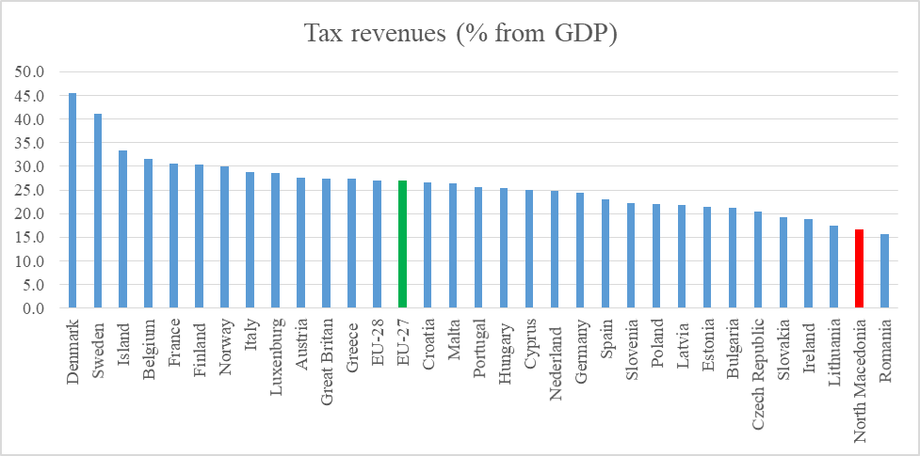

Source: Eurostat (2020) and Ministry of Finance (2020)
Should tax revenues be divided in three main pillars, i.e. revenues on the basis of income taxes, revenues on the basis of taxes on capital and revenues on the basis of consumption taxes, their share as percentage of gross domestic product, i.e. tax burden as % of GDP, is obtained. With respect to revenues on the basis of consumption taxes, they account for 12.69% of GDP. Taxes falling within consumption taxes are VAT, as basic consumption tax/tax on supply of goods and services, import duties and excise duties.
Two charts presented below lead to the conclusion that Republic of North Macedonia has one of the lowest tax burdens (expressed as percentage of GDP). The reasons therefore should be looked for in the low tax rates, the level of informal economy, as well as the numerous tax reliefs or exemptions, which reduce the tax base.
Chart 2. Revenues from consumption taxes (as % of GDP)

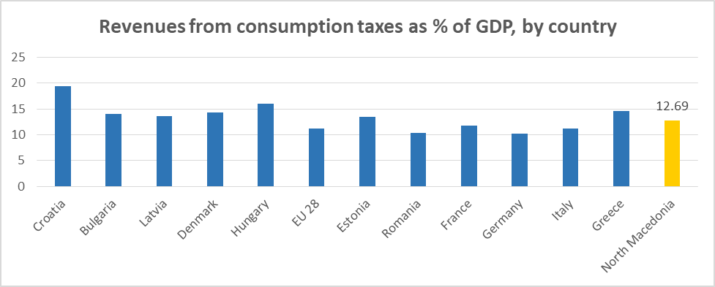
Total tax revenues generated on the basis of income taxes in relation to GDP account for 10.59%. Taxes falling within income taxes are PIT and mandatory social security contributions.
Chart 3. Revenues from income taxes (as% of GDP)

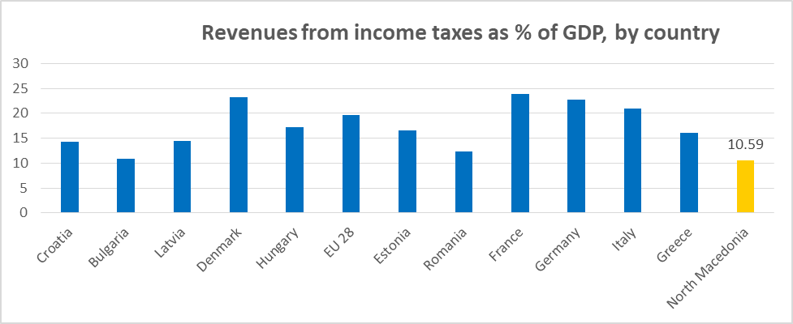
Total tax revenues generated on the basis of taxes on capital in relation to GDP account for 3.67%. Definition of taxes on capital includes property tax and profit tax.

Chart 4. Revenues from capital taxes (as% of GDP)

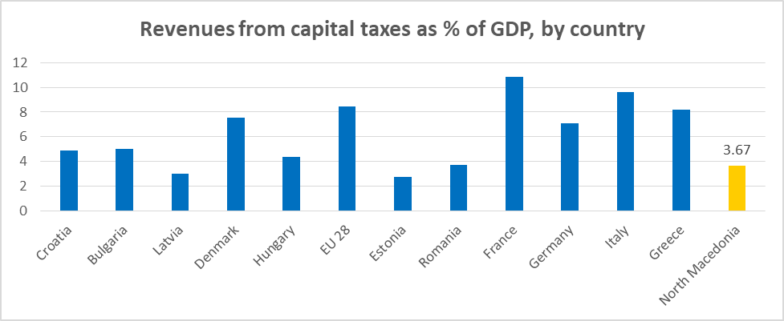

1.1 Direct Taxes
Existing Macedonian tax system in the area of direct taxation is characterized with proportional and equal taxation of personal income and corporate income - both at 10% tax rate (except for the PIT tax rate as regards income on the basis of games of chance, which is taxed with 15% PIT tax rate). The system of flat PIT and corporate income tax (commonly known as “flat tax”) was introduced on 1st January 2007 for the first time, with a tax rate of 12%, which was further reduced to 10%, starting 1st January 2008. Prior to 2006, the tax rate on profit of legal entities was proportional amounting to 15%, while the personal income tax applied accelerated disaggregated progression with three rates; as follows: 15%, 18% and 24%.
Starting 1st January 2019, income of individuals for tax purposes was divided on labour income and capital income. PIT progressive taxation was introduced as regards labour income. Two tax rates were introduced with respect to labour income: 10% tax rate on annual income up to Denar 1,080,000 and higher tax rate of 18% on the amount exceeding the threshold of Denar 1,080,000 (tax base) annually. Capital income is taxed with proportional tax of 15%. Corporate income taxation system has remained unchanged: single proportional tax rate of 10% is applied at corporate income tax (CIT), which pertains to legal entities. This reform was introduced with the main purpose of mitigating the unequal distribution of income and reduce income inequality. Furthermore, in 2019 for the first time, PIT was divided into two segments: (1) PIT on labor and (2) PIT on capital.
The effects from the introduction of the progressive PIT taxation were analyzed on the basis of data for the period 1st January - 30th June and compared to the same period in 2018. Although the reform caused increased revenues on the basis of this type of tax, internal analysis has shown that revenues generated could have been higher by a certain percentage had the taxpayer not changed the behaviour due to the introduction of progressive taxation.
The analysis indicated the likelihood of tax avoidance. The common ways of tax avoidance include opening up accounts in neighboring countries and transferring the earned income to another state (tax jurisdiction) and/or transferring the income to other people (relatives and friends) who have not yet reached the progressive-tax threshold. Therefore, such taxpayers’ behaviour fictitiously improved income distribution, while significantly undermining the fiscal effect. Because of the possibility for increased informal economy and tax evasion, it was decided for the PIT progressive taxation system to be suspended. On the basis of the assessment, starting 1st January 2020, Government of the Republic of North Macedonia decided to suspend this reform for a period of 36 months, while continuing to apply the 10% flat rate for all types of income, except for income generated on the basis of games of chance with the tax rate remaining at 15%.
Direct taxes accounted for 14.8% of the total budget revenue in 2019 (4.4% of GDP), out of which PIT accounted for 9.2% of the total budget revenues (2.7% of GDP), while share of corporate income tax in total budget revenues was 5.7% (1.7% of GDP).

Effective CIT tax rate in 2018 was 5.1%, while estimated effective PIT tax rate in 2019 was 5.49%.

1.2 Value Added Tax
Value added tax is one of the taxes that contributes the most to total public revenues, accounting for 25.5% of the total budget revenues in 2019 (7.6% of GDP) and 45.2% of the total tax revenues in the Budget of the Republic of North Macedonia. VAT general tax rate is 18%, while the two preferential tax rates applied are 10% and 5%. VAT Law was first adopted on 1st April 2000, replacing the then consumption tax.

1.3 Excise Duties
Pursuant to the new Excise Law, which applies starting 1st January 2020, excise goods are the following:
- alcohol and alcoholic beverages;
- tobacco products, and
- Energy products and electricity.
Excise duty paid on excise goods is prescribed in absolute amount per unit measure (specific excise duty), while as regards tobacco products, it is paid as combination of specific and proportional excise duty (excise duty in percentage amount).
Excise duty on gross basis accounted for total of 14.6% of the total revenues in 2019 (4.3% of GDP in 2019). 51.4% of total excise duty was on the basis of mineral oils, 40.1% on the basis of tobacco products, 6.2% on the basis of alcohol and beer, while the remaining portion of 2.3% was on the basis of passenger vehicles which were regulated under the Excise Law by 2020.
By applying the new Excise Law starting 1st January 2020, passenger vehicles are no longer subject to excise duty, but are rather regulated under the new Law on Motor Vehicles Tax, which started to apply from 1st January 2020. The Law on Motor Vehicles Tax regulates the tax on motor vehicles and, in addition to ad valorem, it includes an ecological component aimed at raising the ecological awareness of the individuals and contributing to reduction of environment pollution.

1.4 Customs Duties
Customs rates are relatively low in the Republic of North Macedonia due to the high level of trade liberalization. In 2019, they accounted for 3% of the total budget revenues (0.9% of GDP).

1.5 Mandatory Social Security Contributions
Mandatory social security contributions are the largest source of public revenues, accounting for 30.5% of the total revenues in 2019. They account for 9.0% of GDP.
Mandatory social insurance contributions are calculated on gross wages of insured persons and represent revenues for the respective social funds that finance the current and the future rights of the insured persons - rights to health care, right to pension or unemployment benefits.
Starting 1st January 2020, total mandatory social security contributions amount to 28% of the gross wage (18.8% for pension insurance, 7.5% for health insurance, 1.2% for unemployment insurance and 0.5% for additional health insurance). They are capped at 16 average gross wages, meaning that if someone earns more than this amount, his/her base for calculating the contributions would still be 16 average gross wages.

1.6 Property Taxes
Property taxes are the main revenue source of the municipalities (local government units), as part of the fiscal decentralization process. Law on Property Taxes distinguishes three types of property taxes:
- property tax - the tax rate varies from 0.10% to 0.20% of the market value of the real estate and is paid each year;
- gift and inheritance tax - the tax rate varies from 2% to 5% of the market value of the real estate, depending on the order of inheritance;
- Property sales tax - the tax rate varies from 2% to 4%.
The exact tax rates in each municipality are determined by the municipality itself, with the Law specifying the rates range and specifying that the rates are proportional (flat).
Total revenues on the basis of property taxes accounted for 0.5% of GDP in 2019, being among the lowest in Europe.

1.7 Summary Comparison Tables
As tax policy has become a key area of competition across countries, in particular when it comes to attracting foreign direct investments, two benchmarks are worth considering:
Table 1.1 compares the tax rates in North Macedonia with the Southeastern European countries.

Table 1.2 compares the tax rates of selected European Union countries, European Union average and Eurozone average. It can be seen that tax rates for all the taxes in North Macedonia are among the lowest.

Table 1.1. Tax rates in the countries in the region in 2019

 | Macedonia | Serbia | Albania | Kosovo | Bulgaria | Croatia | Slovenia
PIT | 10% and 18% progressive and 15% proportional rate on capital income | 10%-20% | 13%-23% progressive | 4%-10% progressive | 10% flat | 24%-36% progressive | 16-50% progressive
CIT | 10% proportional | 15% flat | 0-15% progressive | 10% flat | 10% flat | 12%-18% progressive | 19% flat
VAT | 18% standard and 5% preferential | 20% standard and 10% preferential | 20% general and 6% preferential | 18% general and 8% preferential | 20% general and 9% preferential | 26% standard and 13% and 5% preferential | 22% standard and 9.5% and 5% preferential
Mandatory social security contributions (all) | 27.5% | 37.05% | 27.9% | 10% | 32.7% to 33.4% | 36.5% | 38.2%
Property tax, recurrent | 0.1%-0.2% | 0.4%-2% | 0.05-0.2% | 0.05%-1% | 0.15% | N/A | N/A
Property tax, transfer | 2%-4% | 5% | 2-4% | N/A | 2% | 3% | 2%

Table 1.2 Tax rates in European Union Member States

 | EU average | Eurozone average | Austria | Czech Republic | Germany | Greece | Italy | Slovakia
PIT | 39.4% (average max) | 43.2% (average max) | 0.0% - 50.0% (progressive) | 15.0% (flat) | 14,0% - 47.5% (progressive) | 22.0% - 55.0% (progressive) | 23.0% - 47.2% (progressive) | 19.0% - 25.0% (progressive)
CIT | 16.0% | 16.2% | 17.2% | 20.2% | 16.8% | 15.1% | 19.5% | 29.3%
VAT | 21.5% (standard) | 20.8% (standard) | 20,0% (standard) 10,0% (preferential) | 21.0% (standard) 10.0% (preferential) | 19.0% (standard) 7.0% (preferential) | 24.0% (standard) 6.0% (preferential) | 22.0% (standard) 4.0% (preferential) | 20.0% (standard) 10.0% (preferential)
Mandatory social security contributions (all) | 24.2% | 26.7% | 30.6% | 30.8% | 25.5% | 34.8% | 28.5% | 28.7%
Property tax, recurrent | N/A | N/A | 0.1% | 0.2% | 0.3% | 1.5% | 0.7% | 0.4%
Source: Taxation trends in the European Union (2019) and Tax Bases for Property Tax, 2019

1.8 Additional Analysis of the Tax System in North Macedonia

1.8.1 Tax Revenues
Total public revenues in the Republic of North Macedonia accounted for to 29.6% of the GDP in 2019. Tax revenues and revenues collected on the basis of contributions as a percentage of GDP account for 25.95%, while tax revenues in the Budget alone account for 16.7% of GDP. Taxes and contributions participated with 87.7% in the total public revenues, while tax revenues alone accounted for 56.5% of the total revenues in 2019. Chart 1 shows that such tax coverage puts North Macedonia among the countries with relatively low level of tax revenues collection (when expressed as share of GDP), although the collection level is similar to the one in the Czech Republic, Lithuania and Poland. At the other end of the spectrum, we have Luxemburg, Sweden and Denmark, with the highest tax coverage.
- Chart 5. Tax Revenues (as% of GDP)
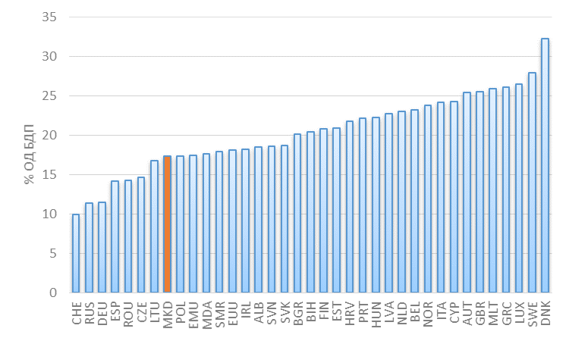

Source: World Development Indicators (2018).
Revenues on the basis of tax on labour income, capital gains and profit tax participate with 4.9% in GDP (Chart 6) and with 28.3% in total tax revenues (Chart 7), positioning North Macedonia on the left side of the chart according to this indicator, similar or better in relation to the countries in the region, as well as in relation to other countries like Finland. Low share of direct taxes in the production in North Macedonia is a result of the low tax rates of profit income tax and tax on labour income, as well as exemptions of certain categories of income. Developed countries, like Italy and Luxembourg, are at the other end, with share of revenues on the basis of income taxes exceeding 50%.
- Chart 6. Income tax revenues (% of GDP)

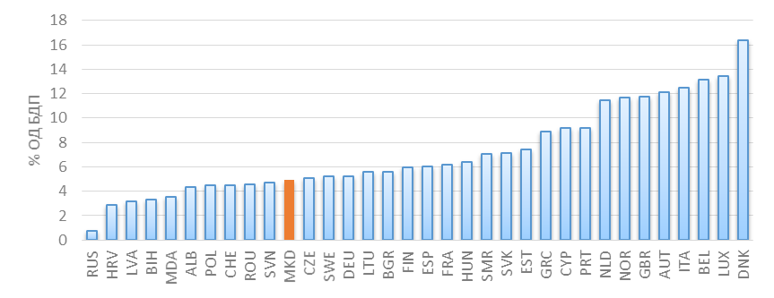

Source: World Development Indicators (2018).
- Chart 7. Income tax revenues (% of total tax revenues)

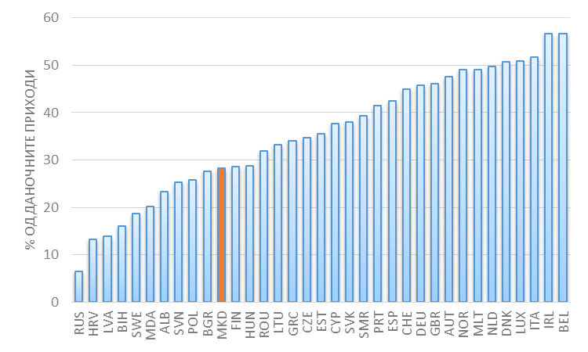
Source: World Development Indicators (2018).
Finally, indirect taxes - value added tax as basic consumption tax, import duties and excise duties - participate with 14.7% in the added value in the industry and the services (Chart 8), positioning North Macedonia in the middle of the chart, similar like Sweden and Poland. Percentages presented in Chart 3 are combination of standard and preferential rates the countries usually apply (also shown in Tables 1.1 and 1.2), as well as of the tax exemptions for certain categories of goods and services which may differ from country to another.

- Chart 8. Indirect taxes (% of added value in the industry and the services)

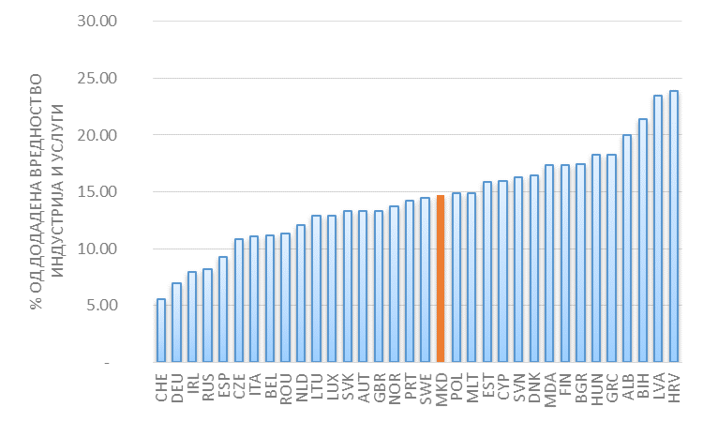
Source: World Development Indicators (2018).
Revenues on the basis of indirect taxes have a dominant share in North Macedonia, exceeding 60% (Chart 9). Chart 9 is an inverse picture of the one shown in Chart 6, i.e. countries with lower share of direct taxes in the total tax revenues have higher share of consumption taxes, and vice versa.
- Chart 9. Indirect taxes (% of total tax revenues)

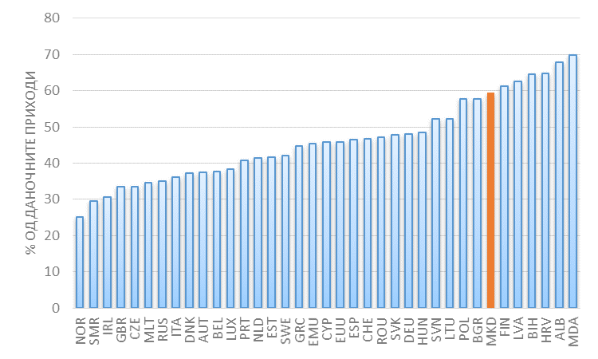
Source: World Development Indicators (2018).
Such tax structure in North Macedonia may be indicatively related to the level of development of the economy, observed through the gross domestic product per capita. Charts 10-11 indicate this potential correlation. In general, developed countries collect higher percentage of GDP in taxes, although there is significant heterogeneity across the countries. This feature is especially visible at direct taxes - labor and corporate income; higher level of development of a country is correlated to higher ratios in wages and profit, although heterogeneity increases at higher levels of income. On the other hand, as regards indirect taxes - consumption tax, developed countries cover smaller portion of the added value in a form of ta
- Chart 10. Tax revenues and level of economic development
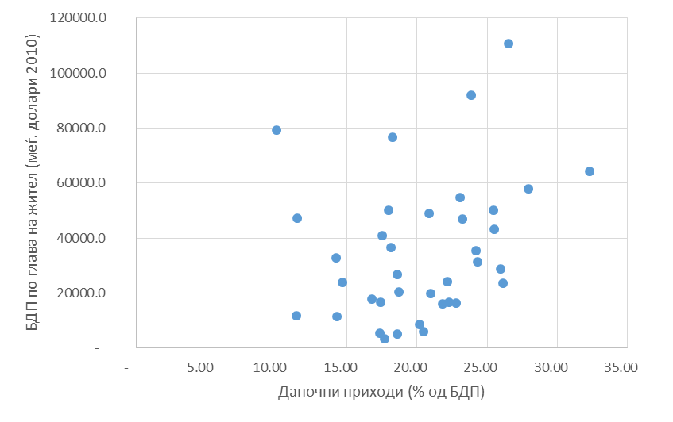
Source: World Development Indicators (2018).

- Chart 11. Revenues on the basis of direct taxes and level of economic development
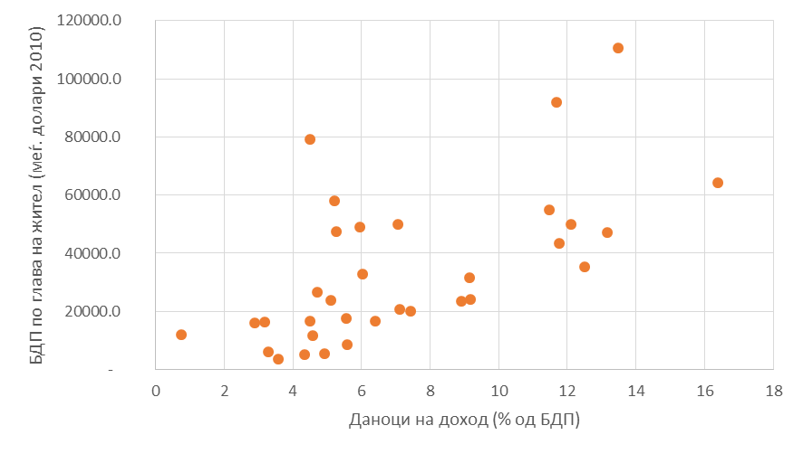
Source: World Development Indicators (2018).
- Chart 12. Revenues on the basis of indirect taxes and level of economic development
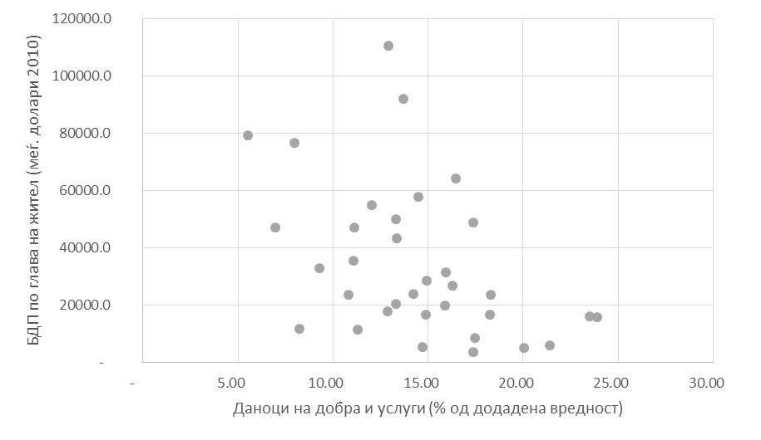
Source: World Development Indicators (2018).

1.8.2 Taxes and Income Inequality
Tax system of a country has to be also considered from income inequality perspective, taking into account its role for making secondary income distribution in areas where the market doesn’t. Hence, brief analysis of income inequlity in the country is presented in this section.
North Macedonia exhibited moderate income inequality of 30.8% in 2019, as measured by the Gini coefficient. The chart suggests that income distribution in North Macedonia is similar to that of Germany and the EU average, and much better than that of some EU Member States, in particular Italy, however, worse than others, such as the Scandinavian countries.

- Chart 13 - Gini coefficient in 2018

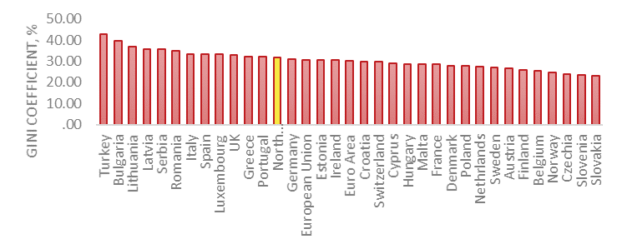
Source: Eurostat.

Next chart shows Gini coefficient in North Macedonia over time and adds the income quintile ratio S80/S20. Both income inequality measures note a downward trend starting 2010: Gini coefficient drops from 40.9% to 31.9% - being a remarkable decline over eight years, while S80/S20 marks even stronger decline from 11.3 to 6.2.
- Chart 14 - Gini coefficient in North Macedonia

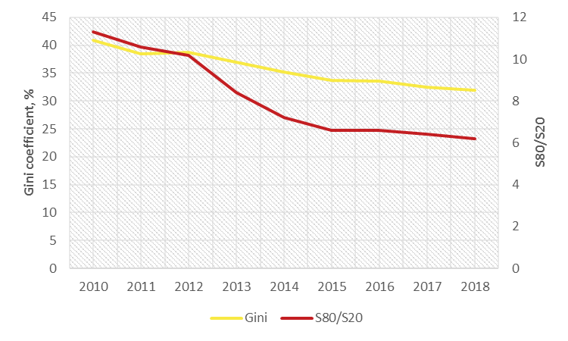
Source: SSO-SILC.

A declining Gini coefficient suggests that the position of poorer segments of the population improves in relation to that of the rich. This is observable in the next chart, which presents the quintile income shares and suggests that the share of the lowest 40% increased by 5.6 percentage points (p.p.) between 2009 and 2017, while the share of the middle 60% increased by 7 p.p., both at the expense of a reduction in the share of the top quintile.

Income shares in North Macedonia, 2009 – 2017

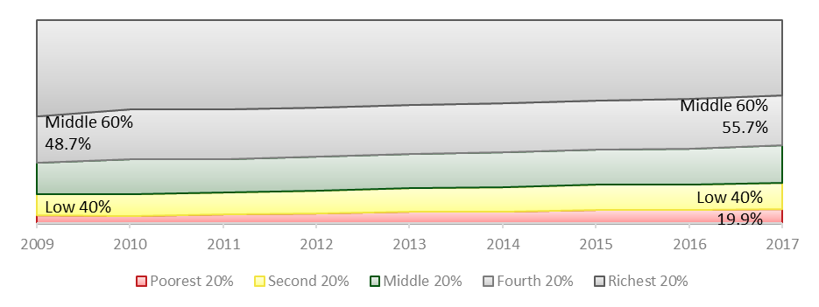

Source: SSO-SILC & World Development Indicators.

1.8.3 Taxes and Business Environment
Tax system of a country can be considered from the business environment perspective as well, taking into account that the ultimate tax burden is borne and paid by the individuals and the business entities on the income and the revenues they generate. Hence, brief analysis of taxes in the context of business environment in the country is presented in this section.
Chart 15 shows the paying taxes indicator within the World Bank Ease of Doing Business index. This subindex covers different aspects of paying taxes, starting from the burden they represent for the businesses, through the time necessary to pay the taxes and handling adjustments before the tax authorities, the time necessary for VAT refund, etc. In the past 15 years and so, North Macedonia achieved certain progress in this sphere, which is due, to a certain extent, to the reduced tax burden in 2007, as well as the improved efficiency of the tax authorities in tax management. Compared to 2006, index on Chart 10 shows 20.3% improvement.
- Chart 15. Paying taxes ranking World Bank Ease of Doing Business

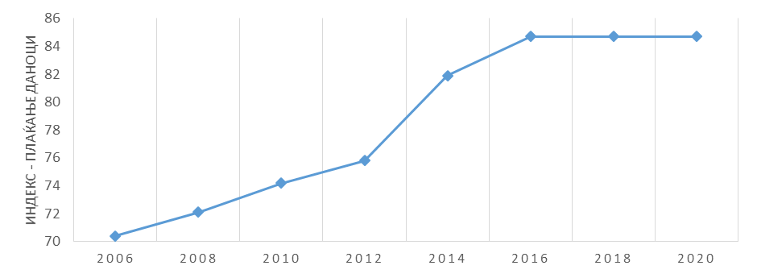
Source: Doing Business, World Bank (2020).
Trends at this indicator are reaffirmed with survey research, such as the 2018-19 Enterprise Survey of the World Bank, carried out by sampling 360 enterprises in the area of manufacturing and services in North Macedonia. According to the chart, majority of the enterprises assessed the tax rates and the tax administration as no obstacle to the ongoing operations of the enterprise, with distribution being more favourable in relation to tax administration. Only 8% of the enterprises responded that tax rates were a major obstacle, while only 4% said that tax administration was also a big obstacle to the ongoing business operations.

ASSESSMENT OF THE MACEDONIAN TAX SYSTEM BY INTERNATIONAL ORGANIZATIONS

2.1 World Bank Group
In its 2018 Public Finance Review, World Bank Group (hereinafter referred to as: World Bank) made the following recommendations for the Republic of North Macedonia in the field of taxation:
- adoption of a more progressive PIT structure with higher marginal rates for high-income earners. This will increase revenue collection and enhance tax fairness.
- broadening the PIT base by removing exemptions for specific capital income and gains. This will not only bring in more tax revenues, but will also create a more progressive PIT system.
- broadening the value added tax base by removing the preferential treatment of selected goods and services. Wide rage of reduced rates creates opportunities for abuse, while a broad-based and standard VAT improves economic and administrative efficiency. VAT is an ineffective redistributive tool.
- raising the excise taxes on tobacco, coal, and diesel fuel. It would lead to both increased revenues and improvements in other social areas, such as health and pollution.
- Using cost-benefit analysis to explore whether the government’s investment incentive strategies have indeed been beneficial. Conduct an analysis to determine whether supporting TIDZ is an efficient use of public revenues. These incentives have net fiscal costs for the Government in terms of foregone tax revenue, grants, administrative and compliance costs, the distortionary effects of raising revenue, and the distorted resource allocation caused by the incentive.
- Conduct a tax expenditure review to clarify the CIT tax incentives to maintain.
- Increase the CIT rate, bringing it closer to its peers (close to 15%). This will increase revenues and rebalance the tax burden between capital and labour.
- Implement the recommendations of the TADAT assessment to modernize tax administration. Challenges remain, including personnel constraints. Investing in the PRO is particularly important at a time when major tax reforms are being considered.

In addition, World Bank published the Report “Tax Administration Assessment for the North Macedonia Public Revenue Office” in 2020 pertaining to a tool targeted towards implementation and monitoring phases of tax system reform (Development of Implementation and Monitoring Directives (“Tax DIAMOND"). In the respective Report, World Bank points out the challenges the Public Revenue Office has to meet in future, i.e. they comprise 6 areas: policy changes, organizational setup, human resources, main functions of the tax administration, implementation of new technologies and enhanced non-technical capacities of PRO.

2.2 IMF
In order to improve the efficiency and fairness of the tax system in the Republic of North Macedonia, the International Monetary Fund has recommendations regarding PIT progressivity, tax efficiency, transfer pricing and the working of the tax administration in general.
The 2017 Selected Issues Paper focuses on progressive taxation and efficiency. Concerning progressive taxation, Government’s plan to adopt a progressive personal income tax system is encouraged, however related parameters need to be designed carefully. This means that appropriate income tax bracket thresholds and deductibles should be designed to make the proposed two-rate progressive taxation functioning in practice.
Introducing progressive tax rates at other taxes more progressive could be also a good basis for increased revenues. Increasing the property tax rate for high-value property could be an additional source of revenues, but once the rate is increased, it is crucial to ensure assessment and audit capacities to avoid underreporting of the property values.
Regarding tax efficiency, efforts should be focused primarily on risk management and tax arrears management. In particular, priority measures should continue in the following areas:
- Strengthening the risk management. Currently, there is no systematic approach to identify, assess, quantify and prioritize compliance risks.
- Strengthening the tax arrears management and collection. Tax arrears are significant, accounting for about 38.6% of the tax revenues during the period 2013–2015. It is also underlined that the amount of uncollectible debt older than 12 months has increased substantially in recent years.
- Improving the efficiency and the operations of the Large Taxpayers Office.
The IMF Report on Reforming the Transfer Pricing Regime in Macedonia contains several recommendations related to:
- Measures to strengthen the control on profit shifting. This should be done by establishing the presentation of TP documentation as a requirement for deduction of related party expenses; introducing an obligation of filing an annual disclosure form on transactions with related parties; introducing specific TP penalties for the omission of tax and failure to file TP documentation or the annual disclosure form.
- Complementary measures for a comprehensive Strategy on Transfer Pricing. Following are the recommendations: redrafting the General Anti Avoidance Rule in the law to the end of upgrading the legal form of the transaction for tax purposes to reflect the real nature of the operation; introducing the possibility for the PRO to issue advance pricing agreement; considering the possibility for introducing a TP safe harbor for simplified contracts on manufacturing activities.

The Macedonia TADAT Performance Assessment Report points out the following areas for improvement:
- Formal administrative dispute review process is limited. In addition, there is no graduated mechanism of administrative and judicial review available to taxpayers.
- External tax audit program does not provide adequate coverage.
- VAT refunds are not reviewed using a proper risk-based verification process, and less than 50 percent of VAT refunds were paid (or rejected) within the TADAT 30-day standard.
Regarding 2019 ARTICLE IV Consultation, the IMF made several recommendations and comments about tax policy, tax rates and tax administration, as well as reduction of informal economy:
- Strengthening revenue administration efficiency and compliance should be the priority, combined with measures that raise public trust in institutions and tax morale.
- Stronger tax administration and tax auditors are essential to reduce informal activity, but also emphasized the role of fiscal incentives, such as MyVAT to encourage VAT registration and the subsidy on social security contributions to reduce envelope payments.
- The tax burden overall does not appear a major obstacle to formal businesses. Both corporate and value added tax rates are low compared to other European countries.
- Ineffective tax administration provides additional incentives for tax evasion and undeclared work. Tax collection efficiency is weak in the Republic of North Macedonia. Partly reflecting a lack of resources, the extent of initiatives to detect unregistered taxpayers and inaccurate reporting is limited.
- Conditional on a strong tax administration, in-work tax credits could be considered to stimulate formal employment of low-income workers.

2.3 European Commission
North Macedonia 2019 Progress Report notes that the country is moderately prepared in this area of taxation. Some progress was made in reducing the administrative burden for taxpayers and in shortening the time needed to process annual income tax returns. In the coming year, the recommendations from the previous year remain valid and the country should in particular:
- improve the capacity of the central and local tax administration by adopting and efficiently implementing the tax system strategy;
- further align the legal framework with the Acquis, in particular the Excise Law, and amend the Laws on Personal Income Tax and Tax Procedures in accordance with the tax system strategy;
- ensure the ratification of the OECD Multilateral Convention on Mutual Administrative Assistance in Tax Matters by the end of 2019.
The EU Code of Conduct for Business Taxation noted deficiencies in three areas: Tax Transparency, Fair Taxation and implementation of anti-BEPS measures.
- Regarding tax transparency, the criteria that a jurisdiction should fulfil in order to be considered compliant on tax transparency are:
  - Initial criterion with respect to the OECD Automatic Exchange of Information (AEOI) standard (the Common Reporting Standard – CRS): the jurisdiction should have committed to and started the legislative process to implement effectively the CRS, with first exchanges in 2018 (with respect to the year 2017) at the latest and have arrangements in place to be able to exchange information with all Member States, by the end of 2017, either by signing the Multilateral Competent Authority Agreement (MCAA) or through bilateral agreements; future criterion with respect to the CRS as from 2018: the jurisdiction should possess at least a “Largely Compliant” rating by the Global Forum with respect to the AEOI CRS; and
  - the jurisdiction should possess at least a “Largely Compliant” rating by the Global Forum with respect to the OECD Exchange of Information on Request (EOIR) standard, with due regard to the fast track procedure; and
  - (for sovereign states) the jurisdiction should have either:
  - ratified, agreed to ratify, be in the process of ratifying, or committed to the entry into force, within a reasonable time frame, of the OECD Multilateral Convention on Mutual Administrative Assistance (MCMAA) in Tax Matters, as amended; or
  - a network of exchange arrangements in force by 31st December 2018 which is sufficiently broad to cover all Member States, effectively allowing both EOIR and AEOI; (for non-sovereign jurisdictions) the jurisdiction should either:
  - participate in the MCMAA, as amended, which is either already in force or expected to enter into force for them within a reasonable timeframe, or
  - have a network of exchange arrangements in force, or have taken the necessary steps to bring such exchange agreements into force within a reasonable timeframe, which is sufficiently broad to cover all Member States, allowing both EOIR and AEOI;
  - Future criterion: in view of the initiative for future global exchange of beneficial ownership information, the aspect of beneficial ownership will be incorporated at a later stage as a fourth transparency criterion for screening.
- As regards fair taxation, criteria that a jurisdiction should fulfil in order to be considered compliant on fair taxation are as follows:
  - the jurisdiction should have no preferential tax measures that could be regarded as harmful according to the criteria set out in the Resolution of the Council and the Representatives of the Governments of the Member States, meeting within the Council of 1st December 1997 on a code of conduct for business taxation (1); and
  - the jurisdiction should not facilitate offshore structures or arrangements aimed at attracting profits which do not reflect real economic activity in the jurisdiction.
- With respect to implementation of anti-BEPS measures, criteria that a jurisdiction should fulfil in order to be considered compliant are the following:
  - the jurisdiction, should commit, by the end of 2017, to the agreed OECD anti-BEPS minimum standards and their consistent implementation.
  - future criteria that a jurisdiction should fulfil in order to be considered compliant as regards the implementation of anti-dumping measures (to be applied once the reviews by the Inclusive Framework of the agreed minimum standards are completed).
  - the jurisdiction should receive a positive assessment for the effective implementation of the agreed OECD anti-BEPS minimum standards.
2015 PEFA Assessment of the Republic of North Macedonia rated the country relatively poorly in the three tax-related areas, Transparency of taxpayer obligations and liabilities (C+), Effectiveness of measures for taxpayer registration and tax assessment (C+) and Effectiveness in collection of tax payments (D+).
As regards the first area, the lowest rating (D) is in the field of Existence and functioning of a tax appeals mechanism, due to the abolition of the administrative appeals system in the MoF in 2015.
With respect to the second area, Controls in the taxpayer registration system and Effectiveness of penalties for non-compliance with registration and declaration obligations were ranked with (С). The issue with the first one was that the databases for the main taxes were not yet integrated, and the links to other databases had yet to be developed. The issue with the effectiveness was that the penalties available to PRO must be improved.
The third area, Effectiveness in collection of tax payments, was assigned the lowest grade, due to the poor collection ratio for gross tax arrears (D), and the separate IT system for each tax (D).

2.4 Organization for Economic Co-operation and Development
The OECD Report “Competitiveness in South East Europe: A Policy Outlook 2018” includes recommendations in the field of tax policy, tax administration, and international taxes and tax cooperation.
With respect to tax policy, following are the key points:
- low statutory CIT rates, ranging between 9% and 15%.
- wide-range of corporate tax incentives for businesses. Corporate income tax incentives are generous across the CEE economies, while some of them also have expenditure-based CIT incentives, which reduce the cost of investment.
“tax wedge” on labour income. It is high despite relatively low personal income tax rates. SEE economies impose relatively low PIT rates, but they levy high SSCs. This could lead to a high overall tax burden on labour income. Additionally, average tax wedge is highly regressive in three out of the six economies, due to the minimum and maximum amounts of SSCs.
- Bringing more taxpayers within the formal economy and increasing tax compliance. Governments have different tools available to achieve this objective, including targeting their audit capacities to those agents who are more likely to evade taxes and operate in the informal economy.
- a well-designed VAT system, that could help reduce the informal economy. SEE economies levy relatively high VAT rates on a narrow VAT base and the VAT registration thresholds are relatively high. They would benefit from broadening the VAT bases having in mind that VAT regimes across the region provide for a long list of VAT-exempted goods and services, and many of the exemptions and reduced rates are not well targeted. They may also consider for gradually lowering the registration thresholds over time, as they continue strengthening their tax administration capacity.
- the need to strengthen the tax policy analytical capacity and to prepare tax expenditure reports on a regular basis. All SEE economies would benefit from the implementation of micro-simulation models and the introduction of systematic tax expenditure reporting. SEE economies should strengthen their tax policy assessment tools, including the development of CIT effective tax rate models and taxing wages models.
As regards tax administration, the key recommendations are directed to:
- compliance assessment and risk management. Compliance assessment and risk management have improved across the SEE region. In this regard, tax administrations should have an on-going process that allows them to consider the areas of compliance risk within their economy in order to be efficient in the monitoring of the compliance and managing risks. Associated with the risk auditing process is the necessary to include third party reporting systems, and developing of this systems especially in combination with the withholding regimes is a proven way for improving the tax compliance, risk analysis and risk treatment, and allowing better target tax audits where it is required.
- tax filing and payment procedures. The use of e-filing is widespread, but e-payment is not yet available. Complying with tax obligations requires internal and/or external resources that can particularly burden small- and medium-sized business. In this regard, the procedures should be streamlined to limit the compliance burden imposed on businesses. SEE economies reported that the length of tax filing and payment procedures are reasonably short and procedures to be relatively simple. All SEE economies have e-filing procedures available for most, if not for all, taxes, which contributes to reducing the complexity of the filing procedures.
- taxpayer services. Bosnia and Herzegovina, Republic of North Macedonia, Montenegro and Serbia do not have a taxpayer ombudsman that is easily accessible by taxpayers. All SEE economies should continue making efforts to modernise their tax administration through automation, risk-based compliance assessments, and by increasing the number and the training of the staff employed in the tax administration, etc.
In the field of international tax and tax cooperation the recommendations are connected with:
- preventing double tax treaty abuse;
- aligning of the SEE economies tax systems with the best practices in the international taxation;
- more effective exchange of financial account information for tax purposes;
- aligning transfer pricing rules with the OECD Transfer Pricing Guidelines;
- improving the design of the SEE economies thin capitalisation rules;
- intensifying regional tax cooperation.

STRATEGY PRIORITIES, MEASURES AND ACTIVITIES
On the basis of the above-presented information, the Tax System Reform Strategy identifies the following key reform priorities:
- Priority 1 - Increased fairness in taxation;
- Priority 2 - Increased efficiency and productivity of the tax system to the end of improved revenue collection;
- Priority 3 - Increased tax transparency;
- Priority 4 - Improved quality of services;
- Priority 5 - Introduction of environmental (“green”) taxation.
Each priority is elaborated in more details in the chapters below.

3.1 Priority 1: Increased fairness in taxation

Objective
The objective of this priority is to increase fairness in the tax system in the country, where fairness describes a system of taxation that is equitable for all taxpayers obliged to pay taxes according the law. Groups focused on tax fairness strive for limiting the volume of tax legislation and rules that benefit one segment of the tax-paying population over another. In other words, tax fairness is about everyone meeting their social obligation to pay their fair share.
The main focus of the fair taxation for the next five years would be establishing vertical equity, which can be considered more widely than progressivity of taxes. The Government achieves income distributional goals through transfers and other government expenditure.
Thus, this priority will be achieved through the following measures and activities.
Measure 1.1: Review the existing tax policy and introduce improvements
- Activity 1.1.1: PIT analysis and improvement
- Activity 1.1.2: CIT analysis and improvement
- Activity 1.1.3: Property tax analysis and improvement
- Activity 1.1.4: Review of cap for mandatory social security contributions threshold and maximum pension amount
Measure 1.2: Ensuring fair competition
- Activity 1.2.1: Countering harmful tax practices more effectively
- Activity 1.2.2: Preventing the granting of treaty benefits in inappropriate circumstances
- Activity 1.2.3: Transfer pricing documentation and country-by-country reporting
- Activity 1.2.4: Making dispute resolution mechanisms more effective

Measure 1.3: Harmonization with EU and best practices
- Activity 1.3.1: Harmonization in the field of VAT
- Activity 1.3.2: Harmonization in the field of PIT
- Activity 1.3.3: Harmonization in the field of CIT
- Activity 1.3.4: Harmonization in the field of excise duties
- Activity 1.3.5: Introduction of data standards for e-commerce through harmonization of relevant tax legislation
- Activity 1.3.6: Prepare for the tax challenges of the Digital Economy and “digital taxation”
- Activity 1.3.7: Harmonization in the field of administrative cooperation in direct taxation

Priority Results
- Proposal of new re-designed and fair model for PIT taxation;
- Implemented minimum BEPS standards;
- Improved tax legislation (PIT, CIT, VAT, excise duties) in accordance with EU and best practices.

Indicators
- Reduced inequality of income distribution, S80/S20%;
- Increased PIT revenues;
- Increased CIT revenues;
- Increased VAT revenues.

Measure 1.1: Review the existing tax policy and introduce improvements

Measure Objective
The objective of this measure is to address the weaknesses of the existing tax system, by simplifying it, eliminating the self-taxation elements through the introduction of automation in the relevant tax authorities that administer the collection and decreasing the tax burden on both sides, thus increasing its efficiency.

Background
Republic of North Macedonia has had a proportional (flat) personal income tax, proportional (flat) property tax, and regressive social security contributions from 2007 onwards. A progressive and higher PIT tax rate of 18% was introduced, as a second rate to the existing 10% rate for labour income above the threshold of Denar 90,000 from 1st January 2019. The effects of the progressive tax rate were analyzed by external experts based on actual data for the period 1st January - 30th June 2019 and the main finding indicated the following:
- Fiscal effects - for the first half of the year, the progressive and higher PIT rate contributed with EUR 12.7 million to public revenues, which is in line with the original budget projections. However, the potential of the PIT reform, based on 2018 data, has been estimated at EUR 19.2 million. Therefore, when this solution was applied, we arrived at a fiscal effect lower by a certain percentage from the PIT reform potential.
- Distributional effects - the analysis indicated that taxpayers most likely made huge efforts for tax avoidance. The probable common ways of tax avoidance include opening up accounts in neighboring countries and transfer of earned incomes onto relatives and friends who have not yet reached the progressive-tax threshold. Therefore, such behavior of the taxpayers artificially improved income distribution, while significantly undermined the fiscal effect.
As already mentioned in the description of the tax system of the country, the key findings from the 3rd party analysis have led to the postponement of the PIT reform by 36 months. This time period will be used to focus on improving the proposed tax reform by implementing the activities described below.

Activity 1.1.1. PIT Analysis and Improvement
The suspension period of the progressive PIT tax rate will be used to focus on improving the proposed tax reform in terms of taking into consideration the introduction of the view of the household income, despite taxing the individual, as well as analysis of the real effect of increasing the progressivity by adding additional rates. Taking into account the coming period which will be a period of economic recovery, the Government, following a detailed analysis and debate with the stakeholders, will strive for deciding on the ideal model on taxing the income of individuals.
When the new PIT law was adopted in 2019 in which the flat rate was introduced once again, the Ministry announced that the suspension period of the progressive PIT tax rate will be used for building a more efficient system that will generate higher PIT revenues. The system will help for streamlined, digitalized and more efficient tax administration (where the principle of income tax withheld from the payer for the account of the recipient will dominate) for all existing types of income and all those to be taxed in future (capital gains and interest from savings deposits).

Activity 1.1.2. CIT Analysis and Improvement
The corporate income tax rate in the Republic of North Macedonia is currently at a 10% flat rate for all companies ranging from startups and SMEs to large enterprises, except companies that are in simplified tax regime or the companies that are beneficiaries of a certain type of state aid. The need for a detailed analysis of the effective CIT rate paid by companies has been acknowledged, as there are larger companies that are the beneficiaries of tax credits and incentives under the current CIT system and the laws governing the state aid.
The results of the assessment of the current state of tax collection indicate the need for further and extensive analysis of the effective tax rate on corporate income tax, in line with best practices from the EU and similar countries, together with a full analysis of the potential impact on the market, how companies are ready to pay taxes and keep in mind the easier migration of capital and the period of economic recovery.

Activity 1.1.3. Property Tax Analysis and Improvement
Property tax paid each year in the Republic of North Macedonia is currently proportional (flat). The rate is determined by the local governments (municipal councils), and it can range between 0.1% and 0.2%, the same rate applies to everyone in the municipality regardless of the property value. It is recognized that this contributes to the increase of wealth inequality, thus to income inequality. In order to resolve this issue, detailed analysis will be made in order to introduce provisions on the basis of which there will be a possibility to revise the value of the property which is to correspond to the real market value to be taken as tax base for the competent authority to tax the property, i.e. the intention of the tax authorities would be for the tax rate to be calculated at the real value of the property at the moment of taxation.
In addition, to the end of stimulating the taxpayers to use the property, the Government will consider a model according to which the tax rate on unused/unproductive property will be higher. More efficient and higher collection of revenues on the basis of property tax is a challenge for the local government units (LGUs). It will be improved by including all stakeholders related to the property tax (Association of Local Government Units (ALGUs), Ministry of Local Government, United Nations Development Program, etc.).

Activity 1.1.4. Review of Cap for Mandatory Social Security Contributions Threshold and Maximum Pension Amount
Mandatory social security contributions in the Republic of North Macedonia are in total 28% (in 2020) of the gross wage and are capped, i.e. there is a highest possible base for calculating the contributions, equal to 16 average gross wages. This means that the highest amount of social security contributions that can be paid is approximately 2,600 euros per month.
It is envisaged for the working group to make detailed analysis to assess the threshold justification for the highest base for calculating contributions, together with an assessment of the pension fund's stability and its ability to provide retirees who have met the requirements for retirement age with income in the form of lifetime pension.
Should the analysis indicate that there is room for increasing the highest amount of retirement pension income, the cap for the highest contribution base will be reviewed.

Table 3.1: Implementation of Measure 1.1 - Review the existing tax policy and introduce improvements

Time Frame | 2025
Measure Deliverables | Analysis for creating a better PIT model  Analysis of the CIT effective rate  Implementation of a better model of the property tax system  Analysis of the Law on Mandatory Social Insurance and the Law on Pension and Disability Insurance
Costs | These activities will be implemented within the regular working duties of the employees in the relevant institutions. In addition, technical assistance will be requested from the World Bank and other institutions.  Total costs for wages are estimated at EUR 21,300.
Competent Authority | Ministry of Finance, Ministry of Transport and Communications, ALGUs and Ministry of Local Government
Risks | Insufficient political will for implementing the changes  Lack of qualified experts for drafting the legal amendments  Insufficient support from stakeholders

Measure 1.2: Ensuring fair competition

Measure Objective
The objective of this measure is to set forth a clear and effective national framework for fair and competitive taxation aligned with the Base Erosion and Profit Shifting (BEPS) package. Following the implementation of the minimum standards under the BEPS package, the country will undertake activities aimed at analyzing the other measures and recommendations from the Inclusive Framework, all to the end of determining the priority and the appropriateness as regards their implementation. Above-mentioned measure will be implemented first by applying the following four minimum standards under the BEPS package:
- Countering Harmful Tax Practices More Effectively, Taking into Account Transparency and Substance (BEPS Action 5);
- Preventing the Granting of Treaty Benefits in Inappropriate Circumstances (BEPS Action 6);
- Transfer Pricing Documentation and Country-by-Country Reporting (BEPS Action 13);
- Making Dispute Resolution Mechanisms More Effective (BEPS Action 14).

Background
The main purpose of BEPS is to tax profits at the place where the economic activity is performed and the value is created. BEPS aims to address tax planning strategies that exploit gaps and mismatches in tax rules, the goal of which is to artificially shift profits to low or no-tax locations, resulting in little or no overall corporate income tax being paid. BEPS solutions aim at creating tools which the tax authorities can use to avoid these activities. BEPS also creates certainty for the companies by reducing the disputes related to implementation of the international taxation rules. The BEPS package consists of 15 standards, 4 of which are a minimum requirement.
The Inclusive Framework on BEPS was designed and agreed by the OECD following a call from G20 leaders for increased inclusiveness in the international tax rules. Republic of North Macedonia is already a BEPS Associate and is going to be able to work with the OECD and G20 countries on developing standards on BEPS-related issues and the implementation of the monitoring processes. As a BEPS Associate, the Republic of North Macedonia is committed to implement the four minimum standards.

Activity 1.2.1. Countering Harmful Tax Practices More Effectively

BEPS Action 5 minimum standard is focused on requiring substantial activity for any preferential regime and on improving transparency, including compulsory spontaneous exchange of information on certain tax rulings.
Within this activity, the country will take the necessary steps to evaluate the national legislation in relation to whether there are preferential regimes that allow artificial profit shifting and whether there is an adequate level of transparency in connection with certain rulings in the context of BEPS Action 5 minimum standard.

Activity 1.2.2. Preventing the Granting of Treaty Benefits in Inappropriate Circumstances
BEPS Action 6 minimum standard refers to treaty-shopping, i.e. cases where multinational companies try to take advantage of more favorable tax treaties available in certain jurisdictions.
Within this activity, the country will take all necessary steps to examine which provisions from the minimum standard on treaty-shopping should be included in the double tax treaties the Republic of North Macedonia has, in order to ensure a minimum level of protection against treaty-shopping.
There are two approaches to implement this standard, through the Multilateral Instrument and by reviewing the bilateral treaties with other jurisdictions. Republic of North Macedonia will implement BEPS Action 6 minimum standard through the Multilateral Convention to Implement Tax Treaty Related Measures to Prevent Base Erosion and Profit Shifting (MLI), which was signed by the Minister of Finance in January 2020 at the 8th BEPS Inclusive Framework meeting at OECD, process of ratification of which will follow.

Activity 1.2.3. Transfer Pricing Documentation and Country-by-Country Reporting
BEPS Action 13 minimum standard refers to transfer pricing. BEPS Action 13 Report introduces a standardized three-tiered approach to transfer pricing documentation for multinational enterprises (MNEs) consisting of a master file containing standardized information relevant for all MNE group members, a local file referring specifically to material transactions of the local taxpayer and an obligation on certain MNE groups to annually file a Country-by-Country Report, containing certain information relating to the global allocation of the MNE group’s income and taxes paid, together with certain indicators of the location of economic activity within the MNE group (CbC Report).
The first step in implementing CbC Reporting is to have a legal and administrative framework that requires certain MNE groups to file CbC Reports in accordance with the Action 13 minimum standard and ensures the confidentiality, consistency and appropriate use of the information contained in those reports. In addition, in line with Action 13 minimum standard, there is a need for legal basis for exchange of information that sets out the terms of the exchange, where the UPE or surrogate entity of an MNE group files a CbC Report with the tax authority in its residence jurisdiction or with the tax authorities in other jurisdictions where constituent entities in that group are either resident for tax purposes or subject to tax with respect to a business carried on through a permanent establishment.
To the end of attaining the desires results, the Public Revenue Office should establish a separate unit within its directorates which is to analyze the reports pertaining to transfer pricing submitted by the taxpayers. By strengthening the respective unit, the risk of illegal profit sharing from the Republic of North Macedonia would be reduced and the tax base for the corporate income tax would be increased.

Activity 1.2.4. Making Dispute Resolution Mechanisms More Effective
BEPS Action 14 Report discusses the obstacles that prevent countries from resolving double tax treaty-related disputes under the mutual agreement procedure (MAP) and recommends measures to overcome such obstacles, including a set of minimum standards to ensure that treaty-related disputes are resolved in a timely, efficient and effective manner.

Table 3.2 Implementation of Measure 1.2 - Ensuring fair competition

Time Frame | 2021-2023
Measure Deliverables | Adopted amendments to tax laws and other relevant laws, should it be estimated as necessary, pertaining to BEPS minimum standards  Updated double tax treaties  Ratified MLI  Signed Competent Authority Agreement (CbC MCAA)
Costs | Annual membership fee of EUR 20,000, cost for technical assistance of EUR 10,000, wages of employees of EUR 21,600
Competent Authority | Ministry of Finance, PRO, Ministry of Economy, FEZ and Customs Administration
Risks | Lack of expert technical assistance  Insufficient human resource capacities

Measure 1.3: Harmonization with EU and best practices

Measure Objective
The objective of this measure is to improve the harmonization of the legislation in the field of taxation with the relevant EU acquis and best practices.

Background
One of the main preconditions for European integration is the harmonization in the area of taxes, i.e. the harmonization of the national tax systems of the countries that aim to integrate into the European common market. Republic of North Macedonia, as a candidate country since 2005, will continue to analyze all relevant EU acts in the field of direct and indirect taxation for the purpose of their transposition in the national legislation in order to achieve full harmonization.

Activity 1.3.1. Harmonization in the field of VAT
Value Added Tax is a part of the acquis communautaire. Taxation of supply of goods and services in the Republic of North Macedonia is regulated by the Law on Value Added Tax, which incorporates the EU requirements for VAT system. In order to achieve better alignment with the EU legislation, the Government, during the next period, will continue to assess the VAT tax legislation and to create the draft acts related to VAT. Expert assistance will be provided therefore within the EU project framework, aimed at aligning the countries efforts with the requirements under Chapter XVI - Taxation.

Activity 1.3.2. Harmonization in the field of PIT
Personal Income Tax is a part of the acquis communautaire. Personal Income Tax Law regulates the taxation procedure of the individuals' personal income generated in the course of the year as a sum of the following types of income: work-related income, income on the basis of independent activity, income from property, income on the basis of copyrights and income on the basis industrial property rights, capital income, capital gains, income on the basis of games of chance and other income. In order to achieve better alignment with the EU legislation, Republic of North Macedonia will continue to assess the PIT legislation and to create the draft acts related to PIT. Expert assistance will be provided therefore within the EU project framework.

Activity 1.3.3. Harmonization in the field of CIT
Corporate Income Tax is a part of the acquis communautaire. Profit generated by the legal entities, residents and non-residents of the Republic of North Macedonia is regulated by the Corporate Income Tax Law. In the coming period, Republic of North Macedonia will continue to assess the CIT legislation and prepare draft acts in order to achieve better alignment with the EU legislation. During this process, Republic of North Macedonia will be extended expert assistance within the EU project framework.

Activity 1.3.4. Harmonization in the field of Excise Duties
Excise duties are subject to legal regulation under the national legislation of the EU - “acquis communautaire”. Excise Law is the basic legal act for regulating excise duties charged indirectly or directly on excise goods produced on the territory of the Republic of North Macedonia and excise goods imported on the territory of our country. Products subject to excise duties, pursuant to the new Excise Law, are: alcohol and alcoholic beverages, tobacco products and energy products and electricity. New Excise Law is to a large extent harmonized with the EU legislation. In the period to come, its implementation will be assessed, and latest practice arising from the EU Member States’ legislation will be monitored.

Activity 1.3.5. Introduction of Data Standards for E-commerce through Harmonization of Relevant Tax Legislation
E-commerce plays an important role in the international trade as it provides for innovative solutions in the trade environment in general. Efficiency of procedures and delivery of low value and small parcels is especially crucial. To manage the e-commerce transactions, Customs Administration needs to engage with all relevant stakeholders to collectively define the appropriate approach to adopt trade facilitation and an enforcement perspective.

Activity 1.3.6. Prepare for the Tax Challenges of the Digital Economy and “Digital Taxation”
Digital economy provides numerous benefits for the citizens, the companies and the governments. However, at the same time, the new digital world and the digital services, as well as, the new business models, pose challenges to the existing tax systems. Numerous challenges arise, including determining the location where value is created, where the tax should be paid when someone is providing digital services across the world, and so on. Some countries believe that multinational profits should be taxed where value is created, while others argue that value for companies in the digital economy is coming from several factors, namely the final user participation and the user’s location.
The European Union is working on a system for preparing and adapting Member States’ tax systems to align with the digital age. In addition, Action 1 in the BEPS Inclusive Framework of OCED is dedicated to tax challenges arising from the digitalization of the economy to the end of creating comprehensive and transparent international tax rules. This activity will be aimed at preparing our tax system for the digital world and the digital taxation.

Activity 1.3.7. Harmonization in the field of Administrative Cooperation in Direct Taxation
Administrative cooperation in direct taxation between the Competent Authorities helps to ensure that all taxpayers pay their fair share of the tax burden, irrespective of where they work, retire, hold a bank account and invest or do business. EU acquis provides for the exchange of specified information in three forms: spontaneous, automatic and on request and provides for other forms of administrative cooperation. In the coming period, Republic of North Macedonia will review its national legislation in order to align it with the EU acquis in the field of administrative cooperation.

Table 3.3 Implementation of Measure 1.3 - Harmonization with EU and best practices

Time Frame | 2025
Measure Deliverables | Implemented amendments to the Law on VAT  Implemented amendments to the Law on PIT  Implemented amendments to the Law on CIT  Implemented new Excise Law (2020).  Implemented amendments to the Law on E-commerce and new Operational Guidance for E-commerce  Analysis and joining the Action 1 of BEPS IF  Implemented amendments as regards administrative cooperation for direct taxation
Costs | EUR 1 million for technical assistance, EUR 302,400 for wages of employees
Competent Authority | Ministry of Finance, PRO and Customs Administration
Risks | Lack of expert technical assistance  Insufficient human resource capacities  Insufficient political will

3.2 Priority 2: Increased efficiency and productivity of the tax system to the end of improved revenue collection

Objective
The objective of this priority is to improve the efficiency and the effectiveness of the tax collection system. To than end, a series of measures will be undertaken, consisting of improvement of the existing tax regulations, introduction of advanced technologies, strengthening the institutions’ capacities, modernization and automation of the working processes, strengthening the institutional coordination and cooperation at international level.
This objective will be achieved through the following measures and activities:
Measure 2.1: Analysis of the tax base
Activity 2.1.1: Analysis of PIT tax reliefs
Activity 2.1.2: Analysis of CIT tax deductions
Activity 2.1.3: Analysis of VAT preferential rate list

Measure 2.2: Reduction of tax evasion

Activity 2.2.1: Reduction of use of cash
Activity 2.2.2: Improved fiscalization
Activity 2.2.3: Improved mechanisms for VAT refund to individuals
Activity 2.2.4: Accreditation of Customs Laboratory
Activity 2.2.5: Improved risk prevention and risk management by the PRO and the Customs Administration
Activity 2.2.6: Regulating unregistered businesses
Activity 2.2.7: Preparing reports on tax avoidance trends

Measure 2.3: Addressing illicit financial flows
Activity 2.3.1: Establishment of Registry of Beneficial Owners
Activity 2.3.2: Increasing efficiency of measures for illicit financial flows

Measure 2.4: Reduction of tax arrears

Activity 2.4.1: Addressing tax arrears of SOEs
Activity 2.4.2: Addressing accounts uncollectible and development of software for managing taxpayers’ debt

Measure 2.5: Improving the capacities of institutions of the tax system
Activity 2.5.1: Human resource development
Activity 2.5.2: Improvement of non-intrusive equipment of the Customs Administration
Activity 2.5.3: New integrated IT system of the PRO
Activity 2.5.4: Introduction of machine learning methods for predicting tax revenue
Activity 2.5.5: Efficient system for calculation and payment of income tax for capital gains generated on the basis of securities and investment units
Activity 2.5.6: Efficient system for calculation and payment of income tax on the basis of interest on term deposits
Activity 2.5.7: Strengthening local government’s capacity to the end of more efficient administration of local taxes

Priority Results
Following are the results of this priority:
Analysing the tax base in the relevant laws;
Analysis pertaining to reduction of tax arrears;
Reduced tax evasion;
Establishment and improvement of the Registry of Beneficial Owners;
Increased efficiency in supervision over the implementation of AML/ CFT measures;
Increased institutional capacity;
Established system for efficient collection of income tax as regards income generated on the basis of capital gains from securities and interest from term deposits.

Indicators
Lower tax arrears
Reduced informal economy
Increased tax revenues and contributions as a percentage of GDP

Measure 2.1: Analysis of the tax base

Measure Objective
The objective of this measure is to analyze the existing tax base on which taxes are applied, as well as its harmonization with the EU directives, recommendations and best practices. Analysis of the tax base would give results on the most efficient way to increase the tax revenues.

Background
All of the three main taxes in the Republic of North Macedonia have a tax base which is reduced in some way. Numerous PIT tax reliefs and recognized expenses exist; as regards CIT, many legal entities are exempted from paying CIT, i.e. certain transactions are not subject to CIT, while with respect to VAT, many products and services are taxed with the preferential VAT rate. All of this reduces the tax revenues.
To the end of addressing this issue, following activities are going to be undertaken.

Activity 2.1.1. Analysis of PIT Tax Reliefs
The PIT Law prescribes reliefs in the form of “recognized expenses” which reduce the tax base. In 2019, lower deductible recognized expenses at each type of income were additionally introduced in the PIT Law, for example, recognized expenses amount to 80% on the income from sale of agricultural products, it can be up to 50% on income from royalties, up to 15% on income in the basis of lease and up to 10% on capital gains, thus significantly expanding the tax base. Ministry of Finance will additionally analyze the tax deductions at the PIT and the non-taxable income, all to the end of improving the tax base.
Considering the coming period aimed at recovery of the economy, the Government will determine which categories of individuals and which type of income they will be supported with the possible new measures pertaining to PIT.

Activity 2.1.2. Analysis of CIT Tax Deductions
Although the nominal CIT rate in the Republic of North Macedonia is 10%, the effective rate is lower due to existing tax deductions which lower the tax base. This reduces revenues and encourages companies to behave in ways that artificially decreases the tax base. In the coming period, tax deductions prescribed under the CIT Law, as well as CIT tax deductions prescribed under other related laws (Law on Control of State Aid, Law on Technological Industrial Developed Zones, Law on State Aid, etc.) will be taken into account, all to the end of precisely determining the effective tax rate and calculating the exact budget costs arising due to the respective deductions.
In the period to come, and to the end of greater productivity and liquidity of the CIT taxpayers, the Government will make analysis whether and in which way to stimulate the companies through CIT tax base in order to restore the economy.

Activity 2.1.3. Analysis of VAT Preferential Rate List
In addition to the standard rate, there is preferential VAT rate as well. The range of goods and services to which the preferential rate is applied in the Republic of North Macedonia would be subject of reviewing in the coming period, in order to synchronize it with the recommendation in the VAT EU Directives.
Table 3.4 Implementation of Measure 2.1 - Analysis of the tax base

Time Frame | 2025
Measure Deliverables | Analysis of PIT Law  Analysis of CIT Law  Analysis of VAT Law
Costs | These activities will be implemented within the regular working duties of the employees in the relevant institutions. Total costs for wages are estimated at EUR 26,640.
Competent Authority | Ministry of Finance
Risks | Insufficient political will for implementing the changes  Insufficient support from stakeholders

Measure 2.2: Reduction of tax evasion

Measure Objective
The objective of this measure is to reduce tax evasion by taking a series of activities targeting the reasons for tax evasion and to overcome the weaknesses of the institutions directly in charge of combating tax evasion.

Background
Tax evasion remains to be a big problem in the Republic of North Macedonia. With informal economy estimated at around 38% of GDP, revenue losses due to tax evasion are sizeable. In general, informal economy arises from the use of illegal financial transactions on the domestic market and the external ones made through illegal channels. The effect of illegal cash on the informal economy reflects through not registering the turnover, as well as undeclared labour income, having adverse impact on the budget revenues. Hence, a comprehensive set of measures is required to improve the situation.
In particular, following activities will be implemented.

Activity 2.2.1. Reduction of Use of Cash
Use of cash remains to be topic for debates in the Republic of North Macedonia. Increasing use of cash is fertile grounds for tax evasion. The optimal amount of cash allowed for using in the payment operations will be subject to further analysis by the Ministry of Finance. To address this problem, a comprehensive set of actions targeted at analyzing the optimal level of use of cash needs to be adopted by all relevant institutions. The Ministry of Finance, in cooperation with the National Bank, will create an updated action plan for reduction of cash use. The Government, through the Ministry of Finance, is currently exploring possibilities for implementation of a project named “Cashless Macedonia” to stimulate the use of cards as means of payment and decrease the use of cash. This and other measures, arising as a result of the analysis, will be part of the action plan.

Activity 2.2.2. Improved Fiscalization
Non-issuance of fiscal receipts by merchants remains a problem in the Republic of North Macedonia. It leaves the budget without revenues, leading further to insufficient investments in public goods and services. An all-encompassing action plan has been developed by the PRO to tackle this issue. A measure that has already been implemented by the PRO, in close collaboration with the Ministry of Finance, is the application “MyVAT” that ultimately aims to increase the number of merchants that issue fiscal receipts, either by their own volition or by active measures by the PRO acting on reports by the individuals.
Additionally, the PRO will develop a software tool that would accurately track in appropriate time the revenues of the taxpayer in order to monitor for deviations in the recorded turnover and a more efficient way of tax audit. Furthermore, new tool for virtual fiscalization will be developed aimed at connecting and including the e-commerce sellers in the PRO system.

Activity 2.2.3. Improved Mechanisms for VAT Refund to Individuals
To the end of reducing the informal economy by improving VAT collection, at the same time improving the economic situation of households, all individuals over 15 years of age have the right to claim % of the VAT declared in the fiscal receipts issued for paid goods and services. This measure is implemented by introducing Law on Refund of Part of VAT to Individuals and launching a special mobile application “MyVAT” which is used for scanning and reporting VAT declared in the fiscal receipts. The application was launched in July 2019 and its implementation is currently monitored.
At the same time, the latest amendments to the respective Law prescribe for part of the tax to be refunded to individuals for bought domestic goods and services to be 20% in order to stimulate domestic goods and services, while VAT refund on other goods and services will be 10% of the VAT declared on the fiscal receipts.
In order to improve the effectiveness of the measure, “MyVAT #MyPrize” gamification was introduced in December 2019 as an additional motivation for the citizens to join the fight against informal economy.
Additional features, such as introducing a mechanism to donate part of the refund amount via the mobile application for humanitarian purposes, will be further explored, aimed at helping certain vulnerable groups.

Activity 2.2.4. Accreditation of Customs Laboratory
Accreditation of the Customs Laboratory in accordance with the EU standards is aimed at providing international recognition of the testing results performed in the Customs Laboratory, for the purpose of reducing the need for repetition of procedures and allowing uninterrupted flow of goods, services and passengers.

Activity 2.2.5. Improved Risk Prevention and Risk Management by the PRO and the Customs Administration
As a response to the increased volume of trading and travelling, as well as the increased corresponding global uncertainty, tax and custom administrations are trying to implement a more structured and systematic way to prevent and manage risk.
For the purpose of improving the existing situation, the current risk assessment software in the PRO and the CA will be upgraded so as to audit compliance of VAT, CIT, PIT, customs duties, excise duties and social security contributions, to evaluate the risks involved, to define the risk environment and thus to contribute to preventing risk build-up, and ultimately to improve risk management. The respective software will be developed according to the experience and the best international practices. It enables automation of the risk analysis process and will contribute to the improvement of the efficiency and cost-effectiveness of the external audit procedures. In addition, it will eliminate the human factor from the whole process and will contribute for impartiality of the overall process.

Activity 2.2.6. Regulating Unregistered Businesses
Currently, there is a lack of consistency in some of the provisions regulating the unregistered activity, in the sense that unregistered entities are treated more favorably than those that are registered but do not comply with tax regulations. It stimulates informality and aggravates tax evasion. The legal framework will be adjusted to address this issue.

Activity 2.2.7. Preparing Reports on Tax Avoidance Trends
Challenges faced in terms of tax avoidance through informal activities are becoming even greater with the constant changes in the market economy, especially as a result of the new trends and the digital economy. Possibilities for tax avoidance by shifting from one to another tax system are even more numerous. Having in mind that the Republic of North Macedonia is a small open economy, it is very likely that domestic taxpayers, especially those that are part of multinationals companies, will transfer and apply these trends. It is very important that the tax authorities keep track of the new challenges so they can take appropriate actions when needed, while also taking measures to strengthen their capacities. In addition, Government of the Republic of North Macedonia has adopted 2018-2022 Strategy on Formalization of Informal Economy and 2018-2020 Action Plan under the coordination of the MLSP. General goal of the Strategy is to create a comprehensive and consistent system to efficiently reduce the number of informally employed, to reduce the share of unregistered business entities and the informal activities. For the purpose of strengthening the mechanisms for eradication of informal economy and intensifying the implementation, Ministry of Finance prepares a special 2020-2021 Action Plan on implementing activities within the competence of MoF and its administrative authorities, as well as adding new measures and activities. Implementation of the activities under the Action Plan should contribute to reduction of informal economy, tax evasion and tax avoidance, as well as increase of the number of taxpayers and tax revenues.

Table 3.5 Implementation of Measure 2.2 - Reduction of tax evasion

Time Frame | 2025
Measure Deliverables | Implemented Action Plan on Reduction of Use of Cash  Implemented Action Plan on Improved Fiscalization  Accredited Customs Laboratory  Improved risk management software  Amended Law on Tax Procedure  Amended Law on Registering Cash Payments  Implemented amendments to other relevant laws  Regular reports on tax avoidance trends  Increase number of taxpayers
Costs | EUR 535,000 for technical equipment and software, EUR 78,600 for wages of employees
Competent Authority | Ministry of Finance, PRO and Customs Administration
Risks | Insufficient human resource capacities  Delays due to technical difficulties  Unplanned additional expenses  Insufficient political will

Measure 2.3: Addressing illicit financial flows

Measure Objective
The objective of this measure is to address enablers of illicit financial flows, thus providing for improved revenue collection.

Background
The term “Illicit financial flows” (IFFs) encompasses several different types of financial transfers made for different reasons, such as: funds with criminal origin, funds with a criminal destination, transfers that seek to evade anti-money laundering/counter-terrorist financing measures or other legal requirements, etc. IFFs constitute a major disabler to sustainable development. They can have a direct impact on a country’s ability to raise, retain and mobilize its own resources to finance sustainable development.

Activity 2.3.1. Establishment of Registry of Beneficial Owners
In order to prevent legal entities from abusing for money laundering, financing terrorism or illicit financial flows purposes, establishment of Registry of Beneficial Owners (i.e. real owners) is foreseen, which will increase transparency of ownership and control structure of legal entities.
Entering adequate, accurate and up-to-date information on the real owners of the legal entities is the basic function of the Registry, thus providing correct information in real time to the institutions in charge of combat against crime, and contributing to ensuring legal certainty in establishing business relationships within the business society.
Registry of Beneficial Owners is envisaged in the Law on Prevention of Money Laundering and Financing Terrorism, the establishment, management and maintenance of which is entrusted to the Central Registry, and, in cooperation with the Financial Intelligence Office, its sole priority is to help prevent money laundering and financing terrorism.

Activity 2.3.2. Increasing Efficiency of Measures for Detecting Illicit Financial Flows
Proper implementation of Customer Due Diligence (CDD) measures by entities obliged to undertake anti-money laundering (AML) and combating the financing of terrorism (CFT) actions will enable efficient detection of IFF and adequate reaction by the competent authorities. Strengthening AML/CFT supervisory regime will contribute to efficient enforcement of CDD rules.
Table 3.6 Implementation of Measure 2.3 - Addressing illicit financial flows

Time Frame | 2024
Measure Deliverables | Implemented new Law on AML/CFT  Operational Registry of Beneficial Owners  Increased number of implemented AML/CFT measures
Costs | No direct costs, an ongoing Project against economic crime will facilitate the implementation of the activities under the Action Plan of the AML/CFT National Strategy. Estimated costs for wages of employees are EUR 46,000
Competent Authority | Financial Intelligence Office and Central Registry of RNM
Risks | Insufficient institutional capacities

Measure 2.4: Reduction of tax arrears

Measure Objective
The objective of this measure is to reduce tax arrears in the Republic of North Macedonia and to develop an effective system for prevention of their recurrence in future.

Background
Tax arrears in the Republic of North Macedonia account for almost 3.89% of GDP, which is approximately 13% of total budget revenues. Should tax arrears reduce, additional revenues for provision of public goods will be generated.

Activity 2.4.1. Addressing tax arrears of SOEs
Large number of state-owned enterprises (SOEs) have sizeable amount of tax arrears. The reasons therefore vary from case to case, however the most common are the following: moral hazard on the part of enterprises due to their nature (“too important to fail”), inefficient management, insufficient revenues due to structural problems, etc. Collecting these tax arrears is further complicated by the notion that these enterprises often do not possess assets that can be confiscated nor can be liquidated and transformed into cash, due to the public goods they have to provide. Therefore, careful and thorough analysis is needed in order to devise measures for improving the situation.

Activity 2.4.2. Addressing Accounts Uncollectible and Development of Software for Managing Taxpayers’ Debt
Certain part of the debt the taxpayers have towards the MoF, the PRO and the CA is uncollectible. Anyhow, there are no clear data on the respective amounts, due to absence of software tolls on the part of PRO for electronic case managements and automatic recording of deadlines statute of limitations. PRO has already acted with the established Commission on Inventory and Determining the Real Value of Uncollectible Debt. Visible results have been achieved by reducing the amount of the recorded debt. To the end of solving this issue permanently and up-to-date debt managing in future, certain changes will be made in the legal framework and special software will be developed, which will allow for getting a full picture of the maturity of debt, the flow of deadlines, and the real situation of total debt (i.e. separating actual debt from uncollectible debt).

Table 3.7 Implementation of Measure 2.4 - Reduction of tax arrears

Time Frame | 2025
Measure Deliverables | Reduced tax arrears of SOEs  Functioning tax debt management software  Legal framework (laws, bylaws…) for addressing uncollectible debt
Costs | EUR 100,000 for software, EUR 31,200 for wages of employees
Competent Authority | Ministry of Finance, PRO and Customs Administration
Risks | Lack of will among officials  Insufficient human resource capacities  Delays due to technical difficulties

Measure 2.5: Improving the capacities of institutions of the tax system

Measure Objective
The objective of this measure is to support the development of the tax authorities, by increasing their capacity for program implementation, while reducing operating costs and creating staff capable for implementing the technical and technological modernization.

Background
Tax authorities need to be improved in terms of both technology and human resources. This will strengthen their capacity and will result in an efficient structure for governing and managing changes.

Activity 2.5.1. Human Resource Development
Human resources are vital for the success of an organization. Therefore, the relevant institutions should bear in mind the professional development of their staff. This implies that tax and customs professionals should possess the required knowledge and skills in order to provide for efficiency of the operations and modernization of the services. To achieve it, developed IT system and adequate staff training for tax and customs professional are required.

Activity 2.5.2. Improvement of Non-Intrusive Equipment of the Customs Administration
Major efforts of tax and customs organizations should be focused on simplifying tax and customs procedures, including those for declaring, control and payment, all to the end of reducing the administrative procedures and costs. When customs administration is concerned, the crucial component in this respect is the modern technical control equipment, which improves the performance of the customs control, which is very important in the context of the constant increase in the illegal movement of goods, vehicles and passengers.

Activity 2.5.3. New Integrated IT System of the PRO
Current IT system of the Public Revenue Office is substantially outdated and the basic business processes are incomplete and fragmented, with separate solutions for different business areas. It cannot provide reliable and clear data related to taxpayer records in real time. This leads to potential risks to services’ integrity and increases the volume of data to be managed manually by the employees.
To address this problem, new integrated IT system that covers all business processes and ensures data records in accordance with the national and international regulations and standards will be introduced. The system will be based on the model previously developed with EU support. It will result in quality services for all users and will contribute to revenue growth and reduction of the tax burden.

Activity 2.5.4. Introduction of Machine Learning Methods for Predicting Tax Revenues
The main feature of this approach is that machine learning algorithms are trained rather than explicitly programmed, so they can learn complex patterns automatically based on provided data. Nowadays, in the era of digitization, this feature of machine learning algorithms can give us key advantage in comparison with statistical modelling or other approach for forecasting the revenues. In order to provide superior results in comparison with other algorithms, machine learning algorithms often use ensemble techniques where they combine models. Accurate estimation of tax revenues means both better liquidity of the Central Budget and funds for different budgetary needs.
Activity 2.5.5. Efficient System for Calculation and Payment of Income Tax for Capital Gains Generated on the Basis of Securities and Investment Units
Taxation of capital gains is postponed until the end of 2022. Personal income tax for this type of income will be taxed after deduction, i.e. income payer will calculate, withheld and pay the tax on behalf of the taxpayer. Prior to taxation of capital gains generated on the basis of sale of securities, all parties involved - Macedonian Stock Exchange, Securities and Exchange Commission and Central Securities Depositary, will be engaged in building an electronically connected system to ensure efficient calculation and payment of PIT on generated capital gains from sale of securities and units in investment funds.

Activity 2.5.6. Efficient System for Calculation and Payment of Income Tax on the basis of Interest on Term Deposits
Taxation of interest on term deposits is postponed till the end of 2022. Tax on this type of income will be taxed after deduction, i.e. income payer will be obliged to calculate, withheld and pay the tax on behalf of the taxpayer - natural person. Prior to taxation of interest on term deposits, the banking sector will adjust their system of interest calculating, in order to calculate and pay personal income tax on interest on term deposits more quickly and efficiently.
Activity 2.5.7. Strengthening Local Government’s Capacity to the end of More Efficient Administration of Local Taxes
Should property tax collection, being within the competence of the local authorities, be analyzed, large difference can be perceived in property tax collection in pre-election and election periods in the years in which local elections do not take place. Action plan will be prepared as part of this Strategy, focusing on strengthening and non-selective local taxes by the local authorities.

Table 3.8 Implementation of Measure 2.5 - Improving the capacities of institutions of the tax system

Time Frame | 2025
Measure Deliverables | Functioning HR management software  Implemented Competency Development Training Program  Functioning non-intrusive equipment of CA  Functioning IT system of PRO  Functioning machine learning models in MoF  Functioning electronically connected system for taxation of capital gains  Functioning system for taxation of income on the basis of interest on term deposits  Strengthening local authorities’ capacity to collect revenues
Costs | EUR 13 million for technical equipment and software, EUR 249,600 for wages of employees
Competent Authority | Ministry of Finance, PRO, Customs Administration, FIO, FP, Macedonian Stock Exchange, Securities and Exchange Commission, Central Securities Depositary, MBA
Risks | Insufficient human and institutional capacities  Delays due to technical difficulties  Lack of finances  Resistance to changes and insufficient commitment from employees

3.3 Priority 3: Increased Tax Transparency

Objective
The objective of this priority is to improve the exchange of information among the tax authorities and other entities, as well as to improve the overall transparency on tax matters, including improvements through e-services, which are elaborated in more details under the following priority.
This objective will be achieved through the following measures and activities:
Measure 3.1: Improved exchange of information
- Activity 3.1.1: Introduction of OECD Common Reporting Standard
- Activity 3.1.2: Introduction of System for Exchange of Excise Data
- Activity 3.1.3: Acceding to EU conventions for exchange of information (Naples II)
Measure 3.2: Increased availability and quality of tax-related information
- Activity 3.2.1: Organizing trainings for taxpayers on important legislative changes
- Activity 3.2.2: Publishing information materials on important legislative changes
- Activity 3.2.3: Publishing reports and data on taxes
- Activity 3.2.4: Publishing international organizations’ reports on tax matters
- Activity 3.2.5: Tax certainty (tax calendar) and transparency

Priority Results
- Improved exchange of information;
- Enhanced fiscal/tax literacy;
- Strengthened voluntary compliance;
- Tax certainty (tax calendar) and transparency

Indicators
- Organized training for taxpayers;
- Introduced OECD common reporting standard

Measure 3.1: Improved exchange of information

Measure Objective
The objective of this measure is to significantly improve and facilitate tax cooperation with other tax administrations by implementing the international tax standards and other instruments, as well as to improve tax authorities’ ability to deter, detect and disrupt tax evasion and avoidance.

Background
Exchange of information is about achieving global tax co-operation through the implementation of international tax standards and other instruments to put an end to bank secrecy and tackle tax evasion.

Activity 3.1.1. Introduction of OECD Common Reporting Standard
OECD Common Reporting Standard (CRS) is the single global standard for the collection, reporting and exchange of financial account information on foreign tax residents. Under this standard, banks and other financial institutions will collect and report to our tax administration financial account information on non-residents. Adoption of this standard will contribute to the exchange of information with foreign tax authorities of non-residents. In return, the tax administration will receive financial account information on Macedonian residents from other countries’ tax authorities. This will help ensure that Macedonian residents with financial accounts in other countries comply with our tax law and act as a deterrent to tax evasion.

Activity 3.1.2. Introduction of System for Exchange of Excise Data
System for Exchange of Excise Data (SEED) is an online service which allows verifying excise numbers through a standard web browser. It is intended for companies to check the validity of an excise number. Introduction of SEED will ease the administrative burden for companies.

Activity 3.1.3. Acceding to EU Conventions for Exchange of Information (Naples II)
Abolition of administrative procedures on crossing the internal frontiers of the European Union heightens the risk of fraud, if all the Contracting Parties do not apply equivalent control measures. Administrative cooperation must encourage a comparative level of checks, thus ensuring the uniform application of the European law at every point of the EU external borders and guaranteeing mutual trust and equal conditions of competition. The efficiency of a customs union depends, indeed, as much on homogeneous rules as on the quality of its operational structures.
The Naples II Convention on Mutual Assistance and Cooperation between Customs Administrations aims at cracking down the proliferation of illicit trafficking in breach of national and European customs provisions by making customs cooperation faster and more effective. The aim of the joint automated information system for customs purposes is to assist in preventing, investigating and prosecuting serious contraventions of national laws by making information available more rapidly, thereby increasing the effectiveness of the cooperation and control procedures of the customs administrations of the Member States.

Table 3.1 Implementation of Measure 3.1 - Improved exchange of information

Time Frame | 2025
Measure Deliverables | Implemented OECD common reporting standard  Implemented System for Exchange of Excise Data  Implemented Naples II
Costs | EUR 500,000 for technical equipment and software, EUR 42,240 for wages of employees
Competent Authority | Ministry of Finance, Customs Administration and PRO
Risks | Failure to receive expert technical assistance  Insufficient administrative and human resource capacities

Measure 3.2: Increased availability and quality of tax-related information

Measure Objective
The main objective of this measure is to increase the voluntary compliance of taxpayers by increasing the transparency and strengthening the trust taxpayers have in the relevant institutions.

Background
According to the best international practices, one of the main objectives of the relevant institutions is to strive to achieve a high level of voluntary compliance, that is, for taxpayers to voluntarily and easily fulfil their tax obligations.
This goal is achieved through a range of activities aimed at providing easy access to tax information, education of taxpayers and public disclosure of information about the work of the relevant institutions.
Increased voluntary compliance not only increases the efficiency and effectiveness of the competent institutions, but also increases the confidence of individuals and companies in both the tax authorities and the tax system.

Activity 3.2.1. Organizing Trainings for Taxpayers on Important Legislative Changes
A key mechanism for increasing voluntary compliance is timely informing and educating the taxpayers. In the light of this context, tax authorities should have an annual plan for education of taxpayers, under which training should be organized for different categories of taxpayers (farmers, craftsmen, newly registered taxpayers, etc.). This activity will be implemented through the PFM School, which will be established under the PFM Reform Program.

Activity 3.2.2. Publishing Information Materials on Important Legislative Changes
To ensure that taxpayers are well informed about the need and the effects of tax legislation changes, it is a good practice to start publishing informative materials whenever some important change is implemented. Informative materials, such as leaflets, infographics, videos and brochures, are much easier for the general public to understand than the laws themselves, and they also include educational and awareness-raising component. This activity will be implemented by adopting a rule that a set of informational materials should be published for each important legislative change.

Activity 3.2.3. Publishing Reports and Data on Taxes
Taxpayers should be aware of all the relevant information on taxes, since it is their money in question. This includes information on tax collection, effective tax rates, distribution of taxes by various criteria (location, size of taxpayer, etc.), estimates of tax expenditures (i.e. foregone taxes due to tax exemptions), etc.

Activity 3.2.4. Publishing International Organizations’ Reports on Tax Matters
Many international organizations publish reports on tax matters of relevance for Macedonia as well, which contain valuable information for the general public, the students, the researchers, the journalists, the taxpayers. Moreover, reports from international organizations provide an objective perspective on the situation and the development of the relevant institutions. However, these reports are scattered on different websites, so it is often difficult to obtain the required information. To address this, it is envisaged that all relevant reports from international organizations are published on the website of the Ministry of Finance, so the public can easily access them.

Activity 3.2.5. Tax Certainty (Tax Calendar) and Transparency
In the coming period, the Government, i.e. the Ministry of Finance as in charge of implementing tax and customs policies, will be entrusted to adopt tax decisions and legal amendments in a fully transparent and timely procedure. In general, all legal solutions and bylaws will be discussed with the stakeholders (chambers, communities, NGOs, …) in order to prepare the best solutions suiting all stakeholders, thereby striving for no retroactive application of such solutions. At the same time, Ministry of Finance, Customs Administration and PRO will undertake to issue clear guidelines and solutions for all problematic tax issues in future, publishing them in their media all to the end of fully transparent tax procedures.

Table 3.2 Implementation of Measure 3.2 - Increased availability and quality of tax-related information

Time Frame | 2023
Measure Deliverables | Organized training for taxpayers  Published materials  Published reports  Publicly available guidelines on tax compliance
Costs | EUR 30,000 EUR for design of materials and printing, EUR 15,000 for organizing trainings, EUR 47,520 for wages of employees
Competent Authority | Ministry of Finance, PRO, Customs Administration and TIDZ
Risks | Insufficient human and institutional capacities  Failure to prepare materials on time

3.4 Priority 4: Improved quality of service

Objective
Main objective of this priority is to improve the quality of services the tax authorities render to the taxpayers, aimed at increasing the economic feasibility of the procedures, simplifying and accelerating the processes and reducing the administrative burden thereto.
Measure 4.1: Improved services to individuals and companies
- Activity 4.1.1: Expansion of E-services
- Activity 4.1.2: Modernization of call center services
- Activity 4.1.3: Introducing paperless customs environment
- Activity 4.1.4: Introducing single window for the companies at border crossings
Measure 4.2: Improved control mechanisms
- Activity 4.2.1: Introducing Diagnostic Control System
- Activity 4.2.2: Support for introduction of Tax Control Framework
- Activity 4.2.3: Improved internal controls and audit in tax institutions
- Activity 4.2.4: Strengthened capacities for external tax audit

Priority Results
- Digitalized services;
- Improved management of issuance of import-export licenses;
- Elimination of unnecessary non-tariff barriers in foreign trade activities;
- Improved internal control and tax audit;
- Improved functioning system for pre-populated annual tax return

Indicators
- Increased percentage of digital services;
- Reduced time for paying taxes;
- Increased number of tax auditors.

Measure 4.1: Improved services to individuals and companies

Measure Objective
The objective of this measure is to improve the quality and efficiency of service delivery through a wide range of initiatives designed to increase service coverage to taxpayers and to implement new and improved business processes.

Background
Tax authorities serve the taxpayers and should therefore offer them the best possible experience. To that end, tax authorities should identify cost efficient methods of service delivery and utilize resources more efficiently. They should determine which resource-intensive programs can be automated; they should identify new taxpayer self-service applications and provide fully automated services through multiple media. Activities under this measure are closely related to activity 2.5.3, which refers to the introduction of a new PRO IT system.

Activity 4.1.1. Expansion of E-services
Taxpayers are continually looking for self-service options to interact with tax authorities. To address this, enhanced filing and payment programs will be launched.
Main aspects to be covered include the following: upgrading pre-populated PIT tax return for individuals, including improving ease of use and user-friendliness; receiving companies’ tax data in real time, instead of having the companies submit them annually at the end of each year; expanding online services in order to allow submission of various requests for tax issues; expanding online services in order to allow obtaining various reports and documents; exploring the possibility of introducing new e-services, such as e-accounting, e-invoice, etc.

Activity 4.1.2. Modernization of Call Center Services
By expanding call center services, it becomes easier for taxpayers to receive the required information, while at the same time it becomes cheaper/easier for tax authorities to provide that information. New services in the Contact Center will be developed and introduced by establishing a new working environment, procuring new equipment and improving the business processes in the Public Revenue Office.
In addition, the existing system of tax counters will be reorganized so as to achieve greater cost effectiveness and efficiency, reducing the number of static tax counters and replacing them with less mobile tax counters. Special emphasis will be put on choosing the regions where the mobile tax counters will be placed, focusing on regions where direct contacts with the individuals is most required.

Activity 4.1.3. Introducing Paperless Customs Environment
In order to provide customs paperless environment, the Customs Administration of the Republic of North Macedonia started the implementation of a new Customs Declaration and Excise Documents Processing System (CDEPS). The overall objective of the CDEPS Project is to provide a system that will allow seamless flow of electronic information between all actors involved in customs and excises-related procedures, thus greatly improving the quality of service rendered to the companies.

Activity 4.1.4. Introducing Single Window for the Companies at Border Crossings
A Single Window Environment is a cross border, “intelligent”, facility that allows parties involved in trade and transport to lodge standardized information, mainly electronic, with a single-entry point to fulfill all import, export and transit related-regulatory requirements. Establishment of the Single Window Environment is considered to be a solution for the complex problems of border automation and information management involving multiple cross border regulatory agencies. The activity related to the introduction of the respective system will be supported under the World Bank National Single Window Project.
Table 3.3 Implementation of Measure 4.1 - Improved services to individuals and companies

Time Frame | 2025
Measure Deliverables | Implemented upgrades to the pre-populated PIT tax returns for individuals  Increased number of online tax services  Increased number of services reachable by phone  Implemented Customs Declaration and Excise Documents Processing System (CDEPS)  Implemented Single Window Environment
Costs | EUR 2,108,000 for technical equipment and software, EUR 211,200 for wages of employees
Competent Authority | PRO, Customs Administration
Risks | Insufficient human capacities  Lack of technical knowledge of project implementation  Delays due to technical difficulties

Measure 4.2. Improved control mechanisms

Measure Objective
The objective of this measure is to improve the control mechanisms as regards the work of the tax institutions, as well as the mechanisms ensuring compliance of companies with the tax legislation, thus improving the overall operations of the tax institutions and the cooperation between companies and tax authorities.

Background
All tax authorities are generally required to achieve as good a compliance outcome as possible (i.e. to maximize the overall level of compliance with the tax laws). Therefore, they are appropriated a finite level of resources, meaning that careful decisions are required as to how and in what ways these resources are to be applied to achieve the best possible outcome in terms of improved compliance with the tax laws. The fundamental issue of deciding the priorities for compliance action and the specific actions to be taken is directly linked to this matter.
In practice, there are many factors that make it difficult to provide answer to these important questions (e.g. diversity of taxpayers’ compliance behaviors, lack of knowledge concerning the nature and the incidence of non-compliance across different segments of taxpayers and complexity of many taxpayers’ tax affairs). For these reasons, tax authorities require a systematic process for making decisions on what is important in a tax compliance context and how major compliance risks will be addressed.

Activity 4.2.1. Introducing Diagnostic Control System
Diagnostic Control System (DCS) is a formal system of organizational information an organization that monitors results and corrects deviations from expected performance standards. It seeks to ensure that decisions align with the goals of the organization. The key organizational unit in this regard is the internal control department. The key factors to be taken into account are the costs for auditing/controlling and the manner in which errors are dealt with.

Activity 4.2.2. Support for Introduction of Tax Control Framework
Companies need tax control framework (TCF) in order to ensure accuracy and completeness of their tax returns and the other disclosures made to the tax authorities. TCFs are not very common in North Macedonia, however they could be very useful because of their potential to improve compliance by companies, thus leading to better cooperation between companies and tax institutions.

Activity 4.2.3. Improved Internal Controls and Audit in Tax Institutions
New methodological tools and legal framework on internal control (financial management and control and internal audit) developed by MoF should be efficiently implemented by the tax authorities. Therefore, capacities of the relevant internal audit and financial control departments should be enhanced.

Activity 4.2.4. Strengthened Capacities for External Tax Audit
Number of tax auditors is constantly declining in recent years, and is currently around 15% of the total number of employees in the PRO, compared to 2006, when it accounted for 25% of the total number of employees. Moreover, age structure of the auditors is worsening, with increasing number of tax auditors reaching the retirement age. Training new staff for tax auditors is time consuming, and there is a lack of specialized guidelines and systemic training of the new staff.
In addition, this activity envisages introducing e-learning on tax administration and inclusion in OECD Program “Tax Auditors without Borders”.
Table 3.4 Implementation of Measure 4.2 - Improved control mechanisms

Time Frame | 2025
Measure Deliverables | Increased tax compliance  Introduced Diagnostic Control System  Implemented Tax Control Framework  Improved internal control  Improved tax audit  Inclusion of tax administration in OECD Program - Tax Auditors without Borders
Costs | EUR 100,000 for technical assistance, EUR 528,800 for wages of employees, EUR 20,000 for preparation of new guidelines and trainings
Competent Authority | PRO, CA, MoF, FIO, FPO
Risks | Insufficient human capacities  Lack of technical knowledge of project implementation  Delays due to technical difficulties

3.5 Priority 5: Introduction of environmental (“green”) taxation

Objective
The objective of this priority is to improve legal arrangements regarding green taxation in the Republic of North Macedonia, i.e. eco-friendly taxation, as well as its implementation, to the end of reducing pollution. Its primary goal is not to increase public revenues: green taxation is rather meant to set up a “smarter” taxation, shifting taxation from labour towards pollution, yielding environmental, social and economic benefits. The objective is to achieve compliance with the New Strategic Agenda for 2019-2024 of the European Union, setting as one of its four priorities the building of a climate-neutral, green, fair and social Europe, as well as the priorities outlined in the Green New Deal, the on-going Seventh Environment Action Program (EAP) and the Council conclusions on the upcoming 8th EAP.
In addition, from the point of view of the Government’s competences, it will strongly commit to implementing all 5 pillars under the Green Agenda for the Western Balkans working document - (1) climate action, including decarbonization, energy and mobility, (2) circular economy, addressing in particular waste, recycling, sustainable production and efficient use of resources, (3) biodiversity, aiming to protect and restore the natural wealth of the region, (4) fighting pollution of air, water and soil and (5) sustainable food systems and rural areas. Digitalisation will be a key enabler in line with the concept of the dual green and digital transition. The objectives of these pillars should be pursued through concrete actions and supported by financial mechanisms such as fiscal incentives and tax incentives.
Measure 5.1: Introducing incentives for environmental responsibility
- Activity 5.1.1: Assessment of legal framework and drafting proposals for introduction of incentives for environmental responsibility
- Activity 5.1.2: Encouraging the circular economy concept
Measure 5.2: Introducing environmental taxation framework
- Activity 5.2.1: Assessment of legal framework and drafting proposals for improvement of environmental behaviour
- Activity 5.2.2: Monitoring the implementation of the Decree on Calculating Motor Vehicles Tax and the Amount Necessary for Calculating the Motor Vehicles Tax

Priority Results
- Reduced pollution;
- Protected natural resources;
- Increased revenues from environmental taxation;
- Established environmental taxation framework;
- Reduced customs duties for eco-friendly products.

Indicators
- Motor vehicles tax based on CO² emission;
- Reduced customs duties for eco-friendly products.

Measure 5.1: Introducing incentives for environmental responsibility

Measure Objective
The purpose of this measure is to raise both households’ and companies’ environmental awareness and promote good practices through fiscal incentives, with the aim of promoting a better use and allocation of resources.

Background
Social and environmental adverse side-effects of production, consumption and investment decisions are generally not fully factored in by individuals and companies when making choices, as they rarely materialize in immediate monetary costs. This well-known type of market failure can be tackled through both fiscal and regulatory measures, aiming at making transaction prices better incorporate negative externalities. Improved transparency through enhanced reporting standards reflecting the environmental costs resulting from the companies’ decisions is also a powerful tool to guarantee stakeholders’ accountability. Republic of North Macedonia is committed to creating and implementing an adequate set of “market signals” as outlined in the 7th EU Environmental Action Program to 2020.

Activity 5.1.1. Assessment of Legal Framework and Drafting Proposals for Introduction of Incentives for Environmental Responsibility
Despite their potential budgetary cost, fiscal incentives to households and companies can be an effective tool in the context of some production, consumption and investment decisions. This activity would envisage assessment of the potential introduction of such incentives in specific laws, such as the Law on Motor Vehicles Tax, Law on Custom Tariffs, etc. Examples of such incentives implemented in other EU countries include tax refund or tax credit for “green expenses” and investments made by households and/or businesses. These incentives may also impact PIT and CIT revenues. In addition, in line with the EU Strategic Agenda, which links social and green policies, such incentives may also pursue redistribution objectives and be targeted to, for instance, low-income households.
Activity 5.1.2. Encouraging the Circular Economy Concept
Circular economy concept should contribute to transforming the production and the consumption system to reduce pollution and emission of CO₂ gases. Primary goal of circular economy is elimination of waste to the end of transforming it into a useful energy and resource growing. Circular systems in circular economy apply waste recycling systems, all to the end of reusing the waste as engine fuel and reducing the number of new purchase of fuel, as well as creating new waste and new emission of CO₂ particles. The circular economy aims to keep products, equipment and infrastructure in use for longer, thus improving the productivity of these resources. Waste materials and energy should become input for other processes: either a component or recovered resource for another industrial process or as regenerative resources for nature.
Table 3.5 Implementation of Measure 5.1 - Introducing incentives for environmental responsibility

Time Frame | 2025
Measure Deliverables | Implemented new Law on Motor Vehicles Tax  Analysis for amendments in the Law on Custom Tariffs  Stimulating households and citizens for environmental responsibility through tax incentives  Encouraging the production processes for circular economy
Costs | These activities will be implemented within the regular working duties of the employees in the relevant institutions. Total costs for wages of employees are estimated at EUR 16,320.
Competent Authority | Ministry of Finance and Customs Administration
Risks | Insufficient knowledge on the issue  Insufficient interest from stakeholders

Measure 5.2: Introducing environmental (“green”) taxation framework

Measure Objective

Environmental taxation charges polluters for the negative impact their actions have on the environment and others. Such taxes reduce environmental harm in the least costly manner, by encouraging changes in behavior that reduce pollution. The underlying goal is not to impose higher taxes, but rather smarter taxes. They are considered to be much more effective than the regulation as regards the pollution reduction and can generate significant economic and environmental benefits. Environmental taxation also contributes to shift taxation from labour to pollution, in line with the EU policies, and hence yield economic benefits. All in all, main priority of this measure is to ensure that taxation is aligned with the climate objectives.

Background
Given the reality of climate change, an effective and efficient fiscal system ought to reduce pollution and environmental damage. A variety of policies and measures can be used to this end, with taxes considered to be amongst the most effective in this respect. Their distinguishing feature is that the final decisions are left with the producers and consumers, while the role of government is to set the appropriate level of tax, thus affecting the final price. By taxing substances which harm the environment, environmental taxation reduces the incentive for producers and consumers to use them. The result therefrom will be lower levels of pollution.
An environmental component is introduced under the new Law on Motor Vehicles Tax, which is to raise environmental awareness of the citizens and stimulate them to use greener vehicles, thus contributing to a healthier environment and reducing air pollution.
Under the new Excise Law, energy products, being a segment of environmental pollution, are subject to excise taxation.
It should be noted that environmental taxation has been gaining momentum over the last decade in Europe, in particular in North Macedonia’s regional peer countries which now rely even more heavily on such measures than the European Union average. Environmental tax revenues range indeed from 3% of GDP in Bulgaria to 3.9% in Serbia against an average of 2.4% in the European Union, and from 9.3% of total revenues and social security contributions in Croatia to 11.4% in Serbia against the European Union average of 6.1% (Table 3.14).
Three types of environmental taxes are generally distinguished: energy taxes, transport taxes and taxes targeting pollution and resources. Countries rely mostly on environmental taxes on energy (European Union average of 77.1% of all environmental tax revenues), and more marginally on transport (19.7%) and pollution and resources (3.2%). Among regional peers, Serbia stands out as a country where taxes targeting pollution and resources are used the most (6.6% of total environmental tax revenues).
Impact on taxpayers varies, depending on the type of taxed economic activity. On average, energy taxes are almost evenly paid by companies (European Union average of 51% of total energy tax revenues in 2016) and households (47%), while households pay more transport taxes (European Union average of 65% of total transport tax revenues in 2016) than companies (33%).
Table 3.6 Environmental taxation in 2018

 | EU average | Bulgaria | Croatia | Greece | Serbia¹ | Slovenia
Share in GDP | 2.4% | 2.9% | 3.6% | 3.7% | 4.1% | 3.5%
Share in total revenues and social security contributions | 6.1% | 9.8% | 9.3% | 9.5% | 11.4% | 9.4%
Share of energy tax in environmental tax revenues | 77.1% | 87.4% | 76.9% | 78.4% | 86.7% | 84.1%
Share of transport tax in environmental tax revenues | 19.6% | 10.5% | 22.6% | 21.4% | 6.8% | 12.5%
Share of pollution/resources tax in environmental tax revenues | 3.3% | 2.0% | 0.6% | 0.3% | 6.6% | 3.4%

Source: Eurostat
Note: Last available data on Serbia is from 2016

Activity 5.2.1. Assessment of Legal Framework and Drafting Proposals for Improvement of Environmental Behaviour
Analysis of the current legal arrangements on pollution taxation and drafting proposals for their improvement are envisaged under this activity. It includes monitoring the implementation of the new Law on Motor Vehicles Tax, assessing the Excise Law, making analysis in terms of amendment to the Law on Communal Fees. In addition, possibility to tax certain products and services currently not subject to taxation, such as certain types of energy, will be analyzed and manner of taxation of certain products will be changed.
To be fully comprehensive, the assessment can take into account the impact on the overall tax burden for the taxpayers, as well as envisage the consequences from tax reductions so as to compensate the higher green taxation, in particular for low-income households. It could also consider the opportunity of allocating additional revenues specifically to green projects.

Activity 5.2.2. Monitoring the Implementation of the Decree on Calculating Motor Vehicles Tax and the Amount Necessary for Calculating the Motor Vehicles Tax
In general, calculation of motor vehicles tax consists of two components: the ad valorem component which implies taxation of a percentage of the vehicle’s value and the specific component which is calculated on the basis of the average carbon dioxide emission according to the data presented in the tables within the respective Decree. In this way, environmental-friendly vehicles with lower CO₂ emissions become more economically viable to procure than those with higher CO₂ emissions. As an exception, motor vehicles tax on certain categories of vehicles is also calculated on the basis of the engine power expressed in kilowatts or on the basis of engine volume expressed in cubic centimeters.
Law on Motor Vehicles Tax should bring environmental benefits aimed at reducing ambient air pollution by rebuilding the vehicle fleet while incentivizing the purchase of greener vehicles with low or “0” carbon dioxide emissions.
The new Law on Motor Vehicles Tax is harmonized with the European Union recommendations on introduction of an environmental component in taxation of vehicles with a view to reducing global environmental pollution and to ensuring that the price of transport reflects the impact it has on the environment, as outlined in the European Green Deal. The new measures may also draw on the experience from other countries, such as the vehicle taxation scheme implemented in Denmark or the Netherlands.

Table 3.7 Implementation of Measure 5.2 - Introducing environmental (“green”) taxation framework

Time Frame | 2025
Measure Deliverables | Introduced environmental taxation framework  Improvement of the new Excise Law  Improvement of the new Law on Motor Vehicles Tax  Analysis regarding amendments to the Law on Communal fees  Implemented Decree on Calculating Motor Vehicles Tax and the Amount Necessary for Calculating the Motor Vehicles Tax
Costs | These activities will be implemented within the regular working duties of the employees in the relevant institutions. Total costs for wages of employees are estimated at EUR 24,600.
Competent Authority | Ministry of Finance and Customs Administration
Risks | Insufficient knowledge on the issue  Delays due to technical difficulties  Insufficient support from stakeholders

MONITORING AND REPORTING ON STRATEGY IMPLEMENTATION
Process of planned monitoring and reporting on Strategy implementation is presented below.
Tax System Reform Strategy Working Group (TSRS WG) will held regular quarterly meetings in order to coordinate the activities. It will also monitor the implementation and prepare the required annual reports to be afterwards submitted to the Public Financial Management Sector Working Group (PFM SWG).
Annual reports will be prepared by the end of the first quarter each year for the previous year and will be submitted to the Minister of Finance and the PFM SWG.
PFM SWG will submit the reports to the PFM Council. If there are no objections, it will return the reports to the TSRS WG, together with particular comments on what needs to be improved.
PFM Council will discuss the reports, alongside with the other reports, will approve them and will then submit them to the Government for their adoption.
In 2022, TSRS WG will make a mid-term review of the Strategy, taking into account the progress made in implementation of both the TSRS and the PFM Reform Program, as well as the changes of circumstances.
Government of the Republic of North Macedonia
Adopts reports
PRF Council
(chaired by the Minister of Finance)
Discusses reports, approves them and submits them to the Government

PFM SWG (chaired by the Head of PFM SWG)
Reviews reports, ensures consistency with PFM reports and submits them to the PFM Council

TSRS WG
(chaired by the TSRS WG Coordinator)
Coordinates actions, monitors the implementation and prepares reports. Holds regular meetings every quarter
Civil society organizations and academia will be also included in the process, through their participation in the TSRS WG and PFM SWG.

STRATEGY FINANCING
Tax System Reform Strategy will be funded from three sources: national contribution, grants from international donors and credits.
Funds under national contribution will be provided by the Government of the Republic of North Macedonia, through the state annual Budget, per respective institution, in accordance with the planned dynamics for implementation of the activities.
Grants from international donors will primarily be on the basis of capacity development projects or technical assistance. This mainly concerns EU donations under the Instrument for Pre-Accession Assistance. In addition, the EU may grant resources within the budget support to Macedonia, indirectly contributing to this effort.
Activity 4.1.4. Introducing single window for the companies at border crossings, allowing the parties involved in trade and transport to submit standardized information, mainly electronic, will be financed with a World Bank loan.
The table below provides a summary of the known estimated costs for the Strategy at the moment it was prepared. Strategy costs are estimated at EUR 18,985,420, EUR 10,050,000 of which as grants from international donors, EUR 7,785,420 EUR allocated from the state Budget, including EUR 700,000 loan from the World Bank. Considerable funds supporting the implementation of the Strategy are already programmed under IPA 2018.

Table 5.1 Strategy financing
Priority | Measure | Total costs (EUR) | National contribution (EUR) | Grants from international donors (EUR) | Credit (EUR)
1. Increased fairness in taxation |  | 1,887,900 | 877,900 | 1,010,000 | -
 | 1.1. Review the existing tax policy and introduce improvements | 21,300 | 21200 | - | -
 | MoF | 14,100 | 14,100 | - | -
 | PRO | 7,200 | 7,200 | - | -
 | 1.2. Ensuring fair competition | 51,600 | 41,600 | 10,000 | -
 | MoF | 42,960 | 32,960 | 10,000 | -
 | PRO | 8,640 | 8,640 | - | -
 | 1.3. Harmonization with EU and best practices | 1,302,400 | 302,400 | 1,000,000 | -
 | MoF | 1,151200 | 151,200 | 1,000,000 | -
 | Customs Administration | 50,400 | 50,400 | - | -
 | PRO | 100,800 | 100,800 | - | -
2. Increased efficiency and productivity of the tax system to the end of improved revenue collection |  | 13,981,440 | 5,621,440 | 8,260,000
 | 2.1. Analysis of the tax base | 26,640 | 26,640 | - | -
 | MoF | 15,120 | 15,120 | - | -
 | PRO | 11,520 | 11,520 | - | -
 | 2.2. Reduction of tax evasion | 526,000 | 166,000 | 360,000 | -
 | MoF | 18,000 | 18,000 | - | -
 | PRO | 384,000 | 24,000 | 380,000 | -
 | Customs Administration | 124,000 | 124,000 | - | -
 | 2.3. Addressing illicit financial flows | 48,000 | 48,000
 | FIO | 48,000 | 48,000 | - | -
 | 2.4. Reduction of tax arrears | 131,200 | 131,200 |  | -
 | MoF | 7,200 | 7,200 | - | -
 | PRO | 114,000 | 114,000 | - | -
 | Customs Administration | 9,600 | 9,600 | - | -
 | 2.5. Improving the capacities of institutions of the tax system | 13,249,600 | 5249,600 | 8,000,000 | -
 | PRO | 11,172200 | 5,172,800 | 6,000,000 | -
 | Customs Administration | 2,019,200 | 19200 | 2,000,000 | -
 | MoF | 19200 | 19200 | - | -
 | FIO | 19200 | 19200 | - | -
 | FP | 19200 | 19200 | - | -
3. Increased tax transparency |  | 619,760 | 119,760 | 500,000
 | 3.1. Improved exchange of information | 542,240 | 42,240 | 500,000 | -
 | MoF | 14,400 | 14,400 | - | -
 | PRO | 19,200 | 19200 | - | -
 | Customs Administration | 508,640 | 8,640 | 500,000 | -
 | 3.2. Increased availability and quality of tax-related information | 77,520 | 77,520 | - | -
 | MoF | 22,960 | 22,960 | - | -
 | PRO | 27,280 | 27,280 | - | -
 | Customs Administration | 27,280 | 27,280 | - | -
4. Improved quality of services |  | 2,968,000 | 1,638,000 | 630,000 | 700,000
 | 4.1. Improved services to individuals and companies | 2,319,200 | 1,089,200 | 530,000 | 700,000
 | PRO | 549,200 | 19,200 | 530,000
 | Customs Administration | 1,770,000 | 1,070,000 |  | 700,000
 | 4.2. Improved control mechanisms | 648,800 | 548,800 | 100,000 | -
 | PRO | 511,680 | 511,680 | - | -
 | Customs Administration | 11,680 | 11,680 | - | -
 | MoF | 109,760 | 9,760 | 100,000 | -
 | FIO | 7,840 | 7,840 | - | -
 | FP | 7,840 | 7,840 | - | -
5. Introducing environmental (“green”) taxation
 | 5.1. Introducing incentives for environmental responsibility | 16,320 | 16,320 | - | -
 | MoF | 8,640 | 8,640
 | Customs Administration | 7,680 | 7,680 | - | -
 | 5.2. Introducing environmental taxation framework | 24,600 | 24,600 | - | -
 | MoF | 12,600 | 12600 | - | -
 | Customs Administration | 12,000 | 12000 | - | -
Total |  | 18.985.420 | 7.785.420 | 10,500,000 | 700,000
*Donation in Measure 2.3 is in the form of a software, rather than in monetary terms.

STRATEGY PERFORMANCE ASSESSMENT FRAMEWORK
Performance Assessment Framework (PAF), which provides indicative targets for monitoring the Strategy implementation, is presented below. As regards each of the indicators stated above in the Strategy, the PAF provides the baseline values as of 2019, and the targeted values for 2022 and 2025. PAF also provides official data sources for measuring and monitoring the indicators. Indicative targets are fully harmonized with the 2021 - 2025 Revised Fiscal Strategy of the Republic of North Macedonia and other strategic documents of the Ministry of Finance.

6.1 Priority 1: Increased fairness in taxation
Table 6.1. Increased fairness in taxation

Indicators | Data source | Baseline (2019) | Medium term (2022) | Target (2025)
Reduced inequality of income distribution (S80/S20%) | MoF | 5.6 times  (calculated on total income of individuals after tax) | 5.5 times  (calculated on total income of individuals after tax) | 5.2 times  (calculated on total income of individuals after tax)
Increased PIT revenues | MoF | PIT efficiency 0.27 | PIT efficiency 0.28 | PIT efficiency 0.29
Increased CIT revenues | MoF | CIT efficiency 0.17 | CIT efficiency 0.19 | CIT efficiency 0.2
Increased VAT revenues | MoF | VAT efficiency 0.53 | VAT efficiency 0.53 | VAT efficiency 0.54
Note: S80/S20 is individuals’ income quantile ratio or, in other words, ratio of total income received by one fifth of the population with the highest income to the total income received by one fifth of the population with the lowest income. Other indicative target, which can be measured, is the often used Gini coefficient. Its value ranges between 0 and 1, whereby the lower the value, the lower the inequality in income distribution. Value 0 would mean perfect income equality, while value 1 would mean maximal possible inequality. The main impediment to both indicative targets (inequal income distribution (S80/S20%) and Gini coefficient) is the strong influence of other factors, in addition to the tax policy.

6.2 Priority 2: Increased efficiency and productivity of the tax system to the end of improved revenue collection
Table 6.2 Improved revenue collection

Indicators | Data source | Baseline (2019) | Medium term (2022) | Target (2025)
Increased tax revenues and contributions (as a percentage of GDP)* | MoF | 25.95% | 26.3% | 26.5%
Lower tax arrears | PRO | 3.89% of GDP | 3.4% of GDP | 3% of GDP
Reduced informal economy | IMF | 38% | 34% | 25%

Note: *Indicative target Increased tax revenues and contributions (as a percentage of GDP) is fully harmonized with the 2021-2025 Revised Fiscal Strategy of the Republic of North Macedonia.

6.3 Priority 3: Increased Tax Transparency
Table 6.3 Increased tax transparency

Indicators | Data source | Baseline (2019) | Medium term (2022) | Target (2025)
Organized training for taxpayers | Ministry of Finance, PRO and Customs Administration | 26 | 33 | 40
Introduced OECD common reporting standard | OECD | Not implemented | Not implemented | Implemented

6.4 Priority 4: Improved quality of service
Table 6.4 Improved quality of services

Indicators | Data source | Baseline (2019) | Medium term (2022) | Target (2025)
Reduced time for paying taxes | World Bank, Doing Business | 119 hours per year | 100 hours per year | 90 hours per year
Improved distance to frontier in line with Trading Across Borders indicator | World Bank, Doing Business | 93.9 | 95 | 97
Increased number of tax auditors | PRO | 14.2% of the employees | 17.5% of the employees (20 new employees) | 20% of the employees (45 new employees)

6.5 Priority 5: Introduction of environmental (“green”) taxation

Table 6.5 Introduction of environmental (“green”) taxation

Indicators | Data source | Baseline (2019) | Medium term (2022) | Target (2025)
Increased revenues from pollution taxes | MoF | - | 5% revenue increase on the basis of pollution taxes | 5% revenue increase on the basis of pollution taxes
Motor vehicles tax based on CO₂ emission | MoF | 0% of motor vehicles tax depending on CO₂ emissions | 50% increase of the value of CO₂ tax rate | Analysis of the increase of the value of CO₂ tax rate

RISK ASSESSMENT AND STRATEGY MANAGEMENT
The table below shows how risk in implementation of the Strategy is assessed and how the Strategy will be managed. Each individual risk detected earlier is first classified in one of the three possible levels - low, medium and high. Mitigation measure for each individual risk is proposed afterwards. Finally, the institution in charge of undertaking the mitigation measure is identified in the end.
TSRS WG will monitor the risks. Risk assessment will be updated on annual basis, whenever significant changes in the underlying risks occurs or risk mitigation actions are undertaken.
Table 7.1 Assessment of Strategy implementation risk

Risk level | Existing systems and institutional structures | Effects on the ultimate goal should the risk materialize
LOW | They are strong enough to make risk occurrence unlikely | Limited
MODERATE | They should prevent risk occurrence, but additional monitoring is needed | Early detection will limit the effects to delayed or partial attainment of the results
SUBSTANTIAL | They are not sufficiently robust to guard against risk occurrence | Should the risk not be detectable and preventable, it will significantly disrupt the attainment of the results in the respective priority
HIGH | They are too weak to prevent the risk occurrence | Risk occurrence will result in a quasi failure of the priority or non-attainment of the key results

Table 7.2 Risk assessment and Strategy management

Priority | Measures | Risk factor | Risk level | Mitigation measure | Competent Authority
1. Increased fairness in taxation | 1.1: Review the existing tax policy and introduce improvements | Insufficient political will for implementing the changes | High | Awareness raising about the need and the benefits of implementing the measure | MoF
 |  | Lack of qualified experts for drafting the legal amendments | Low | Engagement of experts in a timely manner | MoF
 |  | Insufficient support from stakeholders | High | Active and continuous cooperation and communication with stakeholders that could provide support (experts, NGOs, IFIs, etc.) | MoF
 | 1.2. Ensuring fair competition | Lack of expert technical assistance | Medium | Engagement of experts in a timely manner | MoF, PRO
 |  | Insufficient human resource capacities | High | Adequate human resource management (hiring, training, motivation, retention) | MoF, PRO
 |  | Insufficient political will | Low | Informing about the importance of implementing the measure | MoF
 |  | Internal resistance to changes and insufficient commitment from employees | Medium | Implementation of change management | MoF, PRO
 | 1.3. Harmonization with EU and best practices | Lack of expert technical assistance | Low | Engagement of experts in a timely manner | MoF
 |  | Insufficient human resource capacities | Medium | Adequate human resource management (hiring, training, motivation, retention) | MoF, PRO, CA, FIO, FP
 |  | Insufficient political will | Low | Informing about the importance of implementing the measure | MoF
2. Increased efficiency and productivity of the tax system to the end of improved revenue collection | 2.1. Analysis of the tax base | Insufficient political will for implementing the changes | Medium | Awareness raising about the need and the benefits of implementing the measure | MoF
 |  | Insufficient support from stakeholders | High | Active and continuous cooperation and communication with stakeholders that could provide support (experts, NGOs, IFIs, etc.) | MoF
 | 2.2. Reduction of tax evasion | Insufficient human resource capacities | Medium | Adequate human resource management (hiring, training, motivation, retention) | PRO, CA
 |  | Delays due to technical difficulties | Medium | Timely procurement of technical equipment and software | PRO, CA
 | 2.3: Addressing illicit financial flows | Insufficient institutional capacities | Medium | Developing a strategy on institutional capacity development | FIO
 | 2.4. Reduction of tax arrears | Lack of will among officials | Medium | Engagement in active communication with the relevant officials | MoF, PRO, CA
 |  | Insufficient knowledge on the issue | Medium | Establishing an inter-institutional working group on issue assessment | PRO, CA
 |  | Delays due to technical difficulties | Medium | Timely procurement of technical equipment and software | PRO, CA
 | 2.5. Improving the capacities of institutions of the tax system | Insufficient human and institutional capacities | Medium | Strengthening the human resource units and IT units | PRO, CA
 |  | Delays due to technical difficulties | High | Timely procurement of technical equipment and software | PRO, CA
 |  | Lack of finances | Medium | Timely provision of financial support from donors | PRO, CA
 |  | Internal resistance to changes and insufficient commitment from employees | Medium | Employee motivation and commitment by high and middle management to implementing the measure | PRO, CA
3. Increased tax transparency | 3.1. Improved exchange of information | Failure to receive expert technical assistance | Low | Engagement of experts in a timely manner | MoF, PRO, CA
 |  | Insufficient administrative and human resource capacities | Medium | Adequate human resource management (hiring, training, motivation, retention) | MoF, PRO, CA
 | 3.2: Increased availability and quality of tax-related information | Insufficient human and institutional capacities | Low | Preparation of action plans in a timely manner | MoF, PRO, CA
 |  | Failure to prepare materials on time | Low | Preparation of action plans in a timely manner | MoF, PRO, CA
4. Improved quality of services | 4.1. Improved services to individuals and companies | Insufficient human capacities | Low | Strengthening the human resource units and IT units | PRO, CA
 |  | Lack of technical knowledge of project implementation | Medium | Training in project implementation and engagements of external experts | PRO, CA
 |  | Delays due to technical difficulties | High | Timely provision of expertise and timely procurement of technical equipment and software | PRO, CA
 | 4.2. Improved control mechanisms | Insufficient human capacities | Medium | Adequate human resource management (hiring, training, motivation, retention) | MoF, PRO, CA, FIO, FP
 |  | Lack of technical knowledge of project implementation | Low | Training in project implementation and engagements of external experts | MoF, PRO, CA, FIO, FP
 |  | Delays due to technical difficulties | High | Timely provision of expertise and timely procurement of technical equipment and software | MoF, PRO, CA, FIO, FP
5. Introducing environmental (“green”) taxation | 5.1. Introducing incentives for environmental responsibility | Insufficient knowledge on the issue | Medium | Training of entities related to the measure | MoF, CA
 |  | Insufficient interest from stakeholders | Medium | Awareness raising about the need and the benefits of implementing the measure | MoF
 | 5.2. Introducing environmental taxation framework | Insufficient knowledge on the issue | Medium | Training of entities related to the measure | MoF, CA
 |  | Delays due to technical difficulties | Medium | Establishing proper IT support | MoF, CA
 |  | Insufficient support from stakeholders | Medium | Awareness raising about the need and the benefits of implementing the measure | MoF

Total tax revenues, including the property tax account for 17.2% of GDP.
Data in Charts 2, 3 and 4 pertain to 2018.
Projected data on GDP.
Projected data on GDP.
Projected data on GDP.
The data include PIT generated from capital gains, labour income and CIT.
World Bank (2018), FYR Macedonia Public Finance Review.
IMF (2017), Republic of Macedonia—Staff Report for the 2017 Article IV Consultation, Selected Issues Paper.
IMF (2017), Macedonia, Reforming the Transfer Pricing Regime.
IMF (2016), Macedonia TADAT Performance Assessment Report.
European Commission (2018), Commission Staff Working Document, the Republic of North Macedonia.
John Wiggins, Jean-Marc Philip, Bojan Pogačar and Anto Bajo (2015), PEFA Assessment of the Former Yugoslav Republic Of Macedonia Report, December 2015.
Organization for Economic Co-operation and Development (2018) “Competitiveness in South East Europe: A Policy Outlook 2018”.
Indicators are elaborated in details in the Performance Assessment Framework section.
Deliverables refer to end results based on prior extensive analysis and are subject to revision based on the key findings and the results from such analysis.
IMF 2019 Article IV Mission Findings.
A strategy for cash reduction, with an action plan, was prepared and published in 2018. Assessment and revision will follow along with preparation of a new action plan.
Environmental taxation and EU environmental policies, EEA Report N° 17/2016.
“Environmental tax statistics”, Eurostat, January 2019
Energy environmental taxes are implemented by all European Union countries, in particular on fuel used for both transport purposes and stationary purposes (mostly heating and electricity generation). (Source: “Environmental taxation and EU environmental policies”, European Environmental Agency, 2016).
Transport environmental taxes are widely implemented by European Union countries. Taxes are based on sale, registration and use of motor vehicles and are used by almost all Member States. Italy, Malta, Sweden and the United Kingdom are exempted therefrom as having implemented congestion charges in some cities. (Source: “Environmental taxation and EU environmental policies”, European Environmental Agency, 2016).
Pollution and resources targeted environmental taxes include a broad range of measures. Main field are water production, waste management (landfill and incinerator), air pollution and land pollution (pesticides and fertilizers, as well as mineral extraction). Landfill and water production taxes are the most popular measures among European Union countries. (Source: “Environmental taxation and EU environmental policies”, European Environmental Agency, 2016).
Sweden is a relevant precedent to consider. The country implemented carbon tax scheme in the early 1990s by reducing existing excise taxes to maintain the overall level of the tax burden for households and services, while introducing special tax rules for energy-intensive industries (Source: “Environmental taxation and EU environmental policies”, European Environmental Agency, 2016).
Some countries have implemented tax surcharge schemes on specific products or activities to generate funds for renewable energy production. Relevant benchmarks to consider are Netherlands (targeting gas and electricity since 2013) or Slovenia (all energy products).
Communication From The Commission To The European Parliament, The Council And The European Economic And Social Committee Strengthening The Single Market By Removing Cross-Border Tax Obstacles For Passenger Cars Brussels, 14.12.2012 COM(2012) 756 final.
The European Green Deal, Communication from the Commission to the European Parliament, the European Council, the Council, the European economic and social committee and the Committee of the regions, COM(2019) 640 final, December 2019.
Both countries have implemented tax scheme focused on vehicle purchase and registration, varying according to vehicle’s carbon efficiency, and are considered as having been effective in reducing vehicles-related carbon emissions. Nevertheless, these measures proved costly as fiscal income fell significantly – by 65% in the Netherlands and by 46% in Denmark. (Source: “Environmental taxation and EU environmental policies”, European Environmental Agency, 2016).

