REPUBLIC OF NORTH MACEDONIA

**BUILDING EFFECTIVE, TRANSPARENT AND ACCOUNTABLE PUBLIC FINANCIAL MANAGEMENT INSTITUTIONS IN NORTH MACEDONIA**

**STAKEHOLDER ENGAGEMENT PLAN (SEP)**

**DRAFT v.1**

October 2022

Table of Contents

1. INTRODUCTION/PROJECT DESCRIPTION 3

2. BRIEF SUMMARY OF PREVIOUS STAKEHOLDER ENGAGEMENT ACTIVITIES 9

3. STAKEHOLDER IDENTIFICATION AND ANALYSIS 12

4. STAKEHOLDER ENGAGEMENT PROGRAM 17

5. RESOURCES AND RESPONSIBILITIES FOR IMPLEMENTING STAKEHOLDER ENGAGEMENT ACTIVITIES 32

6. GRIEVANCE MECHANISM 33

7. Monitoring and Reporting 35

APPENDICIES 37

APPENDIX 1: Project Implementation Arrangements 37

APPENDIX 2: Records of meetings or consultations 38

APPENDIX 3: Grievance Submission Form 39

APPENDIX 4: Grievance Register 40

APPENDIX 4: Active CSO’s in the relevant domain in the country 41

|  |  |
| --- | --- |
| Abbreviation | Full word |
| EU | European Union |
| PFM | Public Finance Management |
| OBL | Organic Budget Law |
| E&S | Environment and Social |
| MoF | Ministry Of Finance |
| PRO | Public Revenue Office |
| DPM | Deputy President of the Government in charge of economic affairs, coordination of economic sectors and investments |
| PIU | Project Implementation Unit |
| IFI | International Finance Institutions |
| WB | World Bank |
| ESS | Environmental and Social Standards |
| ESF | Environmental and Social Framework |
| GRM | Grievance Redress Mechanism |
| COVID – 19 | Coronavirus Disease (2019) |
| IFMIS | Integrated Financial Management Information System |
| POM | Project’s Operational Manual |
| SEP | Stakeholder Engagement Plan |
| PAP | Project Affected Parties |
| OIP | Other Interested Parties |
| CSO | Civil Society Organization |
| GoNM | Government of North Macedonia |
| CRM | Compliance Risk Management |
| DIAMOND | Development of Implementation and Monitoring Directives |
| DRC | Disaster Recovery Center |
| GRS | Grievance Redress Service |
| ICT | Information and Communication Technologies |
| IFC | International Finance Corporation |
| IMF | International Monetary Fund |
| IPA | Instrument for Pre-Accession |
| IPF | Investment Project Financing |
| IT | Information Technology |
| ITIS | Integrated Tax Information System |
| MDC | Main Data Center |
| OECD | Organization for Economic Cooperation and Development |
| PPP | Public-Private Partnership |
| SAMIS | State Aid Management Information System |
| TADAT | Tax Administration Diagnostic Assessment Tool |
| UK | United Kingdom |
| USAID | United States Agency for International Development |
| VAT | Value-Added Tax |
| MISA | Ministry of Information Society and Administration |
| MoI | Ministry of Interior |
| MoIS | Ministry of Information Society |
| FATCA | Foreign Account Tax Compliance Act |
| FAD | Fiscal Affairs Department |
| JSC | Joint Stock Company |
| ZELS | Association of local-self-government units of North Macedonia |
| IBRD | International Bank for Reconstruction and Development |

# INTRODUCTION/PROJECT DESCRIPTION

* 1. **Background and Project Challenges**

The Republic of North Macedonia is a small upper-middle-income country in the Western Balkans that aspires to achieve the living standard of the European Union (EU). North Macedonia's population, about 2 million, is aging and prone to emigration. Nearly 25 percent of the population lives in the capital, Skopje, and close to 40 percent live in rural areas. In 2019, North Macedonia's gross domestic product (GDP) per capita was US$6,042, about one-sixth of the average for EU member states. Its GDP per capita in purchasing power standards stood at EUR11,530 in 2018, 39 percent of the EU-27 average.

The outbreak of the COVID-19 pandemic swiftly plunged the country’s economy into the deepest recession in almost three decades. The pandemic has had an adverse effect on fiscal accounts and public debt. Private consumption, the main driver of growth in the past, experienced a marked decline of 5.6 percent year over year as a result of containment measures and low consumer confidence. Investments also declined by more than 10 percent on average, and external demand plummeted. An increase in government consumption by over 10 percent partly alleviated the decline as the fiscal stimulus ramped up to protect jobs and firms. Except for agriculture, information and communication, and real estate, all other sectors declined. This has led to a fall in employment, although government response measures partially alleviated the crisis impact.

Over recent years, slow economic growth and inconsistent fiscal policies have adversely affected North Macedonia’s fiscal outcomes, and it is currently facing important challenges in bolstering the economy’s resilience to external shocks. Public investment faces important challenges, related to both the quality and efficiency of expenditures as well as in the utilization of allocated resources.

Other challenges associated withoverall fiscal governance and public financial management include a missing link between strategies/policies and prioritization of budget allocations; the prevalence of extrabudgetary units that impact the comprehensiveness of the budget; difficulties in producing credible medium-term fiscal targets; the existence of only basic notions of program budgeting; the lack of a developed system for monitoring fiscal risks and contingent liabilities; etc.

Furthermore, the country currently lacks the legal framework (the existing budget law does not include gender budgeting) to integrate gender into budgeting decisions, an important input for generating data and analytics to support informed dialogue on opportunities for gender inclusion. Also, due to its slow systemic institutional response for action, North Macedonia's economy is vulnerable to the impacts of climate change.

The lack of an integrated financial management information system (IFMIS) also poses important challenges, including inefficiencies in the processing of payments for invoices; current manual processes create significant delays in many sectors (in some instances, these delays are longer than a month). Efforts to manage state aid programs are also complicated by the lack of a central registry, standard reporting, or data exchange mechanisms to be used by the Commission for Protection of Competition (CPC) to monitor the status of such programs.

North Macedonia needs to accelerate structural reforms that will boost productivity and strengthen investors’ confidence over the medium term. Governance reforms, including public finance management, are part of the government’s reform agenda, and infrastructure, both publicly and privately funded, remains a priority.

* 1. **Project Description**
     1. *Project Objectives*

The main project objective is to improve the efficiency, transparency and sustainability of public expenditure and increase the effectiveness of revenue administration in the country.

Also, specific objectives that project aims to achieve, are the following:

* Reduction of the rate of accumulation of new central government arrears (efficiency)
* Increased comprehensiveness of publicly published general government reporting that includes critical extra-budgetary funds in line with the new OBL-Organic Budget Law[1] (transparency)
* Climate change considerations integrated into project screening (sustainability)
* Reduction in VAT compliance gap (effectiveness)
  + 1. *Project Components*

Project will include the following components and sub-components:

**Component 1: Supporting Public Expenditure Management Reforms**

The objective of Component 1 is to support the implementation of PFM reforms by strengthening institutional capacity and improving the processes and technology platforms in line with the new OBL, including the introduction of an IFMIS, SAMIS and other GovTech solutions[2] in North Macedonia. These activities are key to establishing the foundations for the implementation of the OBL and improving the efficiency, transparency and sustainability of public expenditure, including impacts upon the accumulation of government arrears through coverage of expenditure cycle from budget formulation and expenditure commitment to expenditure verification and payment. In order to more tangibly demonstrate the impact of these reforms, during preparation, pilot ministries in which the implementation of public expenditure management reforms can be tested and highlighted will be selected.

***Subcomponent 1.1 - Implementation of adjustments to legal frameworks:***This subcomponent will provide support for the design and implementation of the public financial management legal framework, and its associated public sector processes, through:

1. Support to the design and implementation of regulations and guidelines related to OBL, including the fiscal risk management framework, the public accounting and reporting framework, and new budget classifications including program-based budgeting – and within that, climate-sensitive and gender-informed budgeting to facilitate the tagging of and reporting on of such expenditures – informed by citizen engagement and within the framework set forward by the OBL; and
2. updating the legal framework for PIM ; and preparation of procedures for standardization of planning and coordination at the sectoral and cross-sectoral levels, the national infrastructure strategy, and guidelines and manuals for , preparing, and implementing public investment projects both for the MoF and other public agencies,, all of which should integrate a climate-informed perspective informed by citizen engagement in areas such as project screening, appraisal and evaluation of climate change impacts and climate induced risks; establishing and implementing climate-related disaster resilience standards, energy efficiency and greenhouse gas emission standards for public infrastructure; and vulnerability and physical risk assessment of public infrastructure assets, and identification of critical infrastructure.

***Subcomponent 1.2 – Development of GovTech Solutions to Support PFM Reforms:***This subcomponent will contemplate support to the development of key GovTech solutions needed to operationalize the new OBL, including the strengthening of expenditure verification (including commitment controls) and payment, as well as the new/enhanced PFM processes. In particular, it includes:

1. development of an IFMIS for the central and local governments based on a cost-effective custom application software, including capabilities for climate and gender tagging expenditures informed through support to climate-sensitive budget tagging under Subcomponent 1.1(a), a data warehouse and interfaces with other government systems, as well as a PIM module,
2. installation of IFMIS hardware in the existing MoF Main Data Center (MDC) and the shared Disaster Recovery Center (DRC) operated by the Ministry of Interior (including energy efficient hardware and engineering systems) as part of the IFMIS development contract,
3. the implementation of digital citizen engagement (CivicTech) solutions to improve budget transparency and accountability, and
4. establishment of secure backup network connections between the MDC and DRC.

***Subcomponent 1.3 – Development of State Aid Management Information System:*** This subcomponent will support the development of a new State Aid Management Information System (SAMIS), which will be used by all state aid providers, to improve the CPC’s institutional capacity to effectively manage state aid and increase internal and external transparency and accountability for the monitoring and evaluation of state aid. It includes:

1. development of SAMIS as a custom software to automate state aid program management through an integrated platform linked with other government systems; and
2. capacity building in state aid providers for effective use of the new system and improving the publication of public data on available state aid.

***Subcomponent 1.4 – Institutional Structures and Enabling Environment*** *-* This subcomponent will contemplate support to the new institutional structures needed for the implementation of the OBL and create a supportive enabling environment to ensure the success of the new model. In particular, it includes:

1. advisory support to new MoF Working Body during the procurement and implementation of IFMIS solution to ensure that the new system meets the functional and technical requirements and the MoF specialists are trained as necessary to take over the system management roles;
2. strengthening of the business continuity model through the development of a business continuity plan and disaster recovery skills that contemplates consideration of climate change associated vulnerabilities; and
3. capacity building activities to, inter alia, (i) assist the MoF in introducing PFM reforms, the OBL, and IFMIS capabilities, (ii) provide training support for the line agencies to implement the new PFM requirements, including the new climate informed methodologies, (iii) carry out other relevant training and awareness raising activities related to implementation of the OBL; and (iv) support capacity building on PIM, including PPP related capacities.

**Component 2: Strengthening Tax Administration Practices and Systems in PRO**

The objective of Component 2 is to strengthen operational effectiveness of PRO operations with focus on strengthening its tax compliance management system and selected management functions. It will finance selected activities that are complementary to the PRO’s ongoing investments in the development of the core modules (Registration, Filling and Service Management, Accounting, Payments, and Refunds, Debt management, Assessments, Legal, and Audit) of the Integrated Tax Information System (ITIS) being undertaken under the national budget.

***Subcomponent 2.1 - Improvements in the effectiveness of revenue management*:** This subcomponent will provide capacity building activities critical for the implementation of an effective tax compliance management system which will, among others, contribute to the reduction of the VAT compliance gap, including:

* 1. implementation of a compliance risk management framework including enhanced enforcement mechanisms, tax audit, and risk analysis;
  2. the development of methodologies and tools to strengthen the tax administration capacity in functional areas, including, among other things, taxpayer registration, tax return and payment processing (including VAT reporting and refund process); the adjustment and improvement of periodic taxpayer surveys on experiences with taxpayer services; and the development of feedback mechanisms and smart apps to support citizen engagement related to revenue administration;
  3. support to the strengthening of the Large Taxpayer Office through capacity building and advisory work;
  4. implementation of international conventions and agreements for more effective tax collection; and
  5. support for the modernization of taxpayer services to increase taxpayers’ voluntary compliance, through support for the enhancement of e-Tax / e-Services portal and additional online capabilities to support citizen engagement in the tax domain through feedback mechanisms and smart apps (e.g., human-centric design, universal / omnichannel access / sentiment analysis / smart apps for access, etc.). This will be done by taking into account the personal data protection and privacy regulations including the EU’s General Data Protection Regulation framework.

***Subcomponent 2.2 - Enhancing and expanding PRO’s tax revenue management information systems (ITIS)***: This subcomponent will support the ongoing modernization of the PRO’s tax revenue management information system through a series of complementary activities that serve as a critical foundation to efforts to increase the effectiveness of revenue administration:

* 1. advisory support for the preparation of detailed functional/technical requirements and bidding documents (including cost/duration estimates) to support the implementation of above activities (DW/BI software and hardware, data center equipment and the establishment of PRO call center);
  2. support to the implementation of new Data Warehouse (DW) for online analytical processing, statistics and reporting through the procurement of related software and hardware;
  3. development of business intelligence (BI) tools (software solutions) for compliance risk management, and decision-making support;
  4. support for the establishment of PRO combined call center/help desk; and
  5. based on the conclusions of the recent technical assistance activities reviewing the ITIS's capabilities, installation of additional servers, data storage units, replication systems and other solutions needed for the implementation of new ITIS modules (including the e-invoicing module being developed by the PRO and expansion of ITIS operations in the existing PRO data center, as well as the new shared DRC operated by the Ministry of Interior and hardware for additional ITIS modules could also be included; and

***Subcomponent 2.3 - Strengthening of PRO management functions:*** This subcomponent will support the strengthening of the PRO’s management functions through:

* 1. support to the adoption of new human resource management procedures;
  2. increasing PRO’s analytical capacity for proper segmentation of taxpayers, revenue forecasting and monitoring and evaluation;
  3. adoption of a modern information governance structure and procedures;
  4. support the implementation of innovative tax compliance approaches implemented by the PRO Center for Excellence through capacity building and advisory work; and
  5. capacity building activities to, inter alia, (i) support the PRO with adequate internal communication strategies, (ii) provide coaching and facilitation support to the PRO’s implementation teams, (ii) develop strategies to help the PRO introduce the use of business intelligence data, and (iii) carry out other relevant training and awareness raising activities related to PRO investments, including on data recovery and back-up plans to prevent data loss and increase resilient design for server systems and data centers against climate vulnerabilities. In all these trainings, a gender balance will be taken into account.

**Component 3: Supporting Change Management, Donor Coordination and Project Management**

The objective of Component 3 is to build ownership and catalyze action for reforms by providing ongoing and continuous support to the implementation of work under Components 1 and 2 through activities focused on change management, stakeholder engagement, and reform management based on a change management plan (to be developed under the Project). Increased ownership and a focus on results will contribute to addressing current challenges in inter-institutional coordination; state-society relations; and institutional capacity constraints; all of which have the potential to hinder the implementation of planned public expenditure and revenue management activities. This component will support change management activities for improved organizational learning, facilitating collaboration on key areas of the reform, including on associated cross-cutting issues linked to the country’s priorities in areas such as climate change and gender equality, and the achievement of results. It will take an adaptive management approach by instituting learning by employing methods with strong stakeholder feedback loops. The adaptive management approach will also ensure flexible and responsive capacity development support that can be adjusted over time.

***Sub-component 3.1 Operationalization of change management for improved stakeholder engagement and communication.***This sub-component will cover:

1. development of change management strategies for stakeholder engagement with integrates communication strategies for OBL, SAMIS and PRO activities targeted at stakeholders within and outside of the Government, including direct support to senior management and the establishment of an advisory body focused on the PFM reform agenda including civil society organizations, taxpayers’ associations and private sector stakeholders, and awareness raising on the Project’s actions to support climate change mitigation and adaptation through support to climate-sensitive budgeting and public investment management;
2. implementation of change management and communication plans developed under Subcomponent 3.1.(a), including mass and social media support for communications with taxpayers and broader citizens;
3. technical assistance for workshops and team-based coaching support to support the uptake of technical training and upgrading of the leadership competency framework; and
4. facilitation support for change management interventions that develop high performance teams within the MoF, Cabinet of the DPM within the General Secretariat of the Government and PRO to bridge implementation gaps and strengthen incentives and momentum for reforms through the definition and communication of strategic short-term results.

***Sub-component 3.2 Staffing and operation of a Project Implementation Unit.***This subcomponent will support the staffing (including focal points for change management and citizen engagement) and the provision of overall support for project coordination and management, including the operation of a Project Implementation Unit within the MoF, and the provision of support for carrying out project audits, as well as technical assistance to the Project Implementation Unit, the PRO Reform team, SAMIS working group and the Steering Committee. The sub-component will also support action to enhance donor coordination to strengthen the efficacy of the program including facilitation support for the development of inter-agency/departmental coordination and consultation mechanisms; technical assistance and facilitation support to associated steering committees and working groups when relevant.

* + 1. *Project Implementation*

The key implementing agency of the project is Ministry of Finance (MoF). The MoF will be accountable for the execution of project activities and implementation would rely on its existing structures within MOF, PRO and Cabinet of the Deputy Prime Minister, with the additional support of a PIU. The PIU will report to the MoF and will be responsible for overseeing day-to-day project management, overall project coordination, monitoring and evaluation, safeguards, fiduciary functions, and reporting in coordination with the Component Managers of IFMIS Working Body, Component Manager of PRO Working Body and Component Manager of DPM Working Body .

The scheme of Project organization can be found in Annex 1.

* 1. **Objectives of Stakeholder Engagement Plan**

This Stakeholder Engagement Plan (SEP) was developed by the Ministry of Finance of the Republic of North Macedonia in order to clearly communicate to all interested and affected parties of the stakeholder engagement program which is to be implemented throughout the entire Project cycle, on national level.

The objective of this SEP is to improve and facilitate Project-related decision-making and create opportunities for active involvement of all stakeholders in a timely manner, and to provide possibilities for all stakeholders to voice their opinions and concerns that may influence Project decisions. The purpose of the SEP is, therefore, to enhance stakeholder engagement throughout the life cycle of the Project (consequently, the sub-projects), and to carry out stakeholder engagement in line with the laws of the Republic of North Macedonia, as well as the requirements of World Bank’s [Environmental and Social Framework](https://thedocs.worldbank.org/en/doc/837721522762050108-0290022018/original/ESFFramework.pdf).

This SEP will be updated as necessary.

# BRIEF SUMMARY OF PREVIOUS STAKEHOLDER ENGAGEMENT ACTIVITIES

There were numerous dialogues, meetings and consultations that preceded this project and were held with ministries, PRO, governmental agencies, local self-government units and other relevant institutions operating on national and local level.

The following table presents the stakeholder engagement activities held so far with reference to the overall Project.

Table 1: Summary of previous stakeholder engagement activities

| Place and type of engagement | Date | Participants | Key issues discussed |
| --- | --- | --- | --- |
| Skopje | April 9, 2019 | 68 participants | IFMIS options |
| Skopje, Consultation’s workshop | June 25, 2019, | 47 participants | OBL |
| Skopje, Consultation’s workshop | December 19, 2019, | 50 participants | IFMIS requirements |
| DIAMOND Assessment | June 15 to July 30, 2020 | World Bank team | Performed Tax Development of Implementation and Monitoring Directives (DIAMOND) assessment for the PRO, highlighting the need for a transformative reform agenda on process reengineering, technical infrastructure, and human resource management areas. |
| Public Consultation Event | December 4, 2020, | Unknown | OBL |
| TADAT Performance Assessment | 7/12/2020 to 5/02/2021 | IMF FAD | Assessment of the system of tax administration of Republic of North Macedonia  Tax Administration Diagnostic Assessment Tool (TADAT). |
| **WB Mission (January 25th-February 5th 2021)** | | | |
| Virtual pre-identification mission | January 25th-February 5th 2021 | World Bank team, officials from Treasury, Budget, Information Technology, and International Relations and Debt Management Departments of the Ministry of Finance (MoF), Public Revenue Office (PRO), the Ministry of Information Society and Administration (MISA), the Ministry of Interior (MoI), development partners and other key stakeholders | Identify and discuss the scope and activities to be supported under the proposed new lending operation to finance implementation of the new Organic Budget Law (OBL), including capacity building, the Integrated Financial Management and Information System (IFMIS), strengthening of tax administration functions, and provide additional support during the implementation of the Integrated Tax Information System (ITIS). |
| Discussions with MoF departments | January 25th-February 5th 2021 | World Bank team ,MoF departments | Formulation and agreeance upon proposed action plan for draft regulation for the IFMIS Unit, clarifying the business objectives, organizational structure, staff composition, selection of internal and external experts and other aspects.  Discussion for the requirements for the establishment of a Disaster Recovery Center (DRC) to support the MoF’s operational needs as a part of the IFMIS implementation with the Ministry of Interior (MoI) officials |
| Meeting and Discussion with MoIS (Ministry of Information Society) | January 25th-February 5th 2021 | MoIS, World Bank team | Learn more about the Government Interoperability Platform |
| Meeting and discussion with MoF Department for Second-Instance Administrative Procedures, Administrative Courts and Claim Collection | January 25th-February 5th 2021 | World Bank team, MoF Department for Second-Instance Administrative Procedures, Administrative Courts and Claim Collection | Discuss possible additional functional requirements that can be included in IFMIS design |
| Meeting and discussion with MoF Tax and Customs Department | January 25th-February 5th 2021 | World Bank team and MoF Tax and Customs Department | Discuss their automation and information needs as part of the IFMIS design |
| Meeting and discussion with Public Procurement Bureau (PPB) | January 25th-February 5th 2021 | World Bank team and Procurement Bureau (PPB) | Discussed the upcoming changes in processes and data exchange needs between the IFMIS and the Electronic System for Public Procurement (ESPP) platform managed by the PPB |
| Meetings and discussion with PRO departments | January 25th-February 5th 2021 | World Bank team and PRO departments | Discuss and identify preliminary list of activities that could be supported by the new project. Those activities would complement current initiatives implemented by the PRO including those supported by other development partners (EU and the IMF). Areas that were discussed were: *Tax registration and assessment, Compliance risk management, Tax audit, Taxpayer’s services, Human Resources (HR) and training, Strategic Planning and Analysis,* *Internal Audit, Internal control, Debt Management* |
| Meetings and discussion with PRO IT Department | January 25th-February 5th 2021 | World Bank team and  PRO IT Department | Clarify the details of the additional needs to support the ongoing ITIS implementation |
| Online platform for public for disclosure and review of draft Law versions | 26.11.2021 | Unknown | VAT tax law  [www.ener.gov.mk](http://www.ener.gov.mk) |

# STAKEHOLDER IDENTIFICATION AND ANALYSIS

Key stakeholders who are to be informed and consulted about the Project are:

1. Affected or likely to be affected by the project (**Project-affected parties**); and
2. May have an interest in the project (**Other interested parties**).

In order to properly identify Project’s stakeholders, a detail analysis of the stakeholders in relation to separate Project’s components has been undertaken and the results are presented in the separate sub-chapters (3.1, 3.2, 3.3).

* 1. **Affected Parties**

Project Affected Parties for this project are Implementing agencies along with their employees, particularly those who will be involved in the project development or project implementation, private and business taxpayers and World Bank. These are presented in the following table:

Table 2: Project Affected Parties

| **Stakeholders** | **Appearance within Project Components** | | | | | | | | | **Main interests in the Project** |
| --- | --- | --- | --- | --- | --- | --- | --- | --- | --- | --- |
| **Stakeholders** | **1.1** | **1.2** | **1.3** | **1.4** | **2.1** | **2.2** | **2.3** | **3.1** | **3.2** | **Reasons** |
| **Implementing Agencies:** | | | | | | | | | | |
| Ministry of Finances | ✓ | ✓ | ✓ | ✓ | ✓ | ✓ | ✓ | ✓ | ✓ | Successful implementation of the project |
| Public Revenue Office | ✓ | ✓ | ✓ | ✓ | ✓ | ✓ | ✓ | ✓ | ✓ | Successful implementation of the project |
| Cabinet of the DPM |  |  | ✓ |  |  |  |  | ✓ |  | Successful implementation of the project |
| Ministry of Interior (Disaster Recovery Center - DRC) |  | ✓ |  |  |  | ✓ |  |  |  | Successful connection of planned hardware and information infrastructure |
| **Taxpayers:** | | | | | | | | | | |
| Citizens | ✓ | ✓ |  |  |  |  |  | ✓ |  | Successful implementation of the project with visible and measurable results |
| Companies | ✓ | ✓ | ✓ | ✓ |  |  |  | ✓ |  | Improved tax-collection system and standardized monitoring and control of PRO, relieved of individual biased approach during regular controls |
| **World Bank** | ✓ | ✓ | ✓ | ✓ | ✓ | ✓ | ✓ | ✓ | ✓ | Successful implementation and functionality of the project with visible and measurable results and outputs |

* 1. **Other Interested Parties**

Other Interested Parties for this project are Business Associations, Civil Society Organizations, Private Sector Companies, International Donors, Government of the Republic of North Macedonia with its Ministries and other Agencies (and JSCs), as well as trade unions and general public. All are presented in the following table:

Table 2: Other Interested Parties

| **Stakeholders** | **Appearance within Project Components** | | | | | | | | | **Main interests in the Project** |
| --- | --- | --- | --- | --- | --- | --- | --- | --- | --- | --- |
| **Other Interested Parties** | **1.1** | **1.2** | **1.3** | **1.4** | **2.1** | **2.2** | **2.3** | **3.1** | **3.2** | **Reasons** |
| **Business associations**: | | | | | | | | | | |
| Associations of Taxpayers | ✓ | ✓ | ✓ | ✓ |  |  |  | ✓ |  | Successful implementation of the project |
| Associations of Accountants | ✓ | ✓ |  | ✓ |  |  |  | ✓ |  | Improved and standardized system of taxes collection and control |
| Economic Chambers | ✓ | ✓ | ✓ | ✓ |  |  |  | ✓ |  | Successful implementation of the project |
| **CSOs** with main activity in: | | | | | | | | | | |
| Gender Inclusion | ✓ | ✓ | ✓ | ✓ | ✓ | ✓ | ✓ | ✓ | ✓ | Increased Gender Inclusion Effects in the society |
| Transparency and Fiscal Policy governmental reforms | ✓ | ✓ | ✓ | ✓ | ✓ |  |  | ✓ |  | Successful implementation of the project in all aspects |
| Taxes and Expenditures | ✓ | ✓ |  | ✓ | ✓ |  |  | ✓ |  | Clearer picture of tax money spendings |
| **Private Sector Companies:** | | | | | | | | | | |
| Consultancy & Advisory |  | ✓ | ✓ | ✓ | ✓ | ✓ | ✓ | ✓ | ✓ | Successful delivery of services and outputs to the Project and to other non-project related work |
| Media & communication |  | ✓ | ✓ | ✓ |  |  |  | ✓ | ✓ | Successful delivery of services and outputs to the Project |
| Software development |  | ✓ | ✓ |  | ✓ | ✓ | ✓ | ✓ | ✓ | Successful delivery of services and outputs to the Project |
| Hardware suppliers |  | ✓ |  |  |  | ✓ |  |  |  | Successful delivery of equipment to the Project |
| Accountants and Bookkeepers companies | ✓ | ✓ | ✓ |  | ✓ | ✓ |  |  |  | Better understanding of uncertainties in their work related to taxes |
| Other companies: equipment suppliers and service providers |  | ✓ |  |  |  | ✓ |  |  |  | Successful delivery of equipment, services and outputs to the Project |
| **International donors:**  EU, EU-IPA, IMF - FAD, EU-IPA, USAID, OECD, SECO (Switzerland), Ministry of Finance of EU countries: (Netherlands, Croatia, Bulgaria, Latvia, Austria), Austrian Development Agency, Agency for European Integration Austria and Other donors | ✓ | ✓ | ✓ | ✓ | ✓ | ✓ | ✓ | ✓ | ✓ | Successful implementation of the Project, without interferences, disruptions and conflicts with their ongoing activities within MoF and PRO |
| **Government of the Republic of North Macedonia with its Ministries and other Agencies /JSCs and ZELS** | ✓ |  | ✓ | ✓ | ✓ | ✓ |  |  | ✓ | Overall successful implementation of the project |
| **Trade unions** | ✓ | ✓ | ✓ | ✓ |  |  | ✓ | ✓ | ✓ | Protection of workers |
| **General Public** | ✓ | ✓ |  |  |  |  |  | ✓ |  | Successful implementation of the project |

* 1. **Disadvantaged / Vulnerable Individuals or Groups**

**Disadvantaged** or **vulnerable** refers to those who may be more likely to be adversely affected by the project impacts and/or more limited than others in their ability to take advantage of a project’s benefits. Such an individual/group is also more likely to be excluded from/unable to participate fully in the mainstream consultation process and as such may require specific measures and/or assistance to do so.

Disadvantaged/vulnerable individuals and groups are also those who may do not have a voice to express their concerns or understand the impacts of the Project.

The following table describes the needs of the disadvantaged or vulnerable groups.

Table 4: Disadvantaged and vulnerable groups need

| Project component | Vulnerable Groups and Individuals | Characteristics/ Needs | Preferred means of notification/consultation | Additional Resources Required |
| --- | --- | --- | --- | --- |
| **Component 3: Supporting Change Management, Donor Coordination and Project Management** | | | | |
| Sub-component 3.1 *Operationalization of change management for improved stakeholder engagement and communication.* | Unemployed youth, women, people living beneath the poverty line, (IT) illiterate women, Roma etc. | Their voice to be heard and their needs to be taken into account. | Mass media  Social media | Translated messages into Roma language  Contracting Stakeholder engagement (or Social aspects and services) Professionals or company |

* 1. **Summary of Project Stakeholder Needs**

The following table presents Matrix that will facilitate in determination where to concentrate stakeholder engagement efforts during project implementation.

|  |  |  |  |  |
| --- | --- | --- | --- | --- |
| **Level of Influence** |  |  |  |  |
| **High** | **Involve/engage** | **Involve/Engage** | **Partner** |  |
| **Medium** | **Inform** | **Consult** | **Consult** |  |
| **Low** | **Inform** | **Inform** | **Consult** |  |
|  | **Low** | **Medium** | **High** | **Level of Interest** |

|  |  |
| --- | --- |
| **Color-coding** | **Engage closely and influence actively:** require regular and frequent engagement, typically face-to-face and several times per year, including written and verbal information |
|  | **Keep informed and satisfied:** require regular engagement (e.g. every half-a-year), typically through written information |
|  | **Monitor:** require infrequent engagement (e.g. once a year), typically through indirect written information (e.g. mass media). |

The following table summarizes the Stakeholder needs and gives overview of the PAP and OIP needs.

Table 2: Stakeholder needs

| **Stakeholder Group** | **Stakeholders sub-Groups** | **Nature of interest in the project** | **Interest** | **Influence** |
| --- | --- | --- | --- | --- |
| Project-affected parties | | | | |
| **Implementing Agencies** | Ministry of Finances | Interest in project impact on their livelihoods and understanding the compensation procedure | **High** | **High** |
| Public Revenue Office | Successful implementation of the project | **High** | **High** |
| Cabinet of Deputy Prime Minister | Successful implementation of the project | **High** | **High** |
| Ministry of Interior (Disaster Recovery Center - DRC) | Successful connection of planned hardware and information infrastructure | **Low** | **Low** |
| **Taxpayers** | Citizens | Successful implementation of the project with visible and measurable results | **Medium** | **Medium** |
| Companies | Improved tax-collection system and standardized monitoring and control of PRO, relieved of individual biased approach during regular controls | **High** | **Medium** |
| **World Bank** | World Bank | Successful implementation and functionality of the project with visible and measurable results and outputs | **High** | **High** |
| **Other interested parties** | | | | |
| **Business associations** | Associations of Taxpayers | Successful implementation of the project | **Medium** | **Medium** |
| Associations of Accountants | Improved and standardized system of taxes collection and control | **High** | **Low** |
| Economic Chambers | Successful implementation of the project | **Medium** | **Low** |
| **CSOs with main activity in:** | Gender Inclusion | Increased Gender Inclusion Effects in the society | **Medium** | **Medium** |
| Transparency and Fiscal Policy governmental reforms | Successful implementation of the project in all aspects | **High** | **Medium** |
| Taxes and Expenditures | Clearer picture of tax money spendings | **High** | **Medium** |
| **Private Sector Companies** | Consultancy & Advisory | Successful delivery of services and outputs to the Project and to other non-project related work | **High** | **Medium** |
| Media & communication | Successful delivery of services and outputs to the Project | **Low** | **Low** |
| Software development | Successful delivery of services and outputs to the Project | **Low** | **Medium** |
| Hardware suppliers | Successful delivery of equipment to the Project | **Medium** | **Low** |
| Accountants and Bookkeepers companies | Better understanding of uncertainties in their work related to taxes | **High** | **Low** |
| Other companies: equipment suppliers and service providers | Successful delivery of equipment, services and outputs to the Project | **Low** | **Low** |
| **International donors** | EU, EU-IPA, IMF - FAD, EU-IPA, USAID, OECD, SECO (Switzerland), Ministry of Finance of EU countries: (Netherlands, Croatia, Bulgaria, Latvia, Austria), Austrian Development Agency, Agency for European Integration Austria and Other donors | Successful implementation of the Project, without interferences, disruptions and conflicts with their ongoing activities within MoF and PRO | **Low** | **High** |
| **Government of the Republic of North Macedonia with its Ministries and other Agencies /JSCs and ZELS** | Government of the Republic of North Macedonia with its Ministries and other Agencies /JSCs and ZELS | Overall successful implementation of the project | **High** | **High** |
| **Trade unions** | Trade unions | Protection of workers | **Low** | **Low** |
| **General Public** | General Public | Successful implementation of the project | **Medium** | **Low** |
| **Vulnerable/Disadvantaged Groups** | | | | |
| **Vulnerable/Disadvantaged Groups** | Unemployed youth, women, people living beneath the poverty line, (IT) illiterate women, Roma etc. | To receive information that Macedonian society is improving and public spendings are becoming more transparent and applicable to the citizen’s needs.  Their voice to be heard and their needs to be taken into account. | **Medium** | **Medium** |

# STAKEHOLDER ENGAGEMENT PROGRAM

* 1. **Purpose and Timing of Stakeholder Engagement Program**

The Stakeholder Engagement Program aims at establishing effective communication channel for interaction with the Project Affected Parties and Other Interested Stakeholders. The SEP should Ensure meaningful engagement with citizen, disseminate project information and above, all include all stakeholders in the strategy for communication and information disclosure of the project, particularly vulnerable groups.

The stakeholder engagement activities have already included series of engagement activities, but it is expected significant interaction to occur with the start of the project activities.

* 1. **Proposed Strategy for Information Disclosure**

Table 6: Information disclosure strategy

| Project stage | List of information to be disclosed | Methods proposed | Timetable: Locations/ dates | Target stakeholders | Responsibilities |
| --- | --- | --- | --- | --- | --- |
| Preparation Phase | Share and exchange of relevant Project information, such as progress reports, exchange of ideas | Online presentation materials.  Media/press releases.  Online social media (Facebook, YouTube, Instagram), Official website, Viber & WhatsApp, other.  Individual and/or group meetings online, or with physical presence  Direct email communication | Regular, as the information is updated it is redisclosed | Implementing Agencies | PIU and MoF |
| Share and exchange of relevant Project information, such as progress reports, exchange of ideas | Direct email communication  Individual and/or group meetings online, or with physical presence | Regularly | World Bank | PIU and MoF |
| Project preparation’s progress information | Media/press releases.  Online social media (Facebook, YouTube, Instagram), Official website, Viber & WhatsApp, other. | on need bases | Taxpayers | PIU and MoF |
| Project preparation’s progress information | Media/press releases.  Online social media (Facebook, YouTube, Instagram), Official website, Viber & WhatsApp, other.  Direct email communication | information is redisclosed as gets updated | CSOs | PIU and MoF |
| Project preparation’s progress information | Information through tender procedure and contracts.  Email communication. | as needed | Private Sector Companies | PIU and MoF |
| Project preparation’s progress information | Media/press releases.  Online social media (Facebook, YouTube, Instagram), Official website, Viber & WhatsApp, other.  Direct email communication | Regularly | International donors | PIU and MoF |
| Project preparation’s progress information | Individual and/or group meetings online, or with physical presence  Direct email communication | Regularly | Government of the Republic of North Macedonia with its Ministries and other Agencies /JSCs | PIU and MoF |
| Project preparation’s progress information | Media/press releases.  Online social media (Facebook, YouTube, Instagram), Official website, Viber & WhatsApp, other | Regularly | Trade unions | PIU and MoF |
| Project preparation’s progress information | Media/press releases.  Online social media (Facebook, YouTube, Instagram), Official website, Viber & WhatsApp, other | update through the channels of communication | General Public | PIU and MoF |
| Project preparation’s progress information | Media/press releases.  Online social media (Facebook, YouTube, Instagram), Official website, Viber & WhatsApp, other | update through the channels of communication | Vulnerable/Disadvantaged Groups | PIU and MoF |
| Implementation Phase | Coordination, share and exchange of relevant Project information, such as progress reports, exchange of ideas  Report on Project Implementation Progress | Online presentation materials.  Media/press releases.  Online social media (Facebook, YouTube, Instagram), Official website, Viber & WhatsApp, other.  Individual and/or group meetings online, or with physical presence  Direct email communication | Monthly | Implementing Agencies | PIU and MoF |
| Share and exchange of relevant Project information, such as progress reports, exchange of ideas  Report on Project Implementation Progress | Direct email communication  Individual and/or group meetings online, or with physical presence | Monthly | World Bank | PIU and MoF |
| Performing separate surveys with taxpayers (companies and citizens) in order to determine needs and efficiency of proposed project activities and measures.  Surveys can also include section satisfaction of implemented measures  Implementation of Stakeholder Engagement Strategy  Awareness rising campaign | Media/press releases.  Online social media (Facebook, YouTube, Instagram), Official website, Viber & WhatsApp, other.  Direct email communication  Individual and/or group meetings online, or with physical presence.  Other means. | Defined by separate Task for each subcomponent. | Taxpayers | PIU, PRO and MoF |
| Performing Survey with relevant organizations and holding Focus group discussions in order to determine needs and proposed measures for realization of planned project activities. | Direct email communication  Performing Questionnaires and Focus Group discussions  Individual and/or group meetings online, or with physical presence  Media/press releases.  Online social media (Facebook, YouTube, Instagram), Official website, Viber & WhatsApp, other platforms in use | During development and implementation of planned Tasks | CSOs | PIU, PRO and MoF |
| Bidding documentation and Implementation reports.  Knowledge share. | Information through tender procedure and contracts.  Monthly reports on progress of works to be submitted by contractors during works performance.  Trainings.  Individual and/or group meetings online, or with physical presence  Email communication. | Upon request or need. | Private Sector Companies  (Bidding and Contracting companies) | PIU, PRO and MoF |
| Share and exchange of relevant Project information and implementation progress | Media/press releases.  Online social media (Facebook, YouTube, Instagram), Official website, Viber & WhatsApp, other.  Direct email communication | Upon request or need, otherwise, annually. | International donors | PIU, PRO and MoF |
| Discussion on Project’s relevant Laws and bylaws  Information exchange during Project implementation  Awareness rising campaign | Individual and/or group meetings online, or with physical presence  Direct email communication | Monthly. | Government of the Republic of North Macedonia with its Ministries and other Agencies /JSCs and ZELS | PIU, PRO and MoF |
| Share of relevant Project information  Awareness rising campaign | Media/press releases.  Online social media (Facebook, YouTube, Instagram), Official website, Viber & WhatsApp, other | Bi-monthly | Trade unions | PIU |
| Share of relevant Project information  Awareness rising campaign | Media/press releases.  Online social media (Facebook, YouTube, Instagram), Official website, Viber & WhatsApp, other | Bi-monthly | General Public | PIU |
| Share of relevant Project information | Individual and/or group meetings online, or with physical presence  Performing Questionnaires and Focus Group discussions  Media/press releases.  Online social media (Facebook, YouTube, Instagram), Official website, Viber & WhatsApp, other  Direct email communication | Defined by separate Task for each subcomponent. | Vulnerable/Disadvantaged Groups | PIU, PRO and MoF |

* 1. **Proposed Strategy for Consultation**

Table 2: Stakeholder engagement strategy

| Project Component | Topic of consultation | Method used | Timetable: Location and dates | Target stakeholders | Responsibilities |
| --- | --- | --- | --- | --- | --- |
| Component 1: Supporting Public Expenditure Management Reforms  (Subcomponent 1.1) | Updating the legal framework for PIM (including bylaws) | Individual and/or group meetings online, or with physical presence  Direct email communication | TBC | Government of the Republic of North Macedonia with its Ministries and other Agencies /JSCs and ZELS | PIU, , MoF |
| Component 1: Supporting Public Expenditure Management Reforms  (Subcomponent 1.2) | Bidding documentation and Implementation reports.  Knowledge share.  Trainings  Implementation of digital citizen engagement (CivicTech) solutions | Information through tender procedure and contracts.  Direct email communication | TBC | Private Sector Companies  (Bidding and Contracting companies)  Consultancy & Advisory;  Media & communication;  Software development;  Hardware suppliers; | PIU, , MoF |
| Component 1: Supporting Public Expenditure Management Reforms  (Subcomponent 1.2) | Installation of IFMIS hardware in the existing MoF Main Data Center (MDC) and the shared Disaster Recovery Center (DRC | Direct email communication  Individual and/or group meetings online, or with physical presence | TBC | Implementing Agencies (Ministry of interior -  Disaster Recovery Center DRC) | PIU, , MoF |
| Component 1: Supporting Public Expenditure Management Reforms  (Subcomponent 1.3) | Development of SAMIS | Direct email communication  Individual and/or group meetings online, or with physical presence | TBC | Government of the Republic of North Macedonia with its Ministries and other Agencies /JSCs and ZELS | PIU, , , DPM |
| Component 1: Supporting Public Expenditure Management Reforms  (Subcomponent 1.4) | Topic? | Direct email communication  Individual and/or group meetings online, or with physical presence | TBC | Government of the Republic of North Macedonia with its Ministries and other Agencies /JSCs and ZELS | PIU, MoF. |
| Component 1: Supporting Public Expenditure Management Reforms  (Subcomponent 1.4) | Bidding documentation and Implementation reports.  Knowledge share.  Trainings | Information through tender procedure and contracts.  Direct email communication | TBC | Private Sector Companies  (Bidding and Contracting companies)  Consultancy & Advisory;  Media & communication;  Software development; | PIU, MoF |
| Component 1: Supporting Public Expenditure Management Reforms  (Subcomponent 1.4) | Awareness raising activities related to implementation of the OBL  Bidding documentation and Implementation reports. | Media/press releases.  Online social media (Facebook, YouTube, Instagram), Official website, Viber & WhatsApp, other.  Direct email communication  Individual and/or group meetings online, or with physical presence.  Other means. | TBC | Private Sector Companies  (Bidding and Contracting companies)  Consultancy & Advisory;  Media & communication; | PIU, MoF  + contractor |
| Component 1: Supporting Public Expenditure Management Reforms  (Subcomponent 1.4) | Awareness raising activities related to implementation of the OBL | Media/press releases.  Online social media (Facebook, YouTube, Instagram), Official website, Viber & WhatsApp, other.  Direct email communication  Individual and/or group meetings online, or with physical presence.  Other means. | TBC | All stakeholders | PIU, MoF  + contractor |
| Component 2: Strengthening Tax Administration Practices and Systems in PRO  (Subcomponent 2.1) | Awareness raising activities related to implementation of the OBL  Bidding documentation and Implementation reports. | Media/press releases.  Online social media (Facebook, YouTube, Instagram), Official website, Viber & WhatsApp, other.  Direct email communication  Individual and/or group meetings online, or with physical presence.  Other means. | TBC | Private Sector Companies  (Bidding and Contracting companies)  Consultancy & Advisory;  Media & communication; | PRO |
| Component 2: Strengthening Tax Administration Practices and Systems in PRO  (Subcomponent 2.1) | Bidding documentation and Implementation reports.  Knowledge share.  Trainings  Capacity building activities, taxpayer surveys on experiences with taxpayer services  and development of feedback mechanisms and smart apps | Information through tender procedure and contracts.  Direct email communication | TBC | Private Sector Companies  (Bidding and Contracting companies)  Consultancy & Advisory;  Media & communication;  Software development;  Hardware suppliers;  Taxpayers (Companies and Citizens) | PRO and Contractor |
| Component 2: Strengthening Tax Administration Practices and Systems in PRO  (Subcomponent 2.1) | taxpayer surveys on experiences with taxpayer services  and development of feedback mechanisms and smart apps | Online tools  Direct email communication | TBC | Taxpayers (Companies and Citizens)  Business associations  CSOs  General Public | Contractor and PRO |
| Component 2: Strengthening Tax Administration Practices and Systems in PRO  (Subcomponent 2.3) | Bidding documentation and Implementation reports.  Knowledge share.  Trainings  Capacity building activities, | Information through tender procedure and contracts.  Direct email communication | TBC | Private Sector Companies  (Bidding and Contracting companies)  Consultancy & Advisory;  Media & communication;  Software development;  Hardware suppliers;  Other companies: equipment suppliers and service providers | PRO |
| Component 3: Supporting Change Management, Donor Coordination and Project Management (Subcomponent 3.1) | Bidding documentation and Implementation reports.  Knowledge share.  Trainings  Capacity building activities,  Stakeholder engagement and communication strategies including mass and social media support for communications with taxpayers and broader citizens | Information through tender procedure and contracts.  Direct email communication | TBC | Private Sector Companies  (Bidding and Contracting companies)  Consultancy & Advisory;  Media & communication;  Software development;  Hardware suppliers;  Other companies: equipment suppliers and service providers | PIU, PRO, MoF |
| Component 3: Supporting Change Management, Donor Coordination and Project Management (Subcomponent 3.1) | Implementation of  Stakeholder engagement and communication strategies including mass and social media support for communications with taxpayers and broader citizens | Individual and/or group meetings online, or with physical presence  Performing Questionnaires and Focus Group discussions  Media/press releases.  Online social media (Facebook, YouTube, Instagram), Official website, Viber & WhatsApp, other.  Direct email communication | TBC | All Stakeholders | Contractor, MoF and PRO |
| Component 3: Supporting Change Management, Donor Coordination and Project Management (Subcomponent 3.1) | Workshops and coaching | Individual and/or group meetings online, or with physical presence  Performing Questionnaires and Focus Group discussions  Direct email communication | TBC | Implementing Agencies (Ministry of interior -  Disaster Recovery Center DRC) | Contractor, MoF and PRO |
| Component 3: Supporting Change Management, Donor Coordination and Project Management (Subcomponent 3.1) | Develop separate strategy for communication and engagement with vulnerable groups.  Incorporate the View of Vulnerable Groups | Dedicated small focus group meetings (where possible with physical presence, otherwise online)  - Conducting survey (Questionnaires) | TBC | All stakeholders | PIU, PRO, MoF  +  Contractor |
| Component 3: Supporting Change Management, Donor Coordination and Project Management (Subcomponent 3.1) | Develop separate strategy for communication and engagement with vulnerable groups.  Incorporate the View of Vulnerable Groups | Dedicated small focus group meetings (where possible with physical presence, otherwise online)  - Conducting survey (Questionnaires) | TBC | Vulnerable/Disadvantaged Groups | PIU, PRO, MoF  +  Contractor |
| Component 3: Supporting Change Management, Donor Coordination and Project Management (Subcomponent 3.1) | Performing separate surveys with different vulnerable groups in order to determine needs and efficiency of proposed project activities and measures.  Surveys can also include section satisfaction of implemented measures  Implementation of Stakeholder Engagement Strategy | Individual and/or group meetings online, or with physical presence  Performing Questionnaires and Focus Group discussions  Media/press releases.  Online social media (Facebook, YouTube, Instagram), Official website, Viber & WhatsApp, other  Direct email communication | TBC | Vulnerable/Disadvantaged Groups | PIU, PRO, MoF  +  Contractor |
| Component 3: Supporting Change Management, Donor Coordination and Project Management (Subcomponent 3.2) | Bidding documentation and Implementation reports.  Knowledge share.  Trainings  Capacity building activities, | Information through tender procedure and contracts.  Direct email communication | TBC | Private Sector Companies  (Bidding and Contracting companies)  Consultancy & Advisory;  Media & communication;  Software development;  Hardware suppliers;  Other companies: equipment suppliers and service providers | PIU, PRO, MoF |
| Component 3: Supporting Change Management, Donor Coordination and Project Management (Subcomponent 3.2) | Implementation of Project activities.  Enhanced donor coordination | Direct email communication | TBC | International donors | PIU, PRO, MoF |

* 1. **Proposed Strategy to Incorporate the View of Vulnerable Groups**

The Project recognizes that vulnerable people require particular consideration, as they might be unable to participate, to the full extent, in the consultation activities, and may also be disproportionately affected by some impacts. The MoF/PIU will closely monitor the consultation process to ensure entree and equal access to the consultation process and to guarantee that their voice is taken into account in order to find and implement solutions to some specific situations or issues.

Table 2: Strategy to Engage Vulnerable Groups

|  |  |  |
| --- | --- | --- |
| **Component** | **Target Group** | **Strategy** |
| Implementation Phase | | |
| Sub-component 3.1 Operationalization of change management for improved stakeholder engagement and communication*.* | Unemployed youth, women, people living beneath the poverty line, (IT) illiterate women, Roma etc. | - Separate, targeted consultations with vulnerable people.  - Develop separate strategy for communication and engagement with vulnerable groups.  - Engage with local organizations representing the interests of vulnerable groups or individuals, or hire consulting company that will perform planned stakeholder engagement and consultation activities with the vulnerable groups.  - Dedicated small focus group meetings (where possible with physical presence, otherwise online)  - Conducting survey (Questionnaires)  - Employ adequate communication channels tailored to the needs of vulnerable groups (e.g. TV, Radio). |

* 1. **Timelines**

Activities described in this SEP are planned to be performed in the period of 2023-2027.

* 1. **Review of Comments**

The Project will gather all comments during consultations held as well as during performance of planned surveys, and a Report will be published on annual base (see chapter 7).

The Report will hold information regarding conducted stakeholder engagement activities, stakeholder views and concerns, as well as section on grievance accepted and solved.

This stakeholder engagement report will be delivered to all registered and consulted stakeholders, including vulnerable groups, to voice their views, comments and opinions, prior to its officialization.

The Report will be published on the websites of MoF and PRO, and it will be delivered to vulnerable groups who participated in stakeholder engagement activities and WB.

* 1. **Future Project Phases**

Throughout the life of the Project, MoF, DPM and PRO, along with PIU, will continue to engage with stakeholders and this Stakeholder Engagement Plan will be updated to reflect Project progress.

All presentation materials, as well as relevant project documentation, will be available on the websites of Ministry of Finance ([www.finance.gov.mk](http://www.finance.gov.mk)) and Public Revenue Office ([www.ujp.gov.mk](http://www.ujp.gov.mk)) during the lifetime of the project.

Any information regarding this project in the implementation phase will be publicized on the MoF and PRO websites, and social media they operate.

# RESOURCES AND RESPONSIBILITIES FOR IMPLEMENTING STAKEHOLDER ENGAGEMENT ACTIVITIES

* 1. **Resources**

Lump sum budget to be defined during the appraisal of the project

Table 2: Budget

|  |  |  |  |  |  |
| --- | --- | --- | --- | --- | --- |
| **Budget categories** | **Quantity** | **Unit costs** | **Times/**  **Years** | **Total costs** | **Remarks** |
| **1. Staff salaries and related expenses** |  |  |  |  |  |
| 1a. *E.g. Communications consultant* | *1* | 21600 | 2 | 43000 |  |
| 1b. *E.g. Travel costs for staff* | 50 | 500 |  | 25000 |  |
| 1c*. E.g. Salaries for Community Liaison Officers* | 2 | 12000 | 2 | 48000 |  |
| **2. Events** |  |  |  |  |  |
| 2a. *E.g. Project launch meetings* | 10 | 500 |  | 5000 |  |
| 2b. *E.g. Organization of focus groups* | 50 | 500 |  | 25000 |  |
| **3. Communication campaigns** |  |  |  |  |  |
| 3a. *E.g. Posters, flyers* | 100000 | 0.1 |  | 10000 |  |
| 3b. *E.g. Social media campaign* | 1 | 5000 |  | 5000 |  |
| **4. Trainings** |  |  |  |  |  |
| 4a. *E.g. Training on social/environmental issues for PIU and contractor staff* | 1 | 3000 |  | 3000 |  |
| 4b. *E.g. Training on GBV for PIU and contractor staff* | 1 | 3000 |  | 3000 |  |
| **5. Beneficiary surveys** |  |  |  |  |  |
| 5a. *E.g. Mid-project perception survey* | *1* | *10000* |  | *10000* |  |
| 5b. *E.g. End-of-project perception survey* | *1* | *10000* |  | *10000* |  |
| **6. Grievance Mechanism** |  |  |  |  |  |
| 6a. *E.g. Training of GM committees* | 1 | 1000 |  | 1000 |  |
| 6b. *E.g. Suggestion boxes in villages* | 500 | 20 |  | 10000 |  |
| 6c. *E.g. GM communication materials* | 10000 | 0.1 |  | 1000 |  |
| **7. Other expenses** |  |  |  |  |  |
| 7a. … |  |  |  |  |  |
| **TOTAL STAKEHOLDER ENGAGEMENT BUDGET:** | | | | 199000 |  |

* 1. **Management Functions and Responsibilities**

The PIU (to be established within the MoF) will report to the Minister of Finance and will be responsible for overseeing day-to-day project management, overall project coordination, monitoring and evaluation, safeguards, fiduciary functions, and reporting in coordination with the Component Managers of IFMMIS Working Body, of PRO Working Body and of DPM Working Body Communication or Social consultant within the PIU whose primary working responsibilities, among others, will be related to Stakeholder engagement. Responsibilities include:

* Develop a communications strategy covering the lifetime of the project
* Liaise with and manage the relationship with any contracted companies producing communication materials (posters, flyers, video/TV spots…)
* Receive and register any grievance voiced by project-affected parties or other interested parties and communicate them immediately to the PIU
* Plan and manage the project’s communications via all media channels (social media, TV, radio, written press…)
* Support the planning and logistics for capacity-building and communication events at the village level
* Build and maintain constructive relationships with all stakeholder groups, particularly with the vulnerable groups and Taxpayers

# GRIEVANCE MECHANISM

PIU/MoF/PRO/DPM will establish a grievance procedure for the overall project, including sub-component’s activities. All stakeholders, engaged on various planned activities, will be informed on the existence and availability of the grievance mechanism, the PIU’s appointed contact persons responsible for implementation of grievance mechanism, as well as the forms of submitting complaints.

Table 10: Summarized Grievance Redress Procedure

|  |  |  |  |
| --- | --- | --- | --- |
| **Step** | **Description of process** | **Timeframe** | **Responsibility** |
| GM implementation structure |  |  |  |
| Grievance uptake | Grievances can be submitted via the following channels: Online, Mail, In person, Telephone, email, | / | Communication or Social consultant |
| Sorting, processing | Any complaint received is forwarded to Communication or Social consultant. Logged in Grievance Log. Categorized according to the following complaint types: (TBC) | Upon receipt of complaint | Communication or Social consultant |
| Acknowledgement and follow-up | Receipt of the grievance is acknowledged to the complainant by email, SMS or mail. | Within 2 days of receipt | Communication or Social consultant |
| Verification, investigation, action | Investigation of the complaint is led by Communication or Social consultant. A proposed resolution is formulated by PIU member and communicated to the complainant by Communication or Social consultant | Within 10 working days | Complaint Committee composed of 2 PFM Reform Unit members, 2 PIU members and Communication or Social consultant |
| Monitoring and evaluation | Data on complaints are collected in Grievance Report and reported to PIU and PFM Reform Unit every 30 days | Monthly | PIU |
| Provision of feedback | Feedback from complainants regarding their satisfaction with complaint resolution is collected by email | Upon demand | Communication or Social consultant |
| Training | Training needs for staff/consultants in the PIU, Contractors and Supervision Consultants are Communication skills | two months upon engagement | PIU |

At all times, complainants may seek other legal remedies in accordance with the legal framework of North Macedonia, including formal judicial appeal.

A separate grievance mechanism will be available for workers.

Contact information for enquiries and grievances:

|  |  |
| --- | --- |
| **Description** | **Contact details** |
| Implementing agency: | Ministry of Finance (MoF) |
| Main contact: | Mr./Ms.to be defined |
| Address: | Dame Gruev nr.12, 1000 Skopje |
| E-mail: | [finance@finance.gov.mk](mailto:finance@finance.gov.mk) |
| Website: | <https://finance.gov.mk/contact/?lang=en> |
| Telephone: | Tel: +389 2 3255-300 |

Communities and individuals who believe that they are adversely affected by a World Bank (WB) supported project may submit complaints to existing project-level grievance redress mechanisms or the WB’s Grievance Redress Service (GRS). The GRS ensures that complaints received are promptly reviewed in order to address project-related concerns. Project affected communities and individuals may submit their complaint to the WB’s independent Inspection Panel which determines whether harm occurred, or could occur, as a result of WB non-compliance with its policies and procedures. Complaints may be submitted at any time after concerns have been brought directly to the World Bank's attention, and Bank Management has been given an opportunity to respond.

For information on how to submit complaints to the World Bank’s corporate Grievance Redress Service (GRS), please visit [*http://www.worldbank.org/en/projects-operations/products-and-services/grievance-redress-service*](http://www.worldbank.org/en/projects-operations/products-and-services/grievance-redress-service). For information on how to submit complaints to the World Bank Inspection Panel, please visit [*www.inspectionpanel.org*](http://www.inspectionpanel.org/)

# Monitoring and Reporting

* 1. **Involvement of Stakeholders in Monitoring Activities**

In order to summarize stakeholder engagement process, the PIU will prepare separate monitoring report (Stakeholder Engagement Activities Report) whereas the first report should be produced three months upon start of the Project implementation activities and will be continued on an annual basis until competition of planned activities. The report will include summarized information for stakeholder engagement activities by separate sub-component activity

Monitoring reports should contain information about:

* Consultation meetings with stakeholders (place, time, issues discussed, mitigation measures provided by PIU)
* Grievances identified in the reporting period (and all detailed information about it)
* PIU will also report on stakeholder engagement activities (on annual basis), to the WB.
* Each Stakeholder Engagement Activities Report for this Project will be published on MoF, DPM/Government and PRO web sites for public review and further comments.

PIU will invite external monitoring by interested NGO/CSO to monitor implementation of SEP activities. More on this issue can be found at World Bank’s Good Practice Note on Third-Party Monitoring.

Indicators to be monitored during SEP implementation are:

* All stakeholders are communicated prior project activity starts.
* Dissemination of information – availability and accessibility of Project documents; frequency of distribution of information, reached stakeholders;
* Realization of planned engagement activities – the number and level of participation by specific stakeholder groups;
* Number of vulnerable groups identified and engaged;
* Minutes of meetings created;
* Correction actions delivered;
* Numbers and type of grievances;
* Compliance with the grievance mechanism – Completed records in grievance log (Annex 4);
* Percentage of grievances resolved within prescribed timelines; and
* Number of repeated grievances.

# APPENDICIES

# APPENDIX 1: Project Implementation Arrangements

# APPENDIX 2: Records of meetings or consultations

|  |  |
| --- | --- |
| **Number: ______** | **Date and location of meeting: _______________________________** |
| **The purpose of the engagement:** *(for example, to inform stakeholders of an intended project or to gather their views on potential environmental and social impacts of an intended project)* | |
| **The form of engagement and consultation:** *(for example, face-to-face meetings such as town halls or workshops, focus groups, written consultations, online consultations)* | |
| **Number of participants and categories of participants:** | |
| **List of relevant documentation disclosed to participants:** | |
| **Summary of main points and concerns raised by stakeholders:** | |
| **Summary of how stakeholder concerns were responded to and taken into account:** | |
| **Issues and activities that require follow-up actions, including clarifying how stakeholders are informed of decisions:** | |

# APPENDIX 3: Grievance Submission Form

|  |  |  |  |
| --- | --- | --- | --- |
| **Reference Number** |  | | |
| **Full name (optional)**   * I wish to raise my grievance anonymously. * I request not to disclose my identity without my consent**.** |  | | |
| **Contact information**  **Please mark how you wish to be contacted (mail, telephone, e-mail).** | * By Post: *Please provide mailing address:*   __________________________________________________________________________________________________________________________________________________By telephone: ___________________________________________________   * By E-mail | | |
| **Preferred language of communication** | * Macedonian * Albanian * Other: ____________________ | | |
|  | | | |
| **Description of Incident for Grievance** | | What happened? Where did it happen? Who did it happen to? What is the result of the problem? | |
|  | | | |
| **Date of Incident / Grievance** |  | | |
|  | * One-time incident/grievance (date ________________) * Happened more than once (how many times? ______) * On-going (currently experiencing problem) | | |
|  | | | |
| **What would you like to see happen?** | | | |
|  | | | |
| *Contact information for enquiries and grievances:*  Attention: **Name & Surname**  Address: **XYZ n., 1000 Skopje**  Tel: + **389 02 XXX XXX**  E-mail: email@email.com | | | Signature: _______________________________  Date: _______________________________ |

# APPENDIX 4: Grievance Register

|  |  |  |  |  |  |  |
| --- | --- | --- | --- | --- | --- | --- |
| **Reception date** | **Name of Complainant** | **Communication Channel (how)** | **Component** | **Description of Problem** | **Actions taken** | **Date of resolution** |
|  |  |  |  |  |  |  |
|  |  |  |  |  |  |  |
|  |  |  |  |  |  |  |
|  |  |  |  |  |  |  |
|  |  |  |  |  |  |  |
|  |  |  |  |  |  |  |
|  |  |  |  |  |  |  |
|  |  |  |  |  |  |  |
|  |  |  |  |  |  |  |
|  |  |  |  |  |  |  |
|  |  |  |  |  |  |  |
|  |  |  |  |  |  |  |
|  |  |  |  |  |  |  |

# APPENDIX 4: Active CSO’s in the relevant domain in the country

Relevant civil society organizations (CSOs) who has their focus on transparency and governmental reform in Macedonia

1. Westminster Foundation for Democracy - Macedonia
2. Association for research and development of society FORUM PLUS Skopje
3. Association for research, analysis and development ZELENA LUPA Skopje
4. Citizens' Association Media Plus
5. IMPETUS Center for Internet, Development and Good Governance – Skopje
6. Initiative for European Perspective
7. Institute for Good Governance and Euro-Atlantic Perspectives
8. Macedonian Center for International Cooperation (MCIC)
9. Transparency International – Macedonia
10. Foundation for Local Development and Democracy "Focus" – Veles
11. Foundation for Sustainable Economic Development PREDA Plus
12. Center for Economic Analysis
13. The Balkan Economic Forum
14. Center for Legal Research and Analysis
15. Association for the Development of Democracy and improvement of the quality of life and improvement of education "Delta Society"
16. Social and economic activities development association-ERGOS Skopje
17. LEGAL RESEARCH NETWORK
18. Association of economists, statisticians and econometricians SIGMA STAT Skopje
19. Righteous and Professional Skopje
20. Association of Finance Officers of the Local Governments and Public Enterprises
21. Association of Economic Researchers Stoke Skopje

# APPENDIX 5: Report from the Public Consultations

## MINUTES OF THE MEETING

**from the Public consultation event in the Ministry of Finance on the “Stakeholder Engagement Plan”, “Labor Management Procedure”, “Environmental and Social Commitment Plan”, for the Building Effective, Transparent and Accountable Public Financial Institution Project**

**Skopje (21.10.2022)**

|  |  |
| --- | --- |
| **Venue** | Ministry of Finance   * Conference Room I floor * Date 21.10.2022 * Duration 10.00 – 11.00 o’clock |
| **Aim** | The purpose of the event was to present the draft versions of the prepared documents „ Stakeholder Engagement Plan“, „Labor Management Procedure“ and „ Environmental and Social Commitment Plan“ within the Building Effective, Transparent and Accountable Public Financial Institutions (BETAPFI) and collecting comments and remarks from various stakeholders. |
| **Invited** | Invitations were sent to various stakeholders across the country related to the BETAPFI Project (ministries, public agencies, public institutions, NGOs, etc). List of invitees is enclosed in Annex 2.   |  | | --- | |  | |
| **Participants** | 13 representatives from Ministry of Finance and World Bank and different stakeholders participated in the public hearing event (Ministry of Information Society and Administration, Macedonian Center for International Cooperation, Westminster Foundation).   |  | | --- | |  | |
| **Presentation Techniques** | Power Point presentation was prepared with key findings from the „Stakeholder Engagement Plan“, „Labor Management Procedure“ and „Environmental and Social Commitment Plan“ in the frame of the BETAPFI Project in the in accordance with national legislation and policies of the World Bank.  Power Point presentation is enclosed in Annex 4.   |  | | --- | |  | |
| **Announcement for public consultations** | The announcement of the public consultation was posted the web site of Ministry of Finance on 07.10.2022 in Macedonian, Albanian and English languages, and was published in two newspapers in Macedonian and Albanian language.  In addition, the official invitation from Ministry of Finance for the public consultationevent was sent to many stakeholders from relevant institutions (ministries, public agencies and institutions, NGOs, etc.).  The revised documents were posted on the web site of Ministry of Finance on 10.10.2022.  The announcement is enclosed in Annex 1.   |  | | --- | |  | |

On the 21.10.2022 at 10:00 o’clock at the premises of the Ministry of Finance was held public consultationevent on the draft „Stakeholder Engagement Plan“, „Labor Management Procedure“ and „Environmental and Social Commitment Plan“ within the Building Effective, Transparent and Accountable Public Financial Institution Project.

In Annex 1 is disclosed the Announcement for holding a public consultationon the draft documents „ Stakeholder Engagement Plan “, „ Labor Management Procedure“ and „ Environmental and Social Commitment Plan“ published on the website of Ministry of Finance [https://finance.gov.mk/2022/10/07 public consultations](https://finance.gov.mk/2022/10/07/public-consultation-in-the-area-of-environmental-protection-and-social-aspects-in-connection-with-the-implementation-of-the-project-on-building-effective-transparent-and-accountable-public/?lang=en) in Macedonian, Albanian and English on 07.10.2022, as well the announcement was published in two newspapers in Macedonian and Albanian.

The revised documents for „ Stakeholder Engagement Plan “, „ Labor Management Procedure“ and „ Environmental and Social Commitment Plan “ were posted on the web site of the Ministry of Finance on 10.10.2022.

In addition, the official invitation from Ministry of Finance for the public consultation event was sent to many stakeholders from relevant institutions (ministries, public agencies and institutions, NGOs, etc.).

Public consultation event was attended by 13 persons from different stakeholder groups (Ministry of Finance, Ministry of Information Society and Administration, Macedonian Center for International Cooperation, Westminster Foundation). Photos from the public consultation are enclosed in Annex 3.

For the needs of the public consultation, a Power Point presentation was prepared, which is attached as Annex 4 to these minutes.

Mr. Daut Hajlurahi, Coordinator of IFMIS Working Group in Ministry of Finance opened the public debate on the draft documents. He informed that in the preparation of the Project for "Building effective, transparent and accountable institutions for the management of public finances in North Macedonia" over a past period several dialogues, meetings and consultation were held with the ministries, the Cabinet of the Deputy Prime Minister in charge of economic issues, the Public Revenue Office, state agencies, local self-government units and with other relevant institutions that are active at the national and local level.

In addition he gave a short overview of the Project Informing that the Ministry of Finance of the Republic of North Macedonia is in the phase of negotiations for the realization of the project "Building effective, transparent and accountable institutions for the management of public finances in North Macedonia" and all project activities will be financed by the World Bank by obtaining a loan through the Government of the Republic of North Macedonia, as well as by a grant from the European Union.

He stressed that the Project will support the implementation of Public Financial Management reforms by strengthening institutional capacity and improving the processes and technology platforms in line with the new Organic Budget Law, including the introduction of an IFMIS, SAMIS and other GovTech solutions in North Macedonia; to strengthen operational effectiveness of PRO operations with focus on strengthening its tax compliance management system and selected management functions and tosupport change management activities for improved organizational learning, facilitating collaboration on key areas of the reform, and the achievement of results.

He presented project goals and that the project consists of three components:

Component 1: **Supporting Public Expenditure Management Reforms**;

*Subcomponent 1.1 - Implementation of new legal frameworks.*

*Subcomponent 1.2 – Development of GovTech Solutions to Support PFM Reforms.*

*Subcomponent 1.3 – Development of State Aid Management Information System.*

*Subcomponent 1.4 – Institutional Structures and Enabling Environment.*

Component 2: **Strengthening Tax Administration Practices and Systems in PRO**;

*Subcomponent 2.1 - Improvements in the effectiveness of revenue management.*

*Subcomponent 2.2 - Enhancing and expanding PRO’s tax revenue management information*

*systems (ITIS).*

*Subcomponent 2.3 - Strengthening of PRO management functions.*

Component 3: **Supporting Change Management, Donor Coordination and Project Management.**

*Sub-component 3.1 Operationalization of change management for improved stakeholder*

*engagement and communication.*

*Sub-component 3.2 Staffing and operation of a Project Implementation Unit.*

Following a brief introduction to the Project, Mr. Daut Hajlurahi presented the main findings of the documents.

He explained that the Ministry of Finance as an Implementing Agency shall ensure that the Project is carried out in accordance with the Environmental and Social Standards (ESSs) and this Environmental and Social Commitment Plan (ESCP), in a manner acceptable to the Bank.

The ESCP sets out material measures and actions that the Ministry of Finance shall carry out or cause to be carried out, including, as applicable, the timeframes of the actions and measures, institutional, staffing, training, monitoring and reporting arrangements, grievance management, and the environmental and social (E&S) instruments to be prepared or updated, consulted, adopted, disclosed, and implemented in accordance with the ESSs. Once adopted, said E&S instruments may be revised from time to time with prior written agreement by the World Bank.

He then referred to the Stakeholder Engagement Plan, which lists information on how stakeholders will be involved during the project, which activities were previously implemented within the project and an overview of the relevant institutions and contractors in the implementation of future activities related to the implementation of the project activities.

In relation to the document Labor Management Procedures, he explained that the draft document defines the procedures related to the management, engagement and definition of the type of manpower that will be included in the project, and more specific tasks will be defined in the operational manual that needs to be approved by the World Bank for the project to achieve effectiveness.

After the presentation of the goals and the meaning of the draft documents, the discussion was opened.

The representative from the Macedonian Center for International Cooperation, Mrs. Valentina Velichkovska, asked how the civil society will be involved in the realization of project activities?

Mr. Daut Hajlurahi replied that it is planned to organize meetings of the working group led by the Minister of Finance (or other responsible person appointed by him), as well as all interested parties, including the non-governmental sector, where all participants can ask questions and be informed about any aspect of the project's implementation. He also added that information about certain activities will be sent by email and press releases. Currently, the documents related to the project are published on the website of the Ministry of Finance in the announcements section, but in the near future it is planned to create a special section on the website of the Ministry of Finance specifically intended for the realization of the project. Furthermore, that with the implementation of IFMIS, greater transparency will be achieved, not only in the work of employees in the institutions, but also citizens will have access to information related to public finances through this system.

The answer was followed up by Ms. Sanja Milivojevic Manchevska, a member of the IFMIS working group at the Ministry of Finance, who explained that the participation of the non-governmental sector in the implementation of the project can also be monitored through the "Public Finance Management Reform Program 2022- 2025" (PFM program - [https://finance.gov.mk/PFM program](https://finance.gov.mk/wp-content/uploads/2022/10/%D0%9F%D0%A4%D0%9C-%D0%BF%D1%80%D0%BE%D0%B3%D1%80%D0%B0%D0%BC%D0%B0-2022-2025-MK-Struktuirana-za-Vlada-1.pdf)) in which one of the priorities is the implementation of the integrated information system for financial management information (IFMIS). Within the framework of this priority, a medium-term plan for the implementation of the project has been developed, with included measures and monitoring indicators.

The representative from the Ministry of Finance, Mrs. Elena, asked how the activities related to the second component will be implemented and whether their system will be connected to IFMIS?

Mr. Daut Hajlurahi explained that the objective of Component 2 is to strengthen operational effectiveness of Public Revenue Office (PRO) operations with focus on strengthening its tax compliance management system and selected management functions. It will finance selected activities that are complementary to the PRO’s ongoing investments in the development of the core modules (Registration, Filling and Service Management, Accounting, Payments, and Refunds, Debt management, Assessments, Legal, and Audit) of the Integrated Tax Information System (ITIS) being undertaken under the national budget. The activities within the framework of the project will enable the upgrading of the existing system of the Public Revenue Administration, as well as the procurement of additional hardware needed to support their system. He also added that discussions are ongoing about including an e-invoice within their system.

After exhausting all the questions and comments, Mr. Daut Hajlurahi thanked the participants for their contribution and closed the public consultations.

## ANNEX 1 - ANNOUNCEMENT

of Public consultation in the area of environmental protection and social aspects, in connection with the implementation of the project on “Building Effective, Transparent and Accountable Public Financial Management Institutions in North Macedonia

**ANNOUNCEMENT**

**Public consultation in the area of environmental protection and social aspects, in connection with the implementation of the project on “Building Effective, Transparent and Accountable Public Financial Management Institutions in North Macedonia**

Ministry of Finance of the Republic of North Macedonia would like to inform the interested public that it plans to implement a project on “Building Effective, Transparent and Accountable Public Financial Management Institutions in North Macedonia”. The Project is planned to be financed with funds from the World Bank with co-finance from the EU. According to the Project requirements in the area of environment protection and social aspects, public consultation is to be held already in the early stage of project document preparation and approval process with the stakeholders pertaining to the following documents:

Environmental and Social Commitment Plan (EN)

Labor Management Procedures (EN)

Stakeholder Engagement Plan (EN)

The respective documents in Macedonian, English and Albanian language are available for review at the premises of the Ministry of Finance.

Public consultation for the respective Project documents as regards environment protection and social aspects will be held at: Ministry of Finance on 21st October 2022 (Friday) at 10 a.m. Please confirm your attendance on the e-mail address indicated below.

Remarks and/or comments about the documents may be submitted at the public consultation and/or in writing by 21st October 2022 at the latest at the following address

Ministry of Finance

Dame Gruev Street, no. 12, 1000 Skopje

Contact Person: Sulejman Qazimi

Phone: 3 255 337

e-mail: sulejman.qazimi@finance.gov.mk

Also available in: Macedonian Albanian

**Announcement posted on Ministry of Finance web site** [https://finance.gov.mk/2022/10/07 public hearing](https://finance.gov.mk/2022/10/07/public-consultation-in-the-area-of-environmental-protection-and-social-aspects-in-connection-with-the-implementation-of-the-project-on-building-effective-transparent-and-accountable-public/?lang=en)

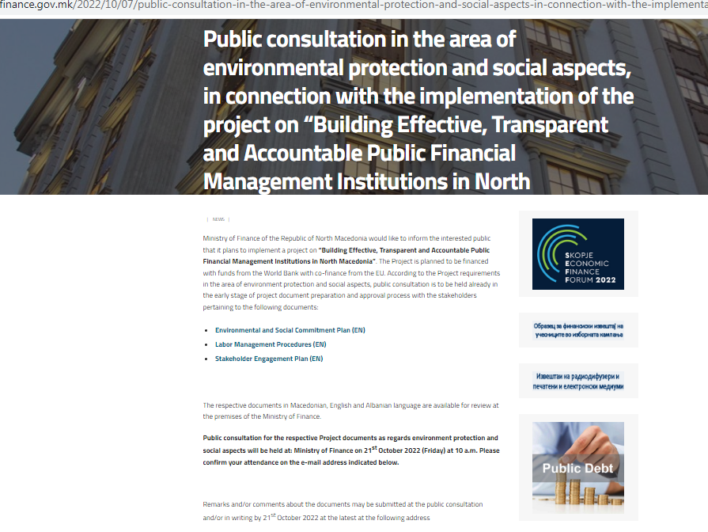

**Announcement published in newspaper Sloboden Pecat, Friday, October 7th, 2022**

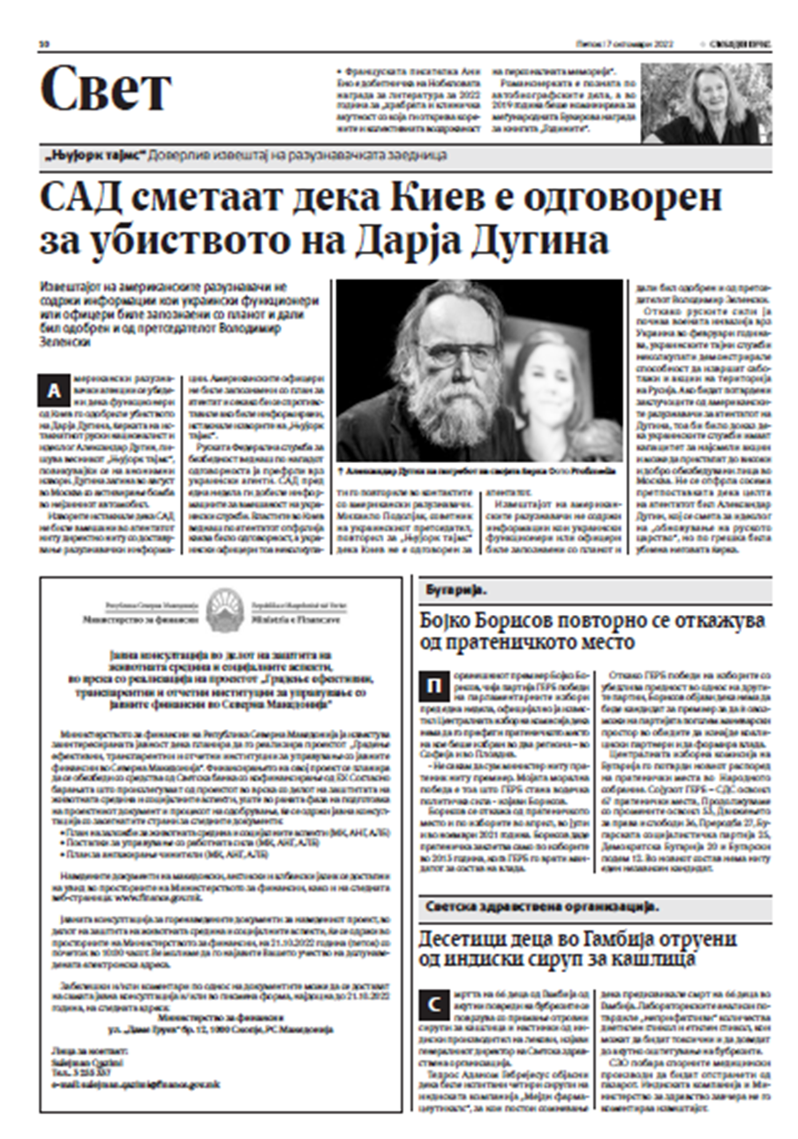

**Announcement published in Koha newspaper, Friday, October 7th, 2022**

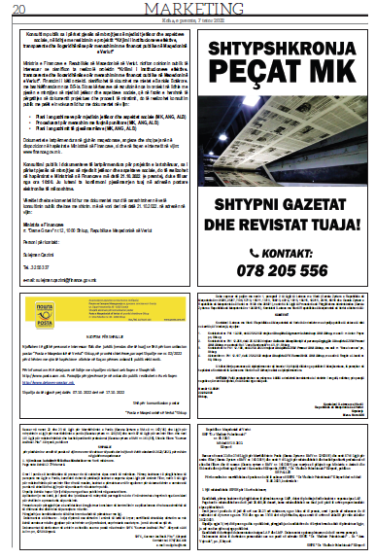

## **ANNEX 2 - LIST OF INVITEES**

For the Public consultation in the area of environmental protection and social aspects, in connection with the implementation of the project on “Building Effective, Transparent and Accountable Public Financial Management Institutions in North Macedonia

Јавна расправа за “**Градење ефективни, транспарентни и отчетни институции за управување со јавните финансии во Северна Македонија**“

Disksutim publik për **“Krijimi i institucioneve efektive, transparente dhe llogaridhënëse për menaxhimin me financat publike në Maqedoninë e Veriut”.**

Public consultation for **“Building Effective, Transparent and Accountable Public Financial Management Institutions in North Macedonia”.**

|  |  |  |
| --- | --- | --- |
| Р.бр. | Институција | Контакт инфо |
| 1 | Министерство за информатичко општество и администрација | cabinet@mioa.gov.mk |
| 2 | Министерство за внатрешни работи | kontakt@moi.gov.mk |
| 3 | Министерство за економија |  |
| 4 | Министерство за животна средина и просторно планирање | infoeko@moepp.gov.mk |
| 5 | Управа за јавни приходи | info@ujp.gov.mk |
| 6 | Вестминстер Фондација за демократија - Македонија | [Damir.neziri@wfd.org](mailto:Damir.neziri@wfd.org) |
| 7 | Здружение за истражување и развој на општеството „ФОРУМ ПЛУС“ Скопје | forumplus.org.mk |
| 8 | Здружение за истражување, анализа и развој „ЗЕЛЕНА ЛУПА“ Скопје |  |
| 9 | Здружение на граѓани „Медиа Плус“ | [info@mediaplus.org.mk](mailto:info@mediaplus.org.mk) |
| 10 | „ИМПЕТУС“ Центар за интернет, развој и добро владеење – Скопје | [contact@impetus.mk](mailto:contact@impetus.mk) |
| 11 | Иницијатива за европска перспектива | [contact@iep.mk](mailto:contact@iep.mk) |
| 12 | Институт за добро владеење и евроатлантски перспективи | [contact@iduep.org.mk](mailto:contact@iduep.org.mk) |
| 13 | Македонски центар за меѓународна соработка (МЦМС) |  |
| 14 | Транспаренси Интернешенл – Македонија | [info@transparency.mk](mailto:info@transparency.mk) |
| 15 | Фондација за локален развој и демократија „Фокус“ ​​– Велес | [contact@focus.org.mk](mailto:contact@focus.org.mk) |
| 16 | Фондација за одржлив економски развој „ПРЕДА Плус“ | info@predaplus.eu |
| 17 | Центар за економски анализи | info@cea.org.mk |
| 18 | Балкански економски форум |  |
| 19 | Центар за правни истражувања и анализи | [contact@cpia.mk](mailto:contact@cpia.mk) |
| 20 | Здружение за развој на демократијата и подобрување на квалитетот на животот и подобрување на образованието „Делта Сосајати“ |  |
| 21 | Здружение за развој на социјални и економски дејности „ЕРГОС“ Скопје | [nvo.ergos@gmail.com](mailto:nvo.ergos@gmail.com) |
| 22 | ПРАВНА ИСТРАЖУВАЧКА МРЕЖА |  |

## ANNEX 3 - PHOTOS

from the Public consultation in the area of environmental protection and social aspects, in connection with the implementation of the project on “Building Effective, Transparent and Accountable Public Financial Management Institutions in North Macedonia

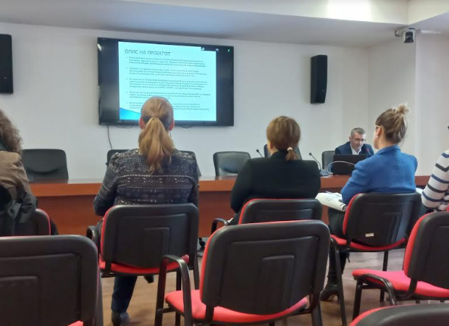

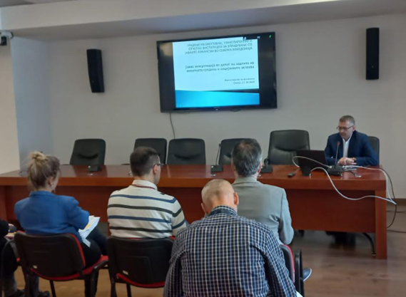

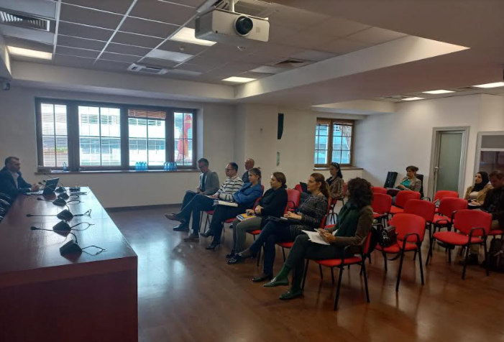

## ANNEX 4 - POWER POINT PRESENTATION

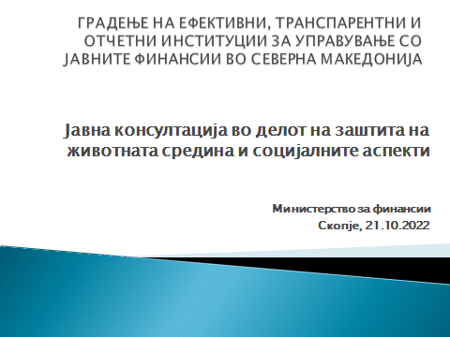

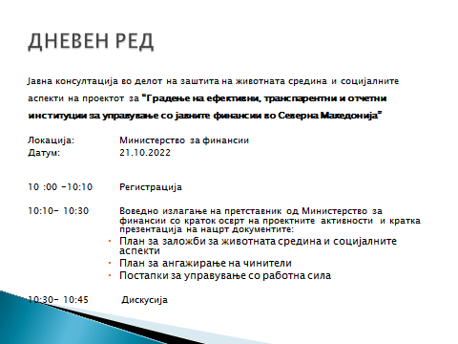

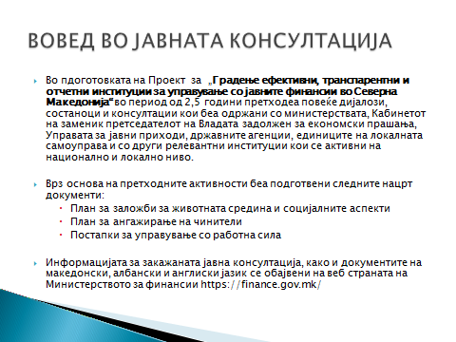

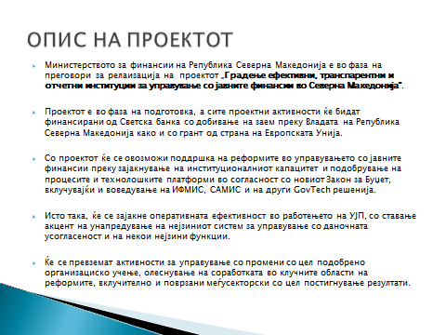

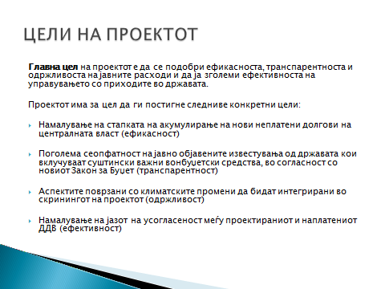

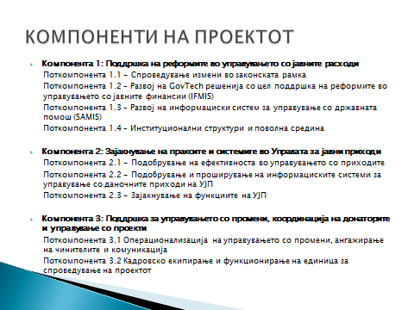

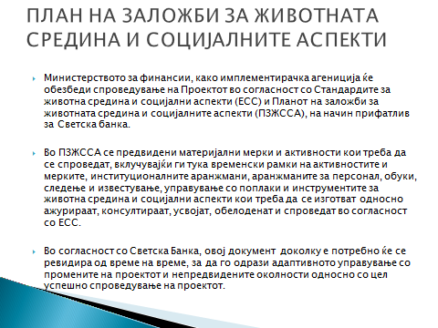

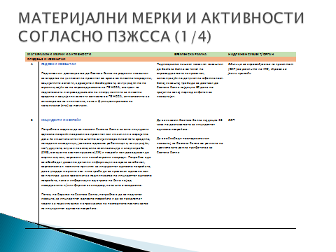

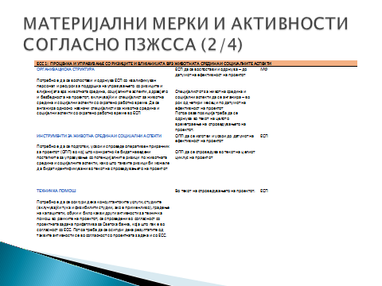

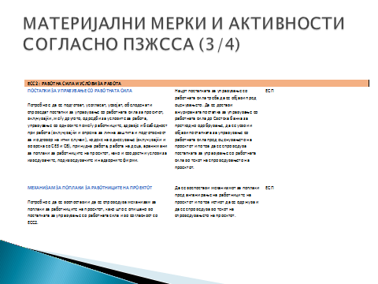

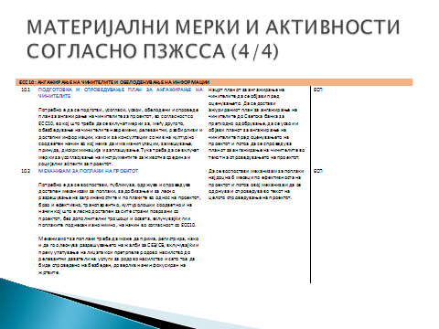

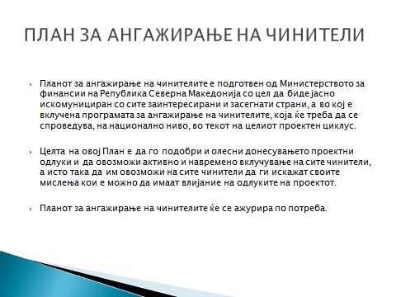

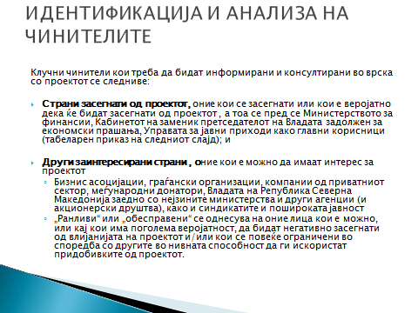

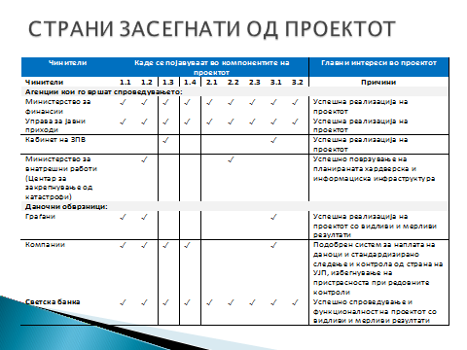

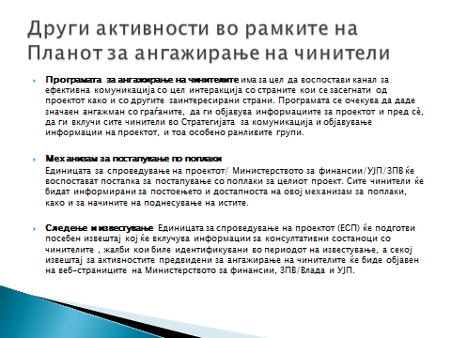

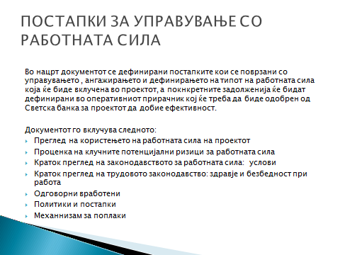

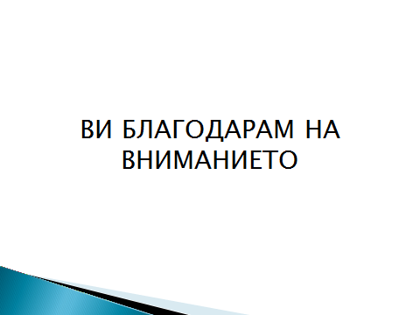

1. **Organic Budget Law** is specifying the schedule and procedures by which the budget should be prepared, approved, executed, accounted for, and final accounts submitted for approval.
2. [**GovTech**](https://www.worldbank.org/en/programs/govtech/) is a whole-of-government approach to public sector modernization that promotes simple, efficient, and transparent government, with citizens at the center of reforms.