REPUBLIC OF NORTH MACEDONIA

BUILDING EFFECTIVE, TRANSPARENT AND ACCOUNTABLE PUBLIC FINANCIAL MANAGEMENT INSTITUTIONS IN NORTH MACEDONIA

LABOR MANAGEMENT PROCEDURES (LMP)

DRAFT v.1

October 2022

Table of Contents
1. OVERVIEW OF LABOR USE ON THE PROJECT 5
1.1. Number of Project Workers 5
1.2. Characteristics of Project Workers 6
1.3. Timing of Labor Requirements 7
1.4. Contracted Workers 7
2. ASSESSMENT OF KEY POTENTIAL LABOR RISKS 7
2.1. Project Activities 7
2.2. Key Labor Risks 8
3. BRIEF OVERVIEW OF LABOR LEGISLATION: TERMS AND CONDITIONS 9
4. BRIEF OVERVIEW OF LABOR LEGISLATION: OCCUPATIONAL HEALTH AND SAFETY 10
5. RESPONSIBLE STAFF 12
6. POLICIES AND PROCEDURES 14
7. AGE OF EMPLOYMENT 16
8. TERMS AND CONDITIONS 17
9. GRIEVANCE MECHANISM 17
10. CONTRACTOR MANAGEMENT 18
11. COMMUNITY WORKERS 19
12. PRIMARY SUPPLY WORKERS 19
APPENDICIES 20
APPENDIX 1: Grievance Submission Form 21
APPENDIX 2: Grievance Register 23

Abbreviation | Full word
EHS | Environment, health and safety
DRC | Disaster Recovery Center
ESS | Environmental and Social Standards
GIIP | Good International and Industry Practices
GRM | Grievance Redress Mechanism
IFMIS | Integrated Financial Management Information System
LMP | Labor Management Procedures
MDC | Main Data Center
MoF | Ministry Of Finance
DPM | Deputy President of the Government in charge of economic affairs, coordination of economic sectors and investments
OBL | Organic Budget Law
OGRM | Official Gazette of the Republic of Macedonia
OGRNM | Official Gazette of the Republic of North Macedonia
OHS | Occupational Health and Safety
PFM | Public Finance Management
PIM | Public Investment Management
PIU | Project Implementation Unit
PPE | Personal Protective Equipment
PRO | Public Revenue Office
SAMIS | State Aid Management Information System
SEA/SH | Sexual Exploitation and Abuse / Sexual Harassment
SPD | Standard Procurement Documents
WB | World Bank
WBG | World Bank Group

OVERVIEW OF LABOR USE ON THE PROJECT

Number of Project Workers
The activities on this project will include direct workers and contracted workers. Community workers and primary supply workers are not relevant for this project.
This project foresees combined method of engagement of workers. It will include existing employees (civil servants) from MoF, PRO and DPM, but also new employees performing tasks for beneficiaries (MoF, DPM and PRO) within different sub-components of the project.
Direct Workers will include:
- Members of the working bodies (MoF, PRO, DPM)
- Call Centre employees, within PRO (10-15 workers), who will mostly be new workers
- Individual Consultants and Advisory/training professionals and software experts (5-10 workers). The potential institutional capacity strengthening may will require hiring of a few consultants and advisors.

Contracted Workers, will include employees of:
- Software development companies (5-20 workers)
- Business Management and Strategy Development consultancy companies (3-10 workers)
- Media, Audience and Communication consultancy companies (5-10-workers)
- Energy efficiency and Environmental consultancy companies (3-5 workers)
- Other Training and Advising companies (5-10 workers)
- Hardware supply and installation companies (5-10 workers)
At the moment, it is not precisely known how many direct, contracted or civil servant workers will be engaged on this project. Relevant information regarding the exact number of engaged workers to be engaged on this project is expected to be defined as soon as Project activities are defined and details are set into Project Operation Manual.
Migrant workers are not expected to be engaged on this project, but these cannot be excluded if demand for such activity occurs during the detail planning of the project sub-components’ activities and tasks.

Characteristics of Project Workers
All engaged workers are expected to be sourced nationally and will have adequate educational level. For most engaged workers on this project, due to the demand for systematic approach and structural organization and implementation of the planned activities within the Project sub-components, a university degree will be the minimum requirement for engagement on this project. Relevant and successful professional experience for all engaged workers will also be major demand.
Female workers are expected to outnumber male workers, due to the specifics of existing working environment in the ministries (employing significant number of female workforce), and the project activities, such as communication, software development, management and organizational activities. There is no need of construction and civil works where vast majority of workers are, usually, male.
This project will create the following project operational bodies:
- Project Implementation Unit (PIU) will be established within the MoF and will be staffed by four (4) or five (5) personnel: (i) Project Manager (ii) a financial management specialist; (iii) a procurement specialist; (iv) a monitoring and evaluation specialist; (v) a social and environmental specialist on a needs basis.
- IFMIS Working Body in accordance with article 107 of OBL
- PRO Working Body will include existing employees of PRO
- DPM Working Body will include existing employees in the Government/Cabinet of the DPM in charge of economic affairs, coordination of economic sectors and investments
- Project’s Steering Committee, to be headed by the Minister of Finance with the participation of representatives from the MoF, PRO, Cabinet of the DPM, line ministries and Component Managers of IFMIS, PRO and DPM working bodies.
Civil servants assigned to work on project related activities, regardless of whether they work full time or part time, will continue to work under the terms and conditions of their existing contracts or appointments in the public sector.
The labor legislation of N. Macedonia applies to all groups of Project workers. This includes the provisions regarding workers’ age, forced labor and occupational health and safety, which are compliant to the provisions of ESS2.
Most of the Contracted workers are expected to be experts in their fields, supported by experienced professionals. The experience of all engaged contracted workers should be on a level of the complexity of the given tasks/assignment.

Timing of Labor Requirements
Direct workers and Civil Servants are needed full-time and around the year, for the whole project duration. Other experts/consultants, directly employed on the project, will be engaged upon demand for performance of certain project activity foreseen by sub-components.
Various timeline of activities for Contracted workers (experts/consultants), that relies on separate project sub-component’s activities, will be defined on demand basis, throughout the project period. Timing for involvement of Contracted workers will be known at later stage, when detailed activities on various sub-components are defined.

Contracted Workers
Contracted workers are workers who are employed in the contracting companies (see bullets in the following paragraph) for the needs of the project or have current employment within the companies who will be engaged on this project to provide software, hardware, consulting or intellectual services, including knowledge share and trainings.
Contracted workers are expected to be employed in the following type of companies, that is expected to bid for realization of tasks on various sub-components of this project:
- Software development companies
- Business Management and Strategy Development consultancy companies
- Media, Audience and Communication consultancy companies
- Energy efficiency and Environmental consultancy companies
- Other Training and Advising companies
- Hardware supply and installation companies

ASSESSMENT OF KEY POTENTIAL LABOR RISKS

Project Activities
Main project activities include intervention/adjustment in the legal framework and processes related to the OBL and to strengthen the legal framework for Public Investment Management (PIM).
Other project activities include:
- Development of Integrated Financial Management Information System Software
- Installation of IFMIS hardware in the existing MoF Main Data Center (MDC) and the shared Disaster Recovery Center (DRC) operated by the Ministry of Interior
- Implementation of digital citizen engagement (CivicTech) solutions to improve budget transparency and accountability
- Establishment of secure backup network connections between the MDC and DRC
- Development of a new State Aid Management Information System (SAMIS) Software
- Communication with Taxpayers
- Development of feedback mechanisms and smart apps to support citizen engagement related to revenue administration
- Implementation of a compliance risk management framework including enhanced enforcement mechanisms, tax audit, and risk analysis
- Support to the strengthening of the Large Taxpayer Office through capacity building and advisory work
- Software development
- Development of business intelligence (BI) tools (software solutions) for compliance risk management, and decision-making support;
- Support for the establishment of PRO combined call center/help desk
- Development of change management and stakeholder engagement strategies for OBL and PRO activities,
- Implementation of stakeholder engagement and communication strategies
- Staffing and operation of a Project Implementation Unit

Key Labor Risks
Activities related to this project are training, research, installment of hardware and software, communication with taxpayers, technical assistance and consulting activities for improving the tax legislation. Key overall risks include the applicability of labor laws, issues related to non-discrimination and equal opportunity, accessibility of the grievance mechanism system by all workers, and occupational health and safety aspects specific to office works. Additionally, those who will be installing hardware are faced with low level of Electrical works and accordingly low risk of Electrocutions and arc fault burns and risk of traffic accidents due to the transport of equipment. Overall, there is a moderate risk of Personal data leaks (used in software for communication and registration of taxpayers) of the workers engaged on this project and, accordingly, Taxpayers.
The Project is assessed as low risk on gender-based violence (SEA/SH) risk. Mitigation measures to address SEA/SH risks are included in the section on Policies and Procedures.
However, if other labor risks arise during the project implementation, the Borrower will develop procedures to prevent further impacts.

BRIEF OVERVIEW OF LABOR LEGISLATION: TERMS AND CONDITIONS
The main legislation that covers labor and working conditions issues are following:
Labor Law, manages relationship between parties involved in the process of employment. It protects and applies to any natural person that has concluded an employment contract with an employer. The principle of equal treatment implies a ban on direct and/or indirect discrimination. Any kind of forced or child labor are strictly forbidden. The Law regulates all forms of employment, relations between employees and employers, retirement, lay-offs, and union operations. Special protection is guaranteed to employees under 18, workers with disabilities, pregnant women, women, and single parents.
Law on Pensions and Disability Insurance defines the obligatory pension insurance of workers under working contract and the natural persons performing activity, the bases of the capital funded pension insurance, as well as the special conditions how certain categories of insured persons receive the right to pension and enjoy disability insurance. The rights deriving from the pension and disability insurance are the following: right to age-related pension, right to disability pension, right to re-allocation to other adequate, working post, right to adequate employment, right to re-qualification or higher qualification and right to adequate financial compensations, right to family pension, right to monthly compensation for physical damage, and right to minimal pension
Other labor and workforce related laws are:
- Law on Employment and Insurance Against Unemployment
- Law on Administrative Servants
- Law on Public Sector Employees
- Law on Labor Inspection
- Law on Records in the Field of Labor
- Law on Employment of Disabled Persons
- Law on Private Employment Agencies
- Law on Volunteering
- Copyright and related rights law
- Law on Transformation into Regular Employment
- Law on Peaceful Settlement of Labor Disputes
- Law on Employment and Work of Foreigners
- Law on Minimum Wage
- Law on Protection from Harassment at the Workplace
- Law on Equal Opportunities for Women and Men

In general, the national labor legislation is aligned with ESS2 and EU Labor Law.

BRIEF OVERVIEW OF LABOR LEGISLATION: OCCUPATIONAL HEALTH AND SAFETY
Occupational safety and health topics are covered with the Constitution, the Labor Law and the Occupational Safety and Health Law.
The Law on Safety at Work is the key law that defines measures and obligations in the field of OHS (Occupational Health and Safety). The OHS law defines the occupational health and safety measures, the employers’ obligations and the employees’ rights and duties in the field of occupational health and safety, as well as the preventive measures against occupational risks, elimination of accident-related risk factors, information, consultation, training of workers and their representatives and their engagement in planning and implementing occupational health and safety measures. Prevention of occupational injuries and diseases and work-related illnesses is the fundamental principle of the OHS law.
The Ministry of Labor and Social Protection has adopted numerous Rulebooks related to OHS, available in Macedonian language, here.
Relevant OHS Rulebooks are:
- Rulebook on Preparation of the Health and Safety Statement defines mandatory health and safety statements for each workplace; engagement of an authorized H&S officer and official medical institution; adopting fire protection, first aid and evacuation measures; providing trainings on first aid, fire protection, rescue and evacuation; providing periodical medical examinations for staff.
- Rulebook on minimum requirements for safety and health of employees at work defines the following obligations of employers: providing clear routes to emergency exits; carrying out technical maintenance of the workplace, equipment and devices; keeping the workplace, equipment and devices at an adequate level of hygiene; providing first aid rooms fitted with essential first aid installations and equipment; taking into consideration the needs of disabled workers;
- Rulebook on Personal Protective Equipment used by workers at work defines mandatory provision of PPE for workers;
- Rulebook for Safety and Health at Work on equipment for work defines that adequate and safe work equipment must be available to workers, employers must take measures to minimize risks, including providing appropriate notices and written guidelines for workers, as well as providing training on risks;
- Rulebook on safety and health at work of employees at risk of noise defines mandatory measurement of noise levels at workplaces, prohibits work on locally recognized days of rest, outside of the normal working hours or in extreme weather conditions;
- Regulation on Use of Work Equipment defines mandatory periodical testing of work equipment
- Regulation on OHS in Use of Work Equipment defines that adequate and safe work equipment must be available to workers; employers must take measures to minimize risks, including providing appropriate notices and written guidelines for workers, as well as providing training on risks
- Regulation on Minimum OHS Requirements in Temporary Mobile Sites defines the obligation of contractors to develop an OHS Plan
- Regulation on Minimum OHS Requirements at Workplaces defines the following obligations of employers: providing clear routes to emergency exits; carrying out technical maintenance of the workplace, equipment and devices; keeping the workplace, equipment and devices at an adequate level of hygiene; providing first aid rooms fitted with essential first aid installations and equipment; taking into consideration the needs of disabled workers
- Regulation on Health and Safety of Workers Exposed to Noise Pollution defines mandatory measurement of noise levels at workplaces, prohibits work on locally recognized days of rest, outside of the normal working hours or in extreme weather conditions
- Regulation on OHS Signs defines mandatory health and safety signs for any hazardous work activities and providing suitable instructions to workers

RESPONSIBLE STAFF
An Operational Manual detailing responsibilities, accountabilities, processes and procedures governing the Project will be adopted in a manner acceptable to the Bank before effectiveness. It will include, inter alia, (i) the final decision-maker and ultimately accountable for the Project, (ii) responsibilities and accountabilities of each stakeholder in terms of activity implementation and relevant results, (iii) the procedures for carrying out, monitoring and evaluating the Project; (iv) the final format of the Financial Statements, chart of accounts and the interim unaudited financial reports for the Project; and (v) the performance indicators to be used for monitoring and evaluating the implementation of the Project.
The key implementing agency of the Project is Ministry of Finance (MoF). The PIU (to be established within the MoF) will report to the Minister of Finance and will be responsible for overseeing day-to-day project management, overall project coordination, monitoring and evaluation, safeguards, fiduciary functions, and reporting in coordination with the Component Managers of IFMMIS Working Body, of PRO Working Body and of DPM Working Body .
Headed by a Project Coordinator responsible for overall coordination and oversight of project implementation, the PIU will be staffed by:
- project manager
- financial management specialist;
- procurement specialist;
- monitoring and evaluation specialist;
- a social and environmental specialist on a needs basis.

For direct workers, except for civil servants, the Project Manager/Head of PIU will be responsible. For civil servants existing legal framework will apply. For direct workers engaged as external individuals (consultants or advisory/training personnel) the PIU (Project Manager) will be responsible for complete implementation of the Labor Management Procedure provision.
For contracted workers, if the workers are employed in the company, it will be the HR professional of the respective company, or another designated person with adequate skills within the company.

Currently there are no project implementation arrangements in place, including the procurement function is not defined and a procurement specialist not available.

The Project Implementing Unit will also, be responsible for the following:
- Implement this labor management procedure to project workers.
- Ensure that contractor(s) responsible for separate activities within sub-components prepare their labor management procedure, in compliance with this labor management procedure, and occupational health and safety plan before commencement with work on any planned project activity.
- Monitor and report on implementation of project contractors’ labor management procedures.
- Monitor that the contractors are meeting obligations towards contracted and sub-contracted workers as included in the General Conditions of Contract the World Bank Standard Bidding Documents, and in line with ESS2 and national labor code.
- Maintain records of recruitment and employment process of direct workers.
- Monitor employment process of contracted workers to ensure it is carried out in accordance with this labor management procedure and national labor law.
- Monitor that occupational health and safety standards are met at workplaces in line with national occupational health and safety legislation, ESS2 and Occupational Health and Safety Plan.
- Monitor training of the project workers on OHS, SEA/SH prevention, and any other required trainings.
- Ensure that the grievance mechanism for project workers is established, monitor and report on its implementation.
- Monitor implementation of the workers Code of Conduct.
- Establish and implement a procedure for documenting specific incidents such as project-related occupational injuries, illnesses, and lost time accidents. Maintains such records and require from all third parties and primary suppliers to maintain them. Such records will form an input into the regular review of OHS performance and working conditions.
- In instances of medium, severe, fatal and mass accidents, inform the law enforcement bodies and Labor Inspectorate.

The Contractors will be responsible for the following:
- Employ or appoint qualified social, labor and occupational safety experts to prepare and implement project specific labor management procedure, occupational health and safety plans, and to manage subcontractor performance.
- Develop their own labor management procedure and occupational health and safety plan (if needed), consistent with this LMP and ESS2, which will apply to contracted and sub-contracted workers. These procedures and plans will be submitted to the Supervision Consultant for review and approval before the contractors mobilize for the design stage.
- Contractors will supervise their subcontractors’ implementation labor managements procedures and occupational health and safety plans.
- Maintain records of recruitment and employment process of contracted workers.
- Communicate clearly job description and employment conditions to contracted workers and provide them with one copy of the employment contract.
- Develop, implement, and maintain workers’ grievance mechanism and address the grievance received from the contracted and sub-contracted workers.
- Have a system for regular review and reporting on labor, and occupational safety and health performance.
- Deliver regular work induction trainings including but not limited to OHS, HSE, social induction, SEA/SH prevention training to employees.
- Ensure that all contractor and sub-contractor workers understand and sign the Code of Conduct prior to the commencement of works.
- Establish and implement a procedure for documenting specific incidents such as project-related occupational injuries, illnesses, and lost time accidents. Maintain such records, and require all third parties and primary suppliers to maintain them. Such records will form an input into the regular review of OHS performance and working conditions.
- In instances of medium, severe, fatal and mass accidents, inform the law enforcement bodies, the labor inspection, the president of the trade union, and the employees’ OHS representative.

After the bidding process is completed and the Contractors are known, this labor management procedure can be updated to include additional details about companies, as necessary.

POLICIES AND PROCEDURES
The Contractors will prepare labor management procedures in line with this labor management procedure and national labor law. The principles and procedures presented below represent the minimum requirements but is not an exhaustive list of requirements.

As specified in the Labor Law of North Macedonia, the employment of project workers will be based on the principles of non-discrimination and equal opportunity. There will be no discrimination with respect to any aspects of the employment relationship, such as recruitment, compensation, working conditions and terms of employment, access to training, promotion or termination of employment. The following measures will be developed by the contractors and monitored by the PIU and supervision consultant to ensure fair treatment of all employees:

- As per Labor Law requirements, recruitment procedures will be transparent, public and non-discriminatory with respect to ethnicity, religion, sexual orientation, disability, gender, and other grounds included in the Labor Law and other relevant laws.
- Applications for employment will be considered in accordance with the application procedures established by the contractors.
- Clear job descriptions will be provided in advance of recruitment and will explain the skills required for each post.
- All workers will have written contracts describing terms and conditions of work and will have the contents explained to them. Workers will sign the employment contract. Terms and conditions of employment will be available at work sites.
- Prior to termination, employers must issue a written notice to their employees informing them of the reasons for termination.
- The contracted workers will not pay any hiring fees. If any hiring fees are to be incurred, these will be paid by the Employer (‘Contractor’).
- Depending on origin of the employer and employee the contracts will be developed in corresponding language understandable for both parties.
- In addition to written documentation, an oral explanation of conditions and terms of employment will be provided to workers who may have difficulties with understanding the documentation.
- While communication language related problems are not expected, attention should be given to ensuring coordination between different contractors and means to address any language differences.
- Foreign workers will require residence permit, which will allow them to work in North Macedonia.
- PIU will include in contracts that all contractor (and subcontractor) personnel must be of the age of 18 years or older.

MoF/PIU will include into the bidding documents specific OHS standard requirements that all contractors and sub-contractors will meet under this project. The standards will be consistent with local regulations, WBG EHS guidelines and GIIP (Good International and Industry Practices). The following OHS standard requirements should as a minimum be included in the OHS Plan to be prepared by the contractors:
- Risk Assessment Procedure.
- Emergency response procedure.
- OHS training.
- Refuse to work policy.

Contractors will provide a safe workplace; therefore, a risk assessment will be completed before the commencement of any construction activities, and safety measures will be implemented in accordance with applicable safety standards. OHS Plan will be developed by the Contractor if risk assessment determines need for performing works that include construction activities, use of chemicals and OHS plan must be developed in compliance with WBG EHS guidelines. The supervision consultant will review and approve contractors’ safety plans and procedures, if such need occurs.

MoF/PIU will inform the Bank, within 48 hours, about any incident or accident related to the project which has or is likely to have a significant adverse effect on the environment, the affected communities, the public or workers (labor, health and safety, or security incident, accident or circumstance), but no later than three calendar days after the occurrence of the event. Such events can include strikes or other labor protests, serious worker injuries or fatalities, project-caused injuries to community members or property damage. MoF/PIU will prepare a report on the event and the corrective action and submit to the Bank within 30 calendar days of the event.
All contractors will develop and implement Code of Conduct and it should be submitted to the supervision consultant for review and approval. The Code of Conduct will reflect the company’s core values and overall working culture. The content of the Code of Conduct is included in the World Bank Standard Bidding Documents and will include provisions relating to SEA/SH prevention.

The contractors will be required to provide the periodic information on the performance in terms of labor, occupational health and safety issues. The information will be included in the construction contractor’s monthly report and will be reviewed by the supervision consultant’s team. Additionally, the contractor shall report to MoF/PIU about any inspections and audits carried out by the respective ministries such as the Labor Inspection. The findings of the labor audits will be presented to the MoF/PIU and the Bank, if requested.

AGE OF EMPLOYMENT
The Labor law minimum working-age in this project will be 18 years of age. The national legislation prohibits child labor. Persons under the age of 18 years will not be allowed to be engaged in project activities.
The contractors will be required to verify the identity and the age of all workers. This will require workers to provide official documentation to verify age such as a national identification card, passport, driver’s license, birth certificate, valid medical or school records.
If a child under the minimum age is discovered working on the project, measures will be taken to immediately terminate the employment or engagement of the child in a responsible manner, taking into account the best interest of the child.

TERMS AND CONDITIONS
The terms and conditions applying to MoF, Government/Cabinet of DPM and PRO employees/engaged are set out in this document. These internal labor rules and regulations in line with existing labor legislation will apply to MoF, Government/Cabinet of DPM and PRO employees who are assigned to work specifically in relation to the project (direct workers), as well as to the Public Servants/engaged workers on this project. Terms and conditions of external direct workers are determined by their individual contracts.
In line with existing labor legislation, working time, for all workers engaged on this project, should not exceed 40 hours per week. The overtime work can include maximum 8 hours per week. Overtime hours will be paid at 135 percent of their regular rate. In addition, the law entitles employees who work more than 150 hours of overtime per year to a bonus of one month’s salary.
All wages earned, social security benefits, unused leave time, pension contributions and any other entitlements will be paid on or before termination of employment.
The contractors’ labor management procedure will set out terms and conditions for the contracted workers. These terms and conditions will be in line, at minimum, with this labor management procedure, national Labor Law and General Conditions of the World Bank Standard bidding documents and comparable industry standards.

GRIEVANCE MECHANISM
The PIU will develop and implement a grievance mechanism for direct workers and public servants to address workplace concerns.
PIU will require contractors to develop and implement a grievance mechanism for their workforce including sub-contractors, prior to the start of works.
The workers grievance mechanism will include:
- a procedure to receive grievances such as comment/complaint form, suggestion boxes, email, a telephone hotline.
- stipulated timeframes to respond to grievances and to address cases.
- a register to record and track the timely resolution of grievances.
- a responsible department to receive, record, address and track resolution of grievances.

The Supervision Consultant will monitor the contractors’ recording and resolution of grievances, and report these to PIU in their monthly progress reports. The process will be monitored by the GRM Focal Point, a PIU representative who will be responsible for the project GRM.
The workers grievance mechanism will be described in staff induction trainings, which will be provided to all project workers. The mechanism will be based on the following principles:
- The process will be transparent and allow workers to express their concerns and file grievances.
- There will be no discrimination against those who express grievances, and any grievances will be treated confidentially.
- Anonymous grievances will be treated equally as other grievances, whose origin is known.
- Management will treat grievances seriously and take timely and appropriate action in response.
Information about the existence of the grievance mechanism will be readily available to all project workers (direct, civil servants and contracted) through notice boards, the presence of “suggestion/complaint boxes”, and other means as needed.
The Project workers’ grievance mechanism will not prevent workers to use conciliation procedure provided in the Labor law or any other judicial mechanisms.
World Bank Grievance Redress System. Communities and individuals who believe that they are adversely affected by a World Bank supported project may submit complaints to existing project-level grievance redress mechanisms or the World Bank’s GRS. The GRS ensures that complaints received are promptly reviewed in order to address project-related concerns. Project affected communities and individuals may submit their complaint to the World Bank’s independent Inspection Panel which determines whether harm occurred, or could occur, as a result of World Bank noncompliance with its policies and procedures. Complaints may be submitted at any time after concerns have been brought directly to the World Bank’s attention, and Bank Management has been given an opportunity to respond.

CONTRACTOR MANAGEMENT
MoF/PIU will use the World Bank’s 2017 Standard Procurement Documents (SPD) for solicitations and contracts, and these include labor and occupational, health and safety requirements.
PIU, through the Supervision Consultant, will manage and monitor the performance of contractors in relation to contracted workers, focusing on compliance by contractors with their contractual agreements (obligations, representations, and warranties) and labor management procedures. This may include periodic audits, inspections, and/or spot checks of project locations and work sites as well as of labor management records and reports compiled by contractors.
Contractors’ labor management records and reports that may be reviewed would include: representative samples of employment contracts or arrangements between third parties and contracted workers, records relating to grievances received and their resolution, reports relating to safety inspections, including fatalities and incidents and implementation of corrective actions, records relating to incidents of non-compliance with national law, and records of training provided for contracted workers to explain occupational health and safety risks and preventive measures.

COMMUNITY WORKERS
Not Applicable

PRIMARY SUPPLY WORKERS
Equipment shall be provided from licensed computer hardware importers in the country, that can guarantee data safety of the computer equipment.

APPENDICIES

APPENDIX 1: Grievance Submission Form
Reference Number
Full name (optional)

- I wish to raise my grievance anonymously.
- I request not to disclose my identity without my consent.
Contact information.  Please mark how you wish to be contacted (mail, telephone, e-mail). | - By Post: Please provide mailing address:  ____________________________________________________________________________________________________________  - By telephone: __________________________  - By E-mail
Preferred language of communication | - Macedonian  - Albanian  - Other: ____________________
Description of Incident for Grievance |  | What happened? Where did it happen? Who did it happen to? What is the result of the problem?
Date of Incident / Grievance
- One-time incident/grievance (date ________________)
- Happened more than once (how many times? ______)
- On-going (currently experiencing problem)
What would you like to see happen?
Contact information for enquiries and grievances:  Attention: Name & Surname  Ministry of Finance  Address: Dame Gruev 12, 1000 Skopje  Tel: + 389 02 XXX XXX  E-mail: email@finance.gov.mk |  |  | Signature: _____________________________  Date: _______________________________

APPENDIX 2: Grievance Register
Reception date | Name of Complainant | Communication Channel (how) | Component | Description of Problem | Actions taken | Date of resolution

APPENDIX 3: Report from the Public Consultations

MINUTES OF THE MEETING

from the Public consultation event in the Ministry of Finance on the “Stakeholder Engagement Plan”, “Labor Management Procedure”, “Environmental and Social Commitment Plan”, for the Building Effective, Transparent and Accountable Public Financial Institution Project
Skopje (21.10.2022)

Venue | Ministry of Finance  - Conference Room I floor  - Date 21.10.2022  - Duration 10.00 – 11.00 o’clock
Aim | The purpose of the event was to present the draft versions of the prepared documents „ Stakeholder Engagement Plan“, „Labor Management Procedure“ and „ Environmental and Social Commitment Plan“ within the Building Effective, Transparent and Accountable Public Financial Institutions (BETAPFI) and collecting comments and remarks from various stakeholders.
Invited | Invitations were sent to various stakeholders across the country related to the BETAPFI Project (ministries, public agencies, public institutions, NGOs, etc). List of invitees is enclosed in Annex 2.
Participants | 13 representatives from Ministry of Finance and World Bank and different stakeholders participated in the public hearing event (Ministry of Information Society and Administration, Macedonian Center for International Cooperation, Westminster Foundation).
Presentation Techniques | Power Point presentation was prepared with key findings from the „Stakeholder Engagement Plan“, „Labor Management Procedure“ and „Environmental and Social Commitment Plan“ in the frame of the BETAPFI Project in the in accordance with national legislation and policies of the World Bank.  Power Point presentation is enclosed in Annex 4.
Announcement for public consultations | The announcement of the public consultation was posted the web site of Ministry of Finance on 07.10.2022 in Macedonian, Albanian and English languages, and was published in two newspapers in Macedonian and Albanian language.  In addition, the official invitation from Ministry of Finance for the public consultationevent was sent to many stakeholders from relevant institutions (ministries, public agencies and institutions, NGOs, etc.).  The revised documents were posted on the web site of Ministry of Finance on 10.10.2022.  The announcement is enclosed in Annex 1.

On the 21.10.2022 at 10:00 o’clock at the premises of the Ministry of Finance was held public consultationevent on the draft „Stakeholder Engagement Plan“, „Labor Management Procedure“ and „Environmental and Social Commitment Plan“ within the Building Effective, Transparent and Accountable Public Financial Institution Project.

In Annex 1 is disclosed the Announcement for holding a public consultationon the draft documents „ Stakeholder Engagement Plan “, „ Labor Management Procedure“ and „ Environmental and Social Commitment Plan“ published on the website of Ministry of Finance https://finance.gov.mk/2022/10/07 public consultations in Macedonian, Albanian and English on 07.10.2022, as well the announcement was published in two newspapers in Macedonian and Albanian.

The revised documents for „ Stakeholder Engagement Plan “, „ Labor Management Procedure“ and „ Environmental and Social Commitment Plan “ were posted on the web site of the Ministry of Finance on 10.10.2022.

In addition, the official invitation from Ministry of Finance for the public consultation event was sent to many stakeholders from relevant institutions (ministries, public agencies and institutions, NGOs, etc.).

Public consultation event was attended by 13 persons from different stakeholder groups (Ministry of Finance, Ministry of Information Society and Administration, Macedonian Center for International Cooperation, Westminster Foundation). Photos from the public consultation are enclosed in Annex 3.

For the needs of the public consultation, a Power Point presentation was prepared, which is attached as Annex 4 to these minutes.

Mr. Daut Hajlurahi, Coordinator of IFMIS Working Group in Ministry of Finance opened the public debate on the draft documents. He informed that in the preparation of the Project for "Building effective, transparent and accountable institutions for the management of public finances in North Macedonia" over a past period several dialogues, meetings and consultation were held with the ministries, the Cabinet of the Deputy Prime Minister in charge of economic issues, the Public Revenue Office, state agencies, local self-government units and with other relevant institutions that are active at the national and local level.

In addition he gave a short overview of the Project Informing that the Ministry of Finance of the Republic of North Macedonia is in the phase of negotiations for the realization of the project "Building effective, transparent and accountable institutions for the management of public finances in North Macedonia" and all project activities will be financed by the World Bank by obtaining a loan through the Government of the Republic of North Macedonia, as well as by a grant from the European Union.

He stressed that the Project will support the implementation of Public Financial Management reforms by strengthening institutional capacity and improving the processes and technology platforms in line with the new Organic Budget Law, including the introduction of an IFMIS, SAMIS and other GovTech solutions in North Macedonia; to strengthen operational effectiveness of PRO operations with focus on strengthening its tax compliance management system and selected management functions and tosupport change management activities for improved organizational learning, facilitating collaboration on key areas of the reform, and the achievement of results.

He presented project goals and that the project consists of three components:

Component 1: Supporting Public Expenditure Management Reforms;
Subcomponent 1.1 - Implementation of new legal frameworks.
Subcomponent 1.2 – Development of GovTech Solutions to Support PFM Reforms.
Subcomponent 1.3 – Development of State Aid Management Information System.
Subcomponent 1.4 – Institutional Structures and Enabling Environment.

Component 2: Strengthening Tax Administration Practices and Systems in PRO;
Subcomponent 2.1 - Improvements in the effectiveness of revenue management.
Subcomponent 2.2 - Enhancing and expanding PRO’s tax revenue management information
systems (ITIS).
Subcomponent 2.3 - Strengthening of PRO management functions.

Component 3: Supporting Change Management, Donor Coordination and Project Management.
Sub-component 3.1 Operationalization of change management for improved stakeholder
engagement and communication.
Sub-component 3.2 Staffing and operation of a Project Implementation Unit.

Following a brief introduction to the Project, Mr. Daut Hajlurahi presented the main findings of the documents.

He explained that the Ministry of Finance as an Implementing Agency shall ensure that the Project is carried out in accordance with the Environmental and Social Standards (ESSs) and this Environmental and Social Commitment Plan (ESCP), in a manner acceptable to the Bank.
The ESCP sets out material measures and actions that the Ministry of Finance shall carry out or cause to be carried out, including, as applicable, the timeframes of the actions and measures, institutional, staffing, training, monitoring and reporting arrangements, grievance management, and the environmental and social (E&S) instruments to be prepared or updated, consulted, adopted, disclosed, and implemented in accordance with the ESSs. Once adopted, said E&S instruments may be revised from time to time with prior written agreement by the World Bank.
He then referred to the Stakeholder Engagement Plan, which lists information on how stakeholders will be involved during the project, which activities were previously implemented within the project and an overview of the relevant institutions and contractors in the implementation of future activities related to the implementation of the project activities.
In relation to the document Labor Management Procedures, he explained that the draft document defines the procedures related to the management, engagement and definition of the type of manpower that will be included in the project, and more specific tasks will be defined in the operational manual that needs to be approved by the World Bank for the project to achieve effectiveness.

After the presentation of the goals and the meaning of the draft documents, the discussion was opened.

The representative from the Macedonian Center for International Cooperation, Mrs. Valentina Velichkovska, asked how the civil society will be involved in the realization of project activities?

Mr. Daut Hajlurahi replied that it is planned to organize meetings of the working group led by the Minister of Finance (or other responsible person appointed by him), as well as all interested parties, including the non-governmental sector, where all participants can ask questions and be informed about any aspect of the project's implementation. He also added that information about certain activities will be sent by email and press releases. Currently, the documents related to the project are published on the website of the Ministry of Finance in the announcements section, but in the near future it is planned to create a special section on the website of the Ministry of Finance specifically intended for the realization of the project. Furthermore, that with the implementation of IFMIS, greater transparency will be achieved, not only in the work of employees in the institutions, but also citizens will have access to information related to public finances through this system.

The answer was followed up by Ms. Sanja Milivojevic Manchevska, a member of the IFMIS working group at the Ministry of Finance, who explained that the participation of the non-governmental sector in the implementation of the project can also be monitored through the "Public Finance Management Reform Program 2022- 2025" (PFM program - https://finance.gov.mk/PFM program) in which one of the priorities is the implementation of the integrated information system for financial management information (IFMIS). Within the framework of this priority, a medium-term plan for the implementation of the project has been developed, with included measures and monitoring indicators.

The representative from the Ministry of Finance, Mrs. Elena, asked how the activities related to the second component will be implemented and whether their system will be connected to IFMIS?

Mr. Daut Hajlurahi explained that the objective of Component 2 is to strengthen operational effectiveness of Public Revenue Office (PRO) operations with focus on strengthening its tax compliance management system and selected management functions. It will finance selected activities that are complementary to the PRO’s ongoing investments in the development of the core modules (Registration, Filling and Service Management, Accounting, Payments, and Refunds, Debt management, Assessments, Legal, and Audit) of the Integrated Tax Information System (ITIS) being undertaken under the national budget. The activities within the framework of the project will enable the upgrading of the existing system of the Public Revenue Administration, as well as the procurement of additional hardware needed to support their system. He also added that discussions are ongoing about including an e-invoice within their system.

After exhausting all the questions and comments, Mr. Daut Hajlurahi thanked the participants for their contribution and closed the public consultations.

ANNEX 1 - ANNOUNCEMENT

of Public consultation in the area of environmental protection and social aspects, in connection with the implementation of the project on “Building Effective, Transparent and Accountable Public Financial Management Institutions in North Macedonia

ANNOUNCEMENT
Public consultation in the area of environmental protection and social aspects, in connection with the implementation of the project on “Building Effective, Transparent and Accountable Public Financial Management Institutions in North Macedonia

Ministry of Finance of the Republic of North Macedonia would like to inform the interested public that it plans to implement a project on “Building Effective, Transparent and Accountable Public Financial Management Institutions in North Macedonia”. The Project is planned to be financed with funds from the World Bank with co-finance from the EU. According to the Project requirements in the area of environment protection and social aspects, public consultation is to be held already in the early stage of project document preparation and approval process with the stakeholders pertaining to the following documents:

Environmental and Social Commitment Plan (EN)
Labor Management Procedures (EN)
Stakeholder Engagement Plan (EN)

The respective documents in Macedonian, English and Albanian language are available for review at the premises of the Ministry of Finance.

Public consultation for the respective Project documents as regards environment protection and social aspects will be held at: Ministry of Finance on 21st October 2022 (Friday) at 10 a.m. Please confirm your attendance on the e-mail address indicated below.

Remarks and/or comments about the documents may be submitted at the public consultation and/or in writing by 21st October 2022 at the latest at the following address

Ministry of Finance

Dame Gruev Street, no. 12, 1000 Skopje
Contact Person: Sulejman Qazimi
Phone: 3 255 337
e-mail: sulejman.qazimi@finance.gov.mk

Also available in: Macedonian Albanian

Announcement posted on Ministry of Finance web site https://finance.gov.mk/2022/10/07 public hearing

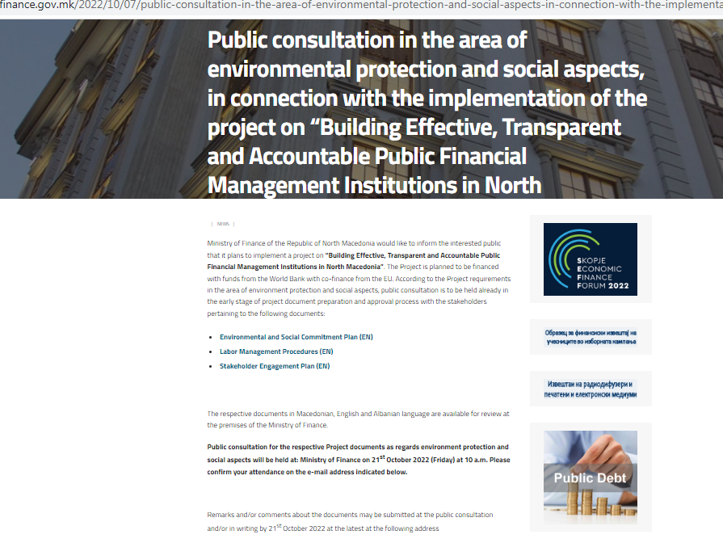

Announcement published in newspaper Sloboden Pecat, Friday, October 7th, 2022
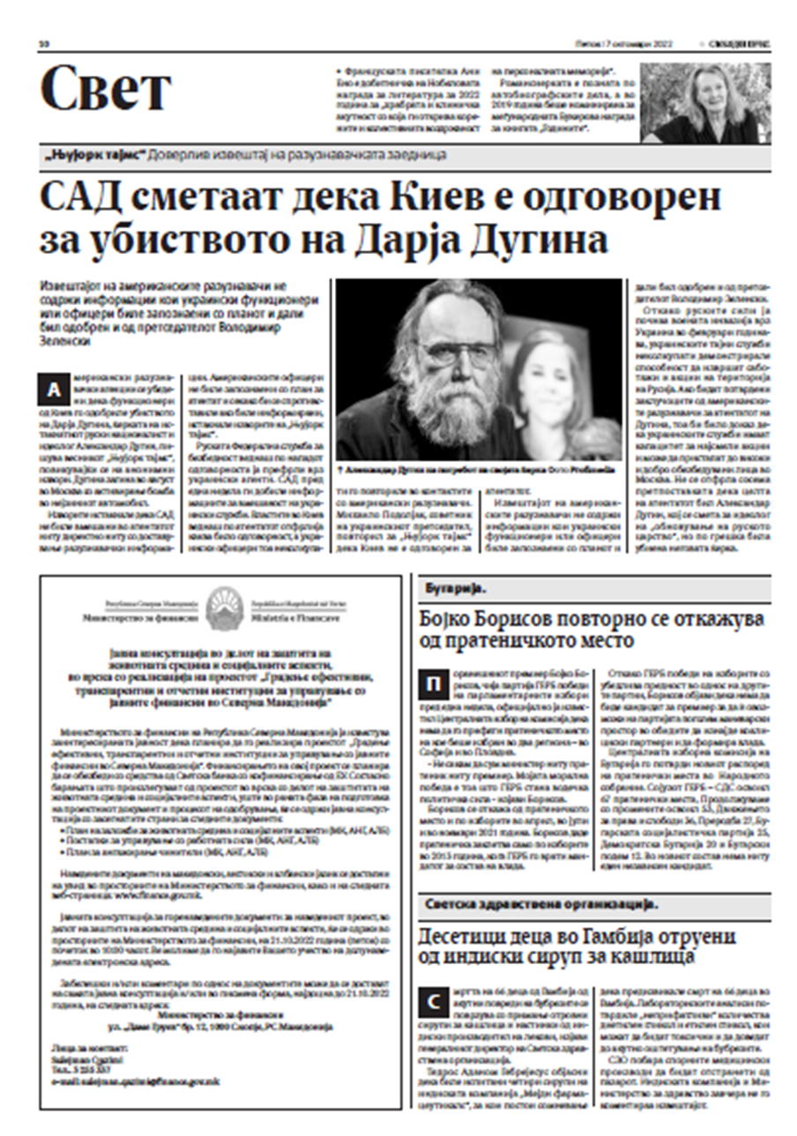

Announcement published in Koha newspaper, Friday, October 7th, 2022
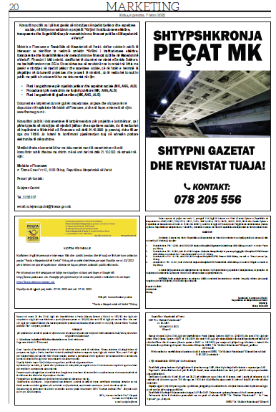

ANNEX 2 - LIST OF INVITEES

For the Public consultation in the area of environmental protection and social aspects, in connection with the implementation of the project on “Building Effective, Transparent and Accountable Public Financial Management Institutions in North Macedonia

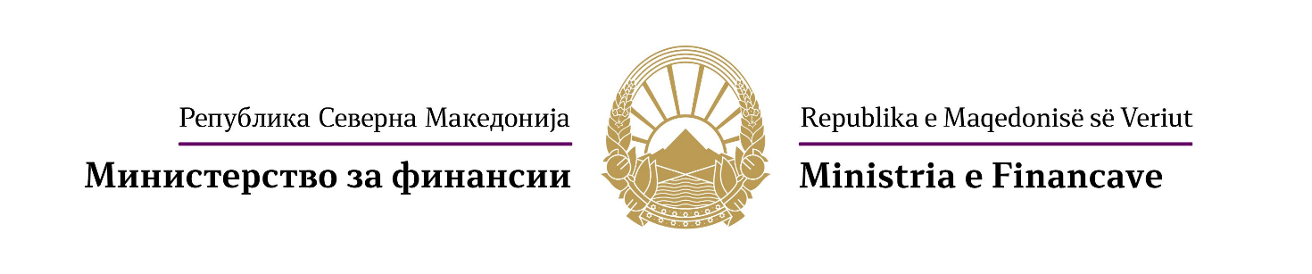

Јавна расправа за “Градење ефективни, транспарентни и отчетни институции за управување со јавните финансии во Северна Македонија“
Disksutim publik për “Krijimi i institucioneve efektive, transparente dhe llogaridhënëse për menaxhimin me financat publike në Maqedoninë e Veriut”.
Public consultation for “Building Effective, Transparent and Accountable Public Financial Management Institutions in North Macedonia”.
Р.бр. | Институција | Контакт инфо
1 | Министерство за информатичко општество и администрација | cabinet@mioa.gov.mk
2 | Министерство за внатрешни работи | kontakt@moi.gov.mk
3 | Министерство за економија
4 | Министерство за животна средина и просторно планирање | infoeko@moepp.gov.mk
5 | Управа за јавни приходи | info@ujp.gov.mk
6 | Вестминстер Фондација за демократија - Македонија | Damir.neziri@wfd.org
7 | Здружение за истражување и развој на општеството „ФОРУМ ПЛУС“ Скопје | forumplus.org.mk
8 | Здружение за истражување, анализа и развој „ЗЕЛЕНА ЛУПА“ Скопје
9 | Здружение на граѓани „Медиа Плус“ | info@mediaplus.org.mk
10 | „ИМПЕТУС“ Центар за интернет, развој и добро владеење – Скопје | contact@impetus.mk
11 | Иницијатива за европска перспектива | contact@iep.mk
12 | Институт за добро владеење и евроатлантски перспективи | contact@iduep.org.mk
13 | Македонски центар за меѓународна соработка (МЦМС)
14 | Транспаренси Интернешенл – Македонија | info@transparency.mk
15 | Фондација за локален развој и демократија „Фокус“ ​​– Велес | contact@focus.org.mk
16 | Фондација за одржлив економски развој „ПРЕДА Плус“ | info@predaplus.eu
17 | Центар за економски анализи | info@cea.org.mk
18 | Балкански економски форум
19 | Центар за правни истражувања и анализи | contact@cpia.mk
20 | Здружение за развој на демократијата и подобрување на квалитетот на животот и подобрување на образованието „Делта Сосајати“
21 | Здружение за развој на социјални и економски дејности „ЕРГОС“ Скопје | nvo.ergos@gmail.com
22 | ПРАВНА ИСТРАЖУВАЧКА МРЕЖА

ANNEX 3 - PHOTOS
from the Public consultation in the area of environmental protection and social aspects, in connection with the implementation of the project on “Building Effective, Transparent and Accountable Public Financial Management Institutions in North Macedonia

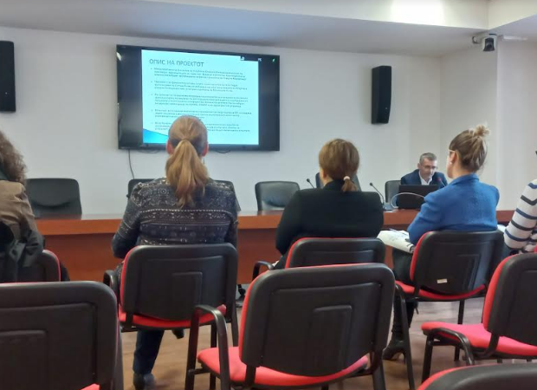

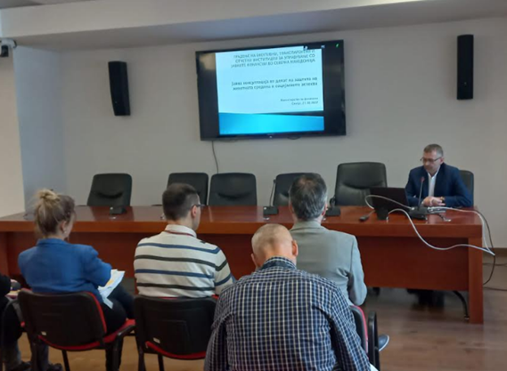

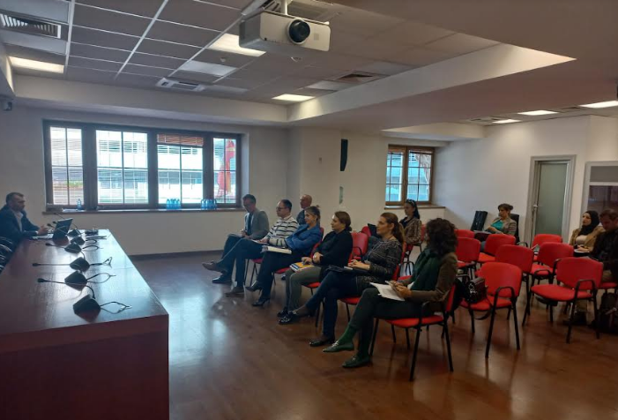

ANNEX 4 - POWER POINT PRESENTATION

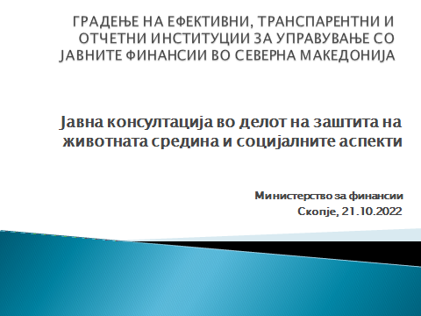

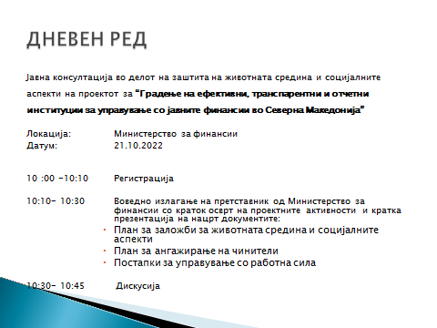

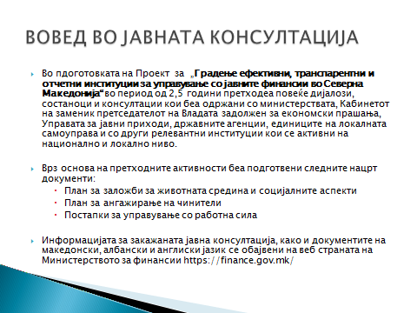

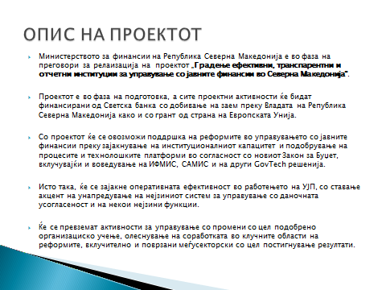
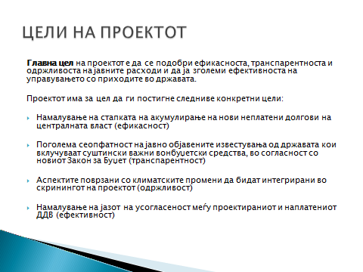

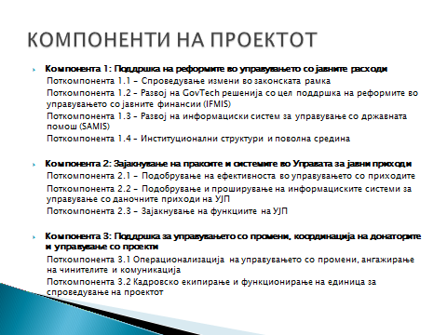
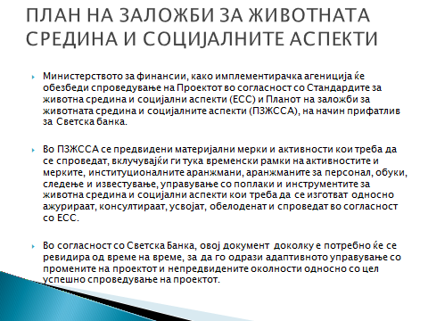

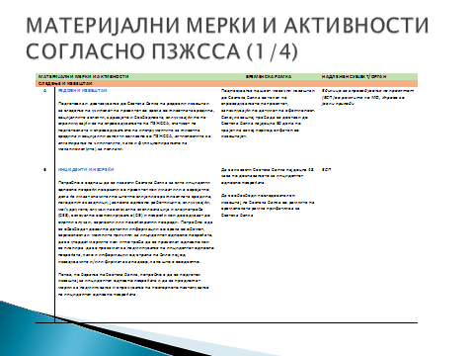
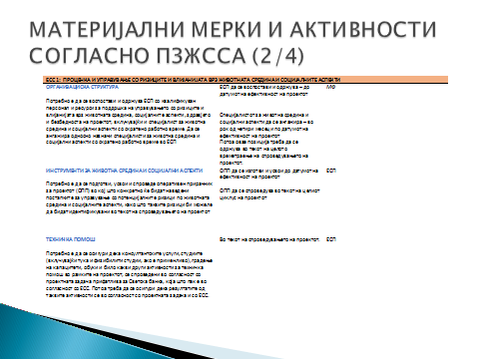

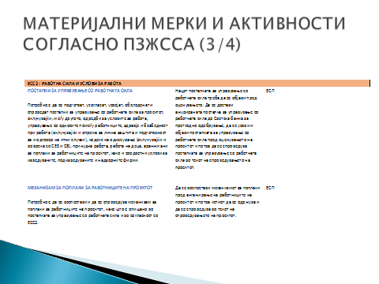
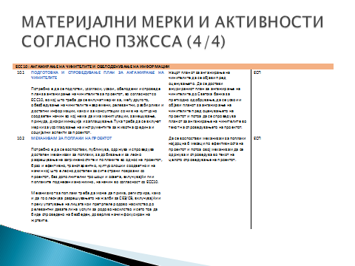

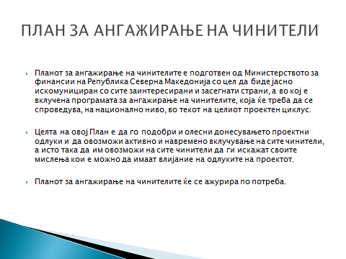

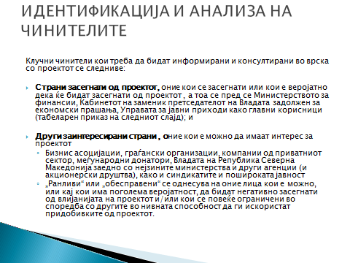

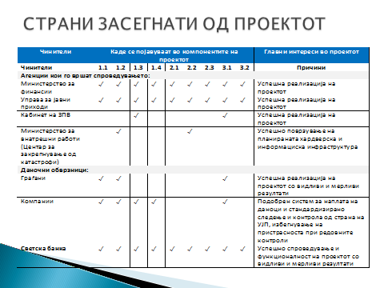
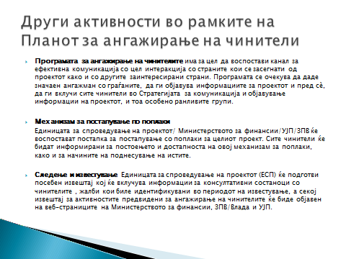

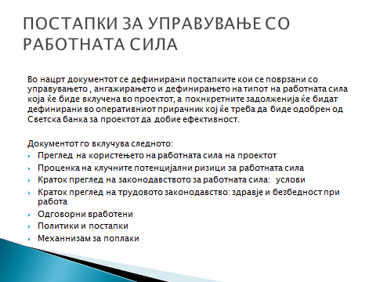
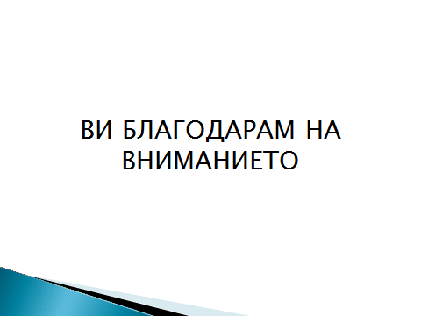

As per World Bank provisions, are workers directly engaged or civil servants deployed to work on Project implementation.
The project will be implemented by the selected MoF, and PRO and Government/Cabinet of DPM staff. Also, selected employees from MoI and MoE, as well as from the Government itself, will participate in successful realization of this project.
As per World Bank provisions, are workers employed or engaged by third parties (contractors, consulting companies etc) to perform tasks on Project implementation,
The provisions of ESS2.? are also determined with national legislation and they are relevant to civil servants.
OGRM no. 62/05, 106/08, 161/08, 114/09, 130/09, 149/09, 50/10, 52/10, 124/10, 47/2011, 11/12, 39/12, 13/13, 25/2013, 170/2013, 187/13, 113/14, 20/15, 33/15, 72/15, 129/15, 27/16, 120/18 and OGRNM no.110/19, 267/20 and 288/21
OGRM no. 53/13, 170/13, 43/14, 44/14, 97/14, 113/14, 160/14, 188/14, 20/15, 61/15, 97/15, 129/15, 147/15, 154/15, 173/15, 217/15, 27/16, 120/16, 132/16, 35/18, 220/18, 245/18, and OGRNM 180/19, 275/19, 31/20, 267/20
OGRM no. 37/1997, 25/2000, 101/2000, 50/2001, 25/2003, 37/2004, 4/2005, 50/2006, 29/2007, 102/2008, 161/2008, 50/10, 88/10, 51/11, 11/12, 80/12, 114/12, 39/14, 44/14, 113/14, 56/15, 129/15, 147/15, 154/15, 27/16, 119/16 and 21/18
OGRM no 27/14,199/14, 48/15, 154/15, 5/16, 127/16, 142/16, 11/18 and OGRNM 275/1914/20, 215/21 and 99/22
OGRM no 27/14, 199/14, 27/16, 35/18, 198/18 and OGRNM 143/19 and 14/20
OGRM no. 35/1997, 29/2002, 36/11, 164/13, 44/14, 33/15, 147/15 and 21/18
OGRM no. 16/2004, 102/2008, 17/11, 166/12 and 147/15
OGRM no. 44/2000, 16/2004, 62/2005, 113/2005, 29/2007, 88/2008, 161/2008, 99/2009, 136/11, 129/15, 147/15 and 27/16
OGRM no. 113/18 and OGRNM no.18/20
OGRM no. 85/07, 161/08, 147/15 and OGRNM no.124/19
OGRM no 115/10,140/10, 51/11, 147/13, 154/15 and 27/16,
OGRM no 20/15 and 44/15
OGRM no. 87/2007, 27/14 and 30/16
OGRM no. 217/15
OGRM no. 11/12, 30/14, 180/14, 81/15, 129/15, 132/17, 140/18 and OGRNM no.124/19
OGRM no. 79/13, 147/15 and OGRNM no.103/21
OGRM no. 166/14
OGRM no. No. 92/07, 136/11, 23/13, 25/13, 137/13, 164/13, 158/14, 15/15, 129/15, 192/15, 30/16, 18/2092/07, 136/11, 23/13, 25/13, 137/13, 164/13, 158/14, 15/15, 129/15, 192/15, 30/16, and OGRNM 18/20.
OGRM no. 2/2009
OGRM no. 154/08
OGRM no. 116/07
OGRM no.116/07
OGRM no.21/08
OGRM no.116/2007
OGRM no.116/2007
OGRM no.105/2008
OGRM no.154/2008
OGRM no. 21/2008
OGRNM no. 107/19 and 239/19
Applied for contracted workers

